Illinois Qualtrics Guide
Apr 15, 2025
Table of contents

Preface
Qualtrics is a popular online survey platform that can be used to create, distribute, and analyze surveys and forms. The University of Illinois has a campus-wide Qualtrics license, so all U of I faculty, staff, and students can use Qualtrics at no cost.
 Work in Progress
This guide is a work in progress, and will be updated substantially as time allows. If you find an error, please let us know.

Overview
The guide is an attempt to compile what we know about using Qualtrics: How to do common tasks, what works, and what should be avoided. It discusses how to navigate through the Qualtrics website for creating, editing, distributing, and viewing the results of your survey. Depending on your goals, you will likely want to jump to the relevant section(s) instead of reading from start to finish.
Sections are listed in the table of contents, which will appear on the left or as a “hamburger-style” menu, depending on your screen size. On a wide enough screen, subsections will also be listed in the “On this page” bar at the right. Many images can be clicked to zoom in.
Qualtrics also maintains extensive documentation on their website. The purpose of this guide is not to re-invent existing materials but to facilitate the research of faculty, students, and staff by presenting information in an easy-to-access and relevant format. This guide also includes some information that is not covered in the official Qualtrics documentation.

Why Qualtrics?
Everyone at the University has access to several survey/form creation tools, including Google Forms, Microsoft Forms, RedCap, and Webtools. So, why use Qualtrics specifically?
Simply put, depending on the nature of your project, the amount of data you are collecting, the sensitivity of the data, and the analyses you plan to perform, some tools may be better suited to your needs than others. For example, for HIPAA-protected health information, RedCap may be the best choice. In contrast, for a quick registration form or two-question survey, the best choice is whatever you are most comfortable using.
For larger forms or projects, Qualtrics offers several useful features. For example:
- Qualtrics is a FERPA-compliant solution for collecting student data (assuming you follow other data protocols correctly).
- Qualtrics surveys can incorporate detailed skip and display logic, meaning you can set it so respondents will only see questions that are relevant to them. This logic can be based on their responses or on information you have previously acquired. (See Section 2.5.)
- You can export response data in a variety of common formats, including .csv, .sav (SPSS), and .xlsx (Excel).
  - Response data can be formatted to split multiple-response/checkbox questions across columns, which can drastically simplify analyses involving race, ethnicity, or preferences. (This feature is absent in several other tools.)
- Qualtrics enables collaboration with colleagues outside the university, as well as with defined groups of Illinois researchers (i.e., within the same division, such as Housing, or with a lab or project group. (See Chapter 13).
- Surveys can be distributed via anonymous links, QR codes, personalized email links, or (for an extra cost) SMS messages. (See Chapter 5.)
- Survey data can be analyzed inside Qualtrics using StatsIQ or TextIQ, or downloaded and analyzed in the tool of your choice (Excel, SPSS, R, Python, etc).
- Surveys can trigger a variety of workflows, such as emailing respondents a summary of their results, sending you (the researcher) a notification in Microsoft Teams, or populating a Google Sheet. (See Chapter 15.)

Features
The University has a Qualtrics CoreXM license with some premium features:
- Premium CoreXM and programming/automation features (details below).
- Training and support.
  - Free courses, events, and webinars through XM Basecamp. (Note that not all Basecamp offerings are included with our license.)
  - Personal support from experts at Illinois as well as experts at Qualtrics.
    - (Note: for best results, login to Qualtrics before attempting to access the Qualtrics Support portal.)
  - Access to the XM Community, a global peer-to-peer discussion board about Qualtrics.
  - System status page that constantly monitors Qualtrics performance.
- The XM Product Roadmap is a great way to learn about changes to Qualtrics software. It includes a history of product updates and a look at upcoming features.
- Illinois does not subscribe to the separate Qualtrics products that are built on top of the CoreXM foundation (CustomerXM, EmployeeXM, whateverXM, etc.). We also do not have access to Conjoints/MaxDiff or Website/App Feedback.
  - We do have access to the Qualtrics offline surveys app, but not the XM Mobile App. The offline app is a workable solution when you need to administer surveys at a location that does not have a reliable internet connection. Please contact us if you would like to use the offline app so we can enable the appropriate permissions.
  - We have XM Directory Lite, which lets you upload contacts and distribute surveys to them, but for data privacy reasons we do not have the full XM Directory.
Premium CoreXM features:
- File Upload question type: allows survey participants to upload a file along with their survey response. This is useful if your survey collects files, images, or documentation from respondents.
- Signature question type: allows participants to draw their signature, essentially ‘signing’ the survey. Can be useful for obtaining informed consent.
- Table of Contents survey flow element: adds a table of contents to your survey, allowing survey participants to navigate between different blocks of questions and track their overall progress.
- SMS Distributions: if you have a list of mobile phone numbers for your respondents, you can distribute a short survey - or a link to a survey - using SMS text messages. SMS distributions can be purchased from the WebStore at $550 for 50,000 SMS credits. See Section 5.4 for details.
Programming and automation features:
- Workflows allow you to trigger tasks based on various events. Examples include sending an email notification about a survey response, or automatically sending a survey invitation when an event occurs on a related system. For both the trigger event and the resulting task, you have a lot of options, most of which are inside the Qualtrics platform and some of which are external, such as connecting to Excel Online or Teams. Workflows report successes and failures when they run, which is useful if you need to troubleshoot. See Chapter 15.
- The Qualtrics Application Programming Interface (API) allows you to automate repetitive processes within the application. API can be used to automate contact lists, create surveys, and to move information in and out of Qualtrics. Detailed API documentation is available online. To obtain access to the Qualtrics API, submit a request.
- Qualtrics lets you embed HTML and JavaScript in the Survey Editor to add custom functionality to your survey. For example, you can change the size of a question text box, create a custom question type, and much more. A few examples of custom JavaScript are included in Section 16.5.
Good to know:
- Qualtrics survey projects and response data are stored and managed by Qualtrics, not by the University of Illinois.
- Qualtrics regularly backs up your data, protects it from unauthorized access, and adheres to several security standards. See the Qualtrics security statement for details.
- For added protection, survey owners can export their surveys and responses to create personal backup copies; multiple file formats are available.

Request a Consultation
If this guide does not answer your questions, you can also schedule a consultation. Consulting is open to all University of Illinois students, faculty, and staff during the Fall, Spring and Summer 2 semesters.
You are encouraged to contact us for appointments by submitting a request. Drop-in questions during consulting hours are welcome either through Zoom during our virtual drop-in hours or in person at Scholarly Commons 220 Main library (check their website for updates - (https://www.library.illinois.edu/sc/)).

1. Getting Started
University of Illinois faculty, staff, and students can use Qualtrics for free by logging in with their netID and password.

1.1 Accessing Qualtrics
To log in to Qualtrics, go to illinois.qualtrics.com and sign in with your Illinois NetID and password.
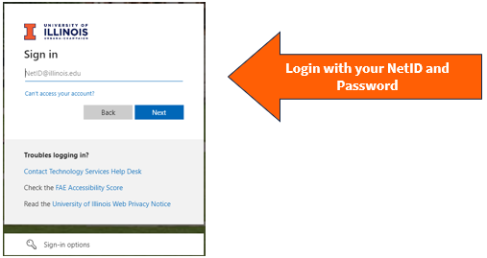
 Tip
Qualtrics accounts are domain-specific, which means that logging in at a different URL will log you into a different account. If you log in at illinois.qualtrics.com, you’ll be logged into an Illinois Qualtrics account. If you try to log in at qualtrics.com you will create a free (non-Illinois) account, and if you try to use illinoislas.yul1.qualtrics.com or another deprecated Illinois college-specific account, it will return an error saying the account is disabled. If you have multiple accounts, surveys and data are NOT shared between them.

1.1.1 College/Unit Accounts
All College/Unit Qualtrics accounts were disabled on December 31, 2023. If you are missing data from a college/unit account, please contact CITL Data Analytics.

1.2 Create a Project
After logging into Qualtrics, you will see all of your current surveys under the tabs Recently visited and See all projects. (Qualtrics refers to surveys as “projects.”) Click Create a new project on the bottom left corner on the home page.
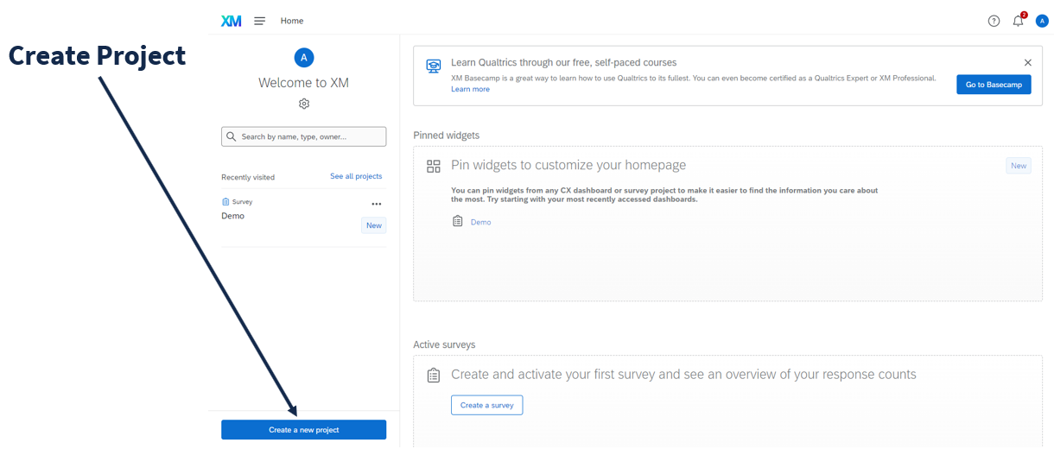
To create a new, blank survey, select “Survey” under the “From scratch” heading.
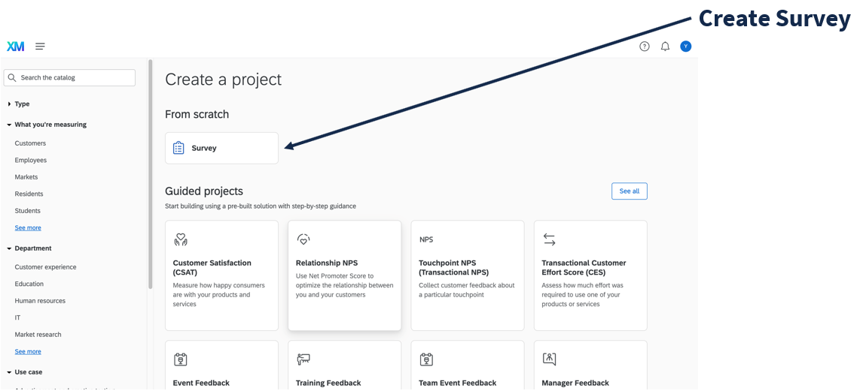
 Note
Only use the “Imported Data” project type if you want to use Qualtrics to analyze external data (i.e., similar to how you would use Excel or SPSS). Imported data projects cannot currently be combined with survey projects, so if you are trying to merge external data with survey results, you should do so within that survey project or in another program (i.e., Excel or SPSS).
Then, click “Get started”, name the project, and click “Create project”.
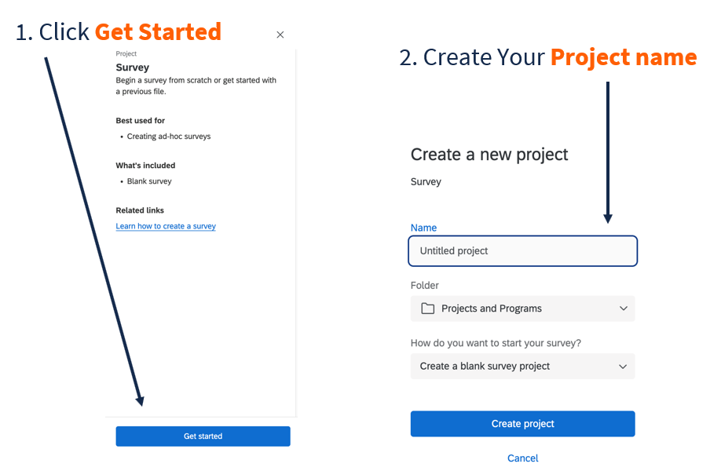

2. Survey Interface
In the main survey edit screen, from left to right you will see the Survey toolbar, the Question editing pane, and the Question editing area.
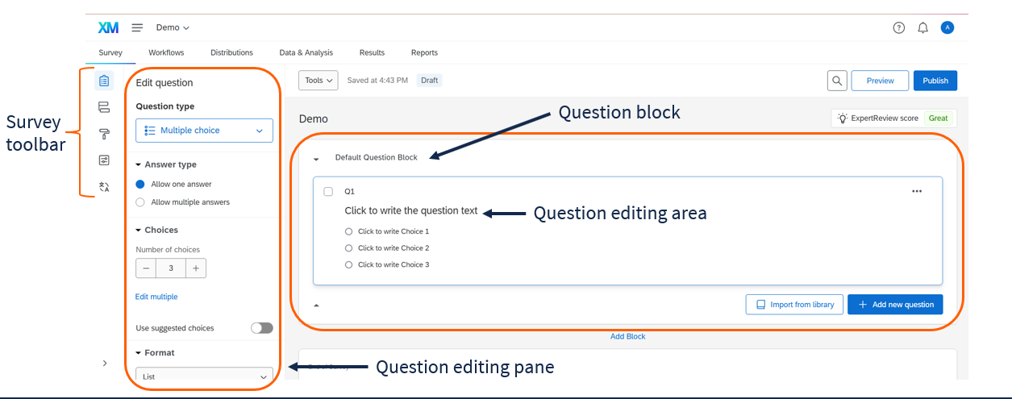
The elements of the survey builder interface

2.1 Survey toolbar
The Survey toolbar on the far left lets you navigate between managing the survey’s content, flow, look and feel, options, quotas, and translations. Of these options, you will likely use the Survey Content and Survey Flow most often.
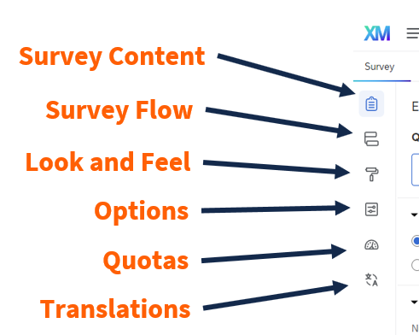

2.2 ExpertReview
For survey design suggestions, click the ExpertReview Score button on the right side of the survey editor.
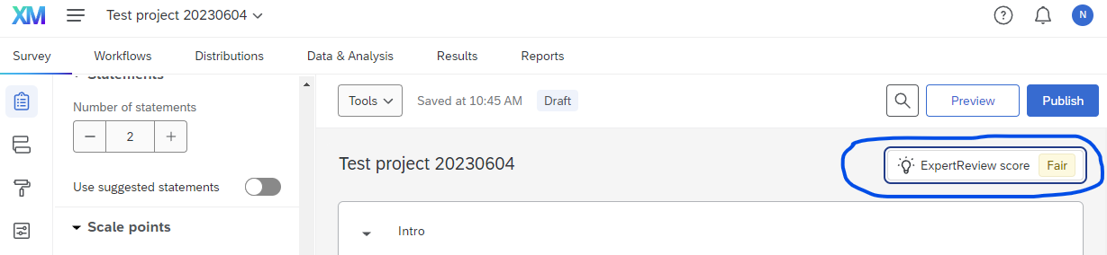
In the window that appears, you will see suggestions to improve your survey and some accessibility tips.
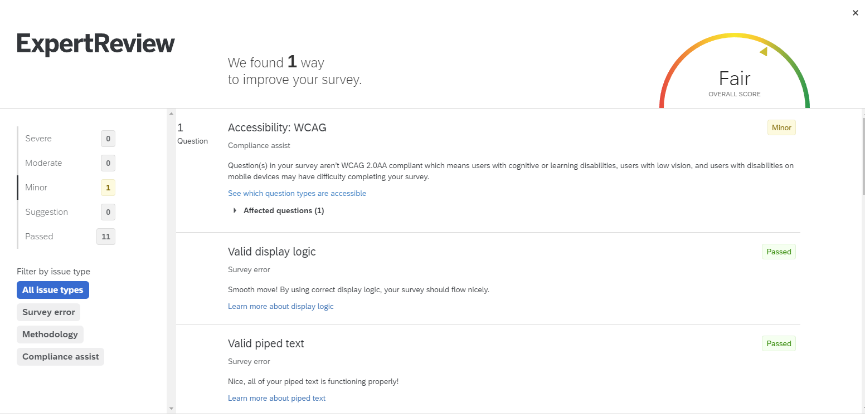
 Warning
The ExpertReview check ignores some crucial accessibility issues like alt text and color contrast. Please check these on your own or reach out to an accessibility specialist.

2.3 Question editing area
In the question editing area, you can type question text, add/delete new questions and question blocks, and click-and-drag to rearrange questions.
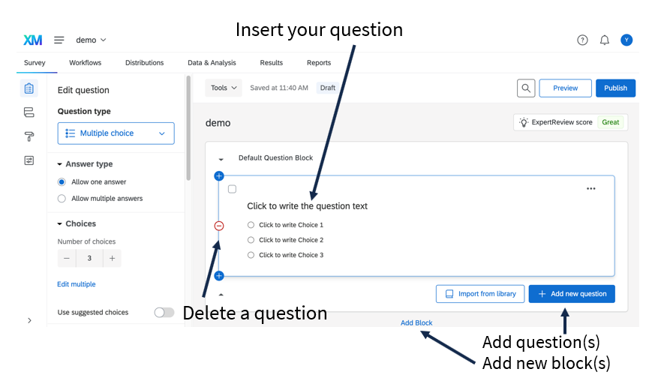

2.3.1 Numbering Questions
By default, questions are numbered in the order they are created, starting with Q1. In many cases, as you add or delete questions, the default numbering will not correspond to the order of the questions in the survey.
Tip
Question numbers are not visible to respondents unless you explicitly choose to make them visible in Survey Options.
We recommend renaming your questions using one of the following methods:
You can rename a question by clicking on its name (i.e., where it says Q1) and typing another name. This lets you provide descriptive names that will appear throughout Qualtrics and in your downloaded data.
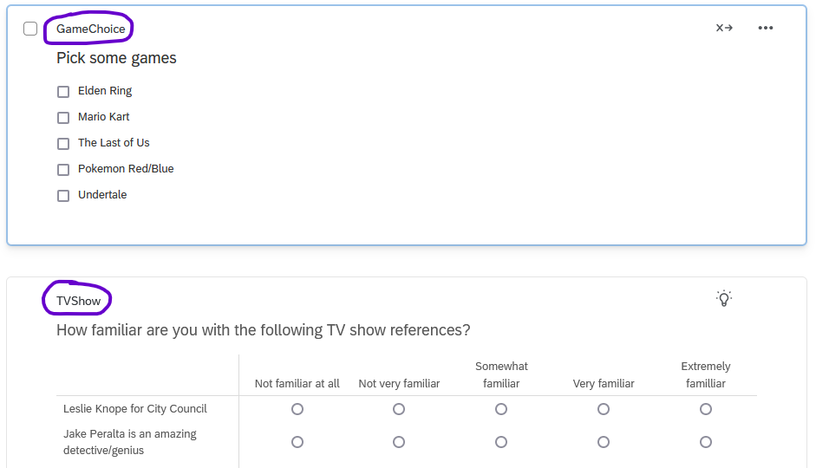
Example of named questions
For matrix questions, after you rename the question, you can also rename the way each statement is exported. (By default, Qualtrics appends numbers to each statement starting with _1)
To do so, click Recode Values in the question editing pane.
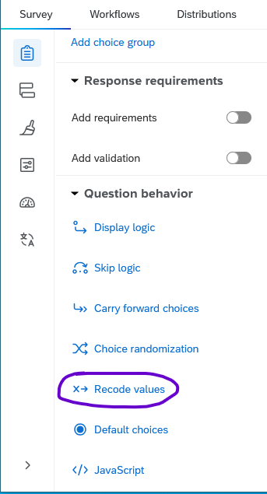
Click the Question Export Tags checkbox and edit the variable names as desired.
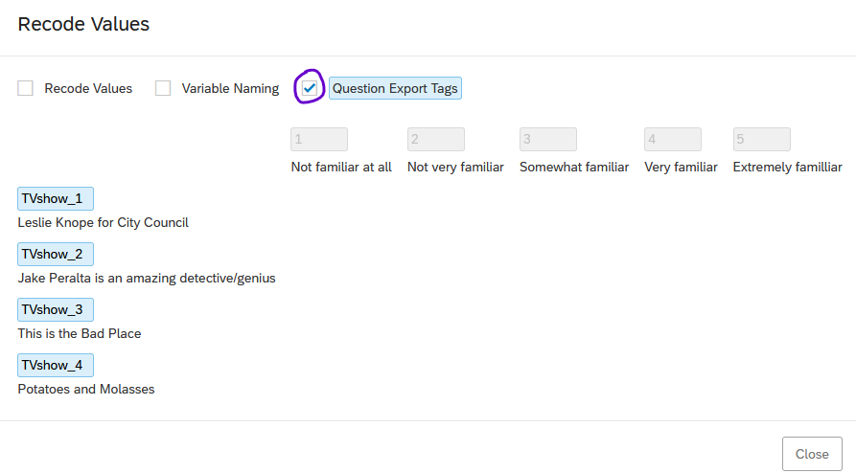
You can also bulk renumber questions by going to the Tools menu and choosing Auto-number questions.
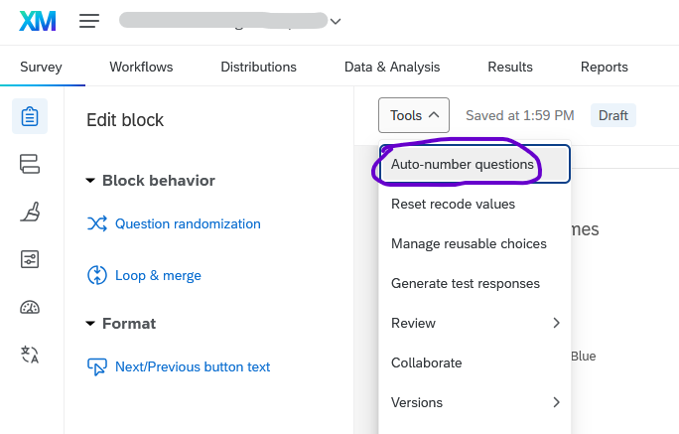
In the following pop-up dialog, choose how you’d like to number the questions, then click Apply.
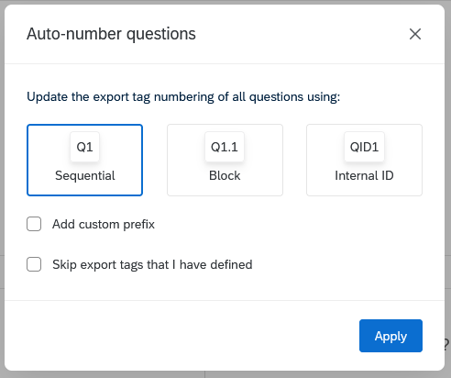
Tip
It’s possible to rename (or re-number) questions even after people have taken your survey. Renaming questions will affect the column headers in subsequent data downloads but will not change any response data.

2.3.2 Blocks
In Qualtrics, questions are arranged into blocks. In the question editing area, blocks are arranged vertically, but the order in which they appear to respondents can be rearranged using the Survey Flow interface (see Chapter 3).
As a rule of thumb, we suggest using the following blocks, though the blocks you use will ultimately depend on the structure of your survey.
- Introduction block
  - Example: One text question. The first line is a first-level heading that says “Illinois Diet Study.” Below that, it says, “This study is about diet. Please read the questions carefully and thoroughly and answer them honestly. This survey takes approximately 5 minutes.” 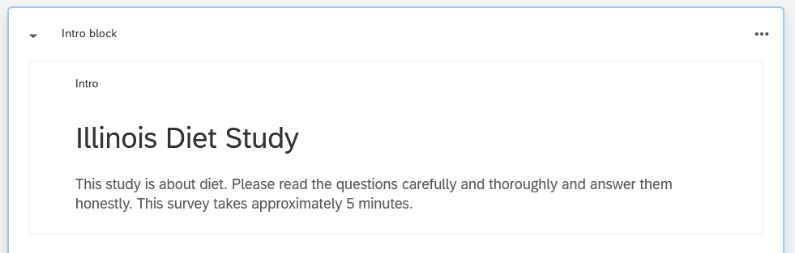
- A few blocks with your main questions
  - If you are conducting a short survey (i.e., event registration, informal feedback), one block may be enough.
  - If you are conducting a longer research project, you can separate your independent variables and dependent variables into separate blocks.
  - If you are conducting a survey experiment, create different blocks for each experimental condition, and use Branch Logic (Section 3.2) to control which respondents see which blocks.
- One demographic block (best practice is to place it after the main survey questions, but it’s up to you.)
  - Standard demographic questions may be available through your college or division (see Section 13.4.2).
- Optionally, one debriefing block if you need to tell participants anything at the end.
  - Example: One text question which says, “The purpose of this survey was to…”
- There is no need to include an “End of Survey” block, since End of Survey messages can be configured in the survey flow (Chapter 3), and because more people will finish the survey if the last element is not a block of text.

2.4 Question editing pane
The Question editing pane lets you specify the question format and requirements, such as the type of question, the number of answer choices, and how the choices are arranged.
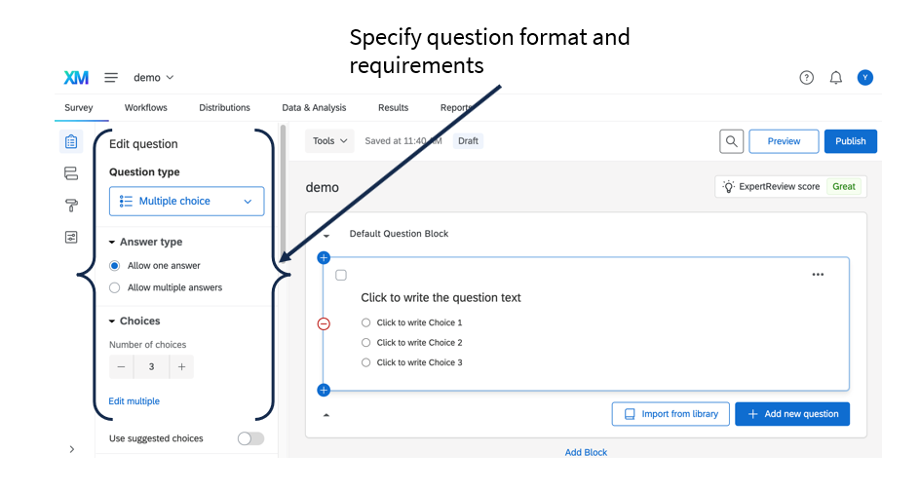 Surveys can contain many types of questions. Here are some of the most common:
- Text/Graphic (good for introduction, instructions, and debriefing)
  - Note that Text/Graphic is inserted as a “question,” even though it provides no way to answer.
  - To insert an image, create a text/graphic question, choose “text,” then insert the image into the text box. Whenever you insert an image, be sure to add alt text! (See Section 4.3.3.)
- Text entry (good for age, email, state/city)
  - The length of the text entry box can be customized from a small box (good for email) to a large essay-sized box (good for feedback).
  - Often, it’s useful to add validation to text entry questions; see Section 2.4.2 below for details.
- Multiple choice (good for gender and ethnicity)
  - This category includes both single-choice and multiple-choice questions. To let respondents choose more than one option, click Allow multiple answers in the question editing pane.
- Matrix tables (good for multiple questions using the same answer scale)
  - Using a matrix table lets you include multiple Likert type items in a single question.
  - Matrix table questions are not accessible to screen readers by default, but they can be configured to be accessible (see Section 4.1.3.1).
The question editing pane also includes a section on “Question behavior” that includes Display Logic and Skip Logic, which are discussed in Section 2.5.

2.4.1 Forced response
To force respondents to answer a question, click on the question, choose “Add requirements” under “Response requirements,” and click “Force response.” This can be useful for consent forms, contact forms, and information request forms; however, take into account best practices from your department and generally avoid requiring response to most questions. (See also: Qualtrics guidance on forced response)
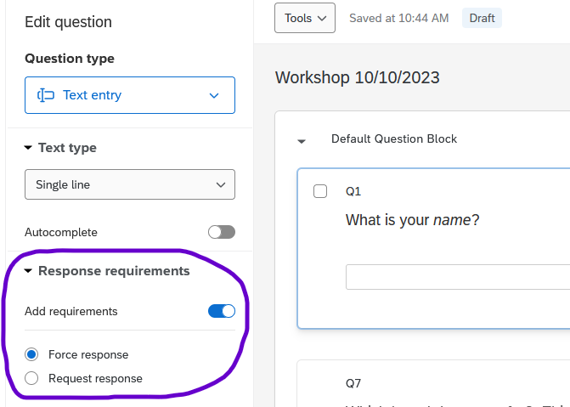
Instead of a forced response, you may consider the “Request response” option, which notifies respondents if they attempt to move on without answering the question, but after the notification, they can still choose not to respond.
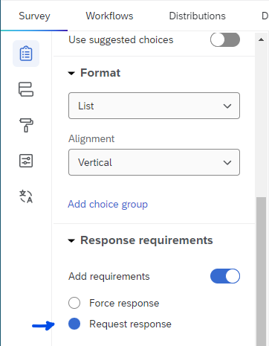

2.4.2 Response validation
When you provide a text box and ask for an email address, phone number, date, number, text, state, or postal code, you can enable Content validation to check that answers are valid.
For example, you can make sure that respondents enter a valid email address (which includes an “@” symbol and a valid domain format like “illinois.edu” or “gmail.com”). Or, you can make sure that respondents enter their age as a number with no decimals. You can also use response validation to set attention checks (i.e., “Please choose Never to proceed”).
To enable content validation for a text question, click on the question, choose “Add validation” under “Response requirements”, select “Content type” from the dropdown menu, and choose the type of content (e.g., “Email address”). (See the Qualtrics documentation on content validation)
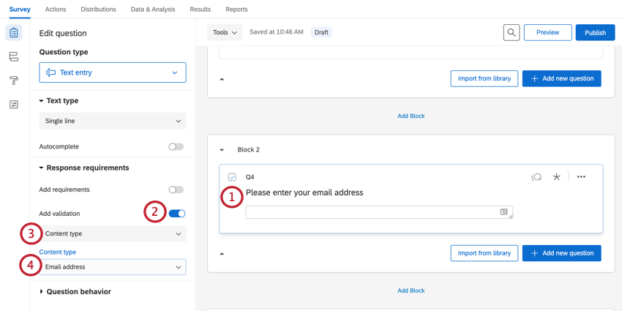
Note
Different question types offer different validation requirements. Text entry questions, for example, will only validate email addresses if the type of text entry is set to “Single line.”

Tip
A text entry question is the simplest way to ask respondents to enter a date. See Section 16.4 if you would like more details.

2.4.3 Recode Values
Qualtrics assigns numbers to the options of a multiple-choice question, and you can choose to download the numbers instead of the text if you prefer.
However, Qualtrics numbers the options (starting with 1) based on the order that they’re entered. This means that if you reorder or delete answer choices, the numbers may not match what you expect. To check the values, click Recode Values in the question editing pane.
Recode values is near the bottom of the question editing pane
The values will display next to the choices. Sometimes, you may be surprised!
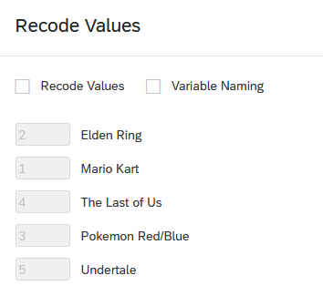
Example: The choices are out of order
To renumber the choices, check the Recode Values box at the top. Edit the choices as desired, then click Save.
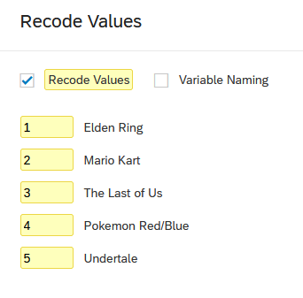
Values have been recoded
After a question’s values have been recoded, a small icon will appear to its right.
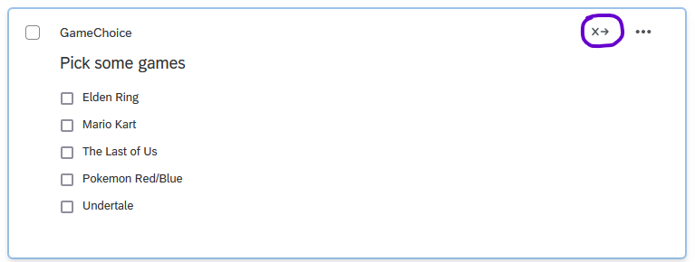
Tip
It’s possible to recode values before or after people have taken your survey. Note that changing the recode values will affect all subsequent data downloads, which can facilitate later data cleaning and analysis processes, but may also require you to revise any existing data workflows.
To see the recode values for all questions in your survey, export the survey as a Word document by going to the Tools menu > Import/Export > Export survey to Word.
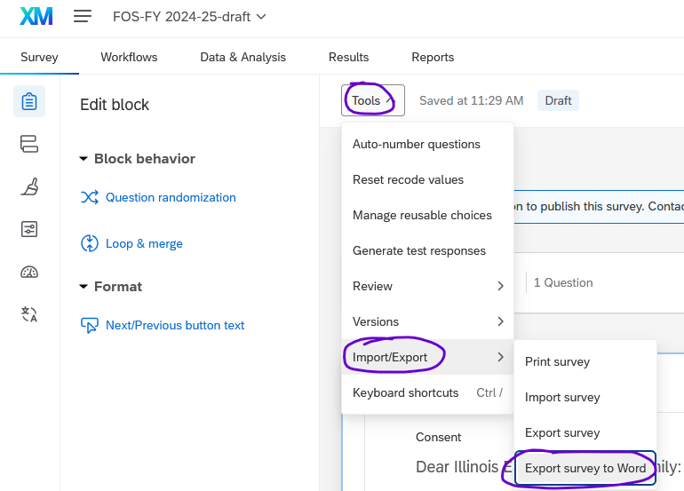
The word document will show the question number or variable name for each question (highlighted yellow in the screenshot below) followed by the question text. Answer choices will be shown with their recoded values (also highlighted yellow).
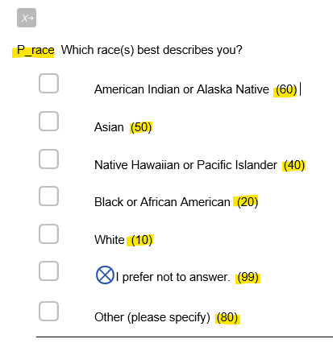

2.5 Survey Logic
Logic is used in surveys to customize respondents’ experiences. Most often, logic is used so that respondents see fewer irrelevant questions, but it can also be used to trigger other behaviors in the survey. There are several Qualtrics features that use logic:
- Logic can be attached to specific questions.
  - Display Logic is used to conditional show specific questions and answers based on respondents’ answers to previous questions.
  - Skip Logic is used to jump respondents to a point further forward in the survey based on responses to questions.
  - Carry Forward Choices ensure that once individual respondents answer certain questions, they only see the specific response options in future related questions.
- Logic can also be used in question blocks.
  - Branch Logic is a common type of survey flow which is used to show users different blocks of questions depending on specific conditions (see Chapter 3).
Because different types of logic are implemented in different parts of the survey interface, the end of this section includes a cheat sheet (Section 2.5.3).
Note
For a more complete explanation, see the Qualtrics documentation on Survey Logic

2.5.1 Display Logic
Display Logic is primarily used to show specific questions and answer options based on respondents’ answers to previous questions. For example, a survey about students may ask respondents to mark whether they are an undergrad or grad student, and respondents who mark “Grad” will see a follow-up question asking where they completed their undergrad degree.
However, display logic is not the most efficient way to hide large numbers of questions. In this example, for a survey with several questions for grad students, it would be better to either use skip logic to skip the questions, or use branch logic to trigger a separate grad student question block.
Display logic can be based on any of the following criteria:
- Previous responses (like the above example)
- Embedded data (such as course enrollment, from a list; or student/staff status, from SSO authentication)
- Quotas (such as asking only the first 50 respondents if they would like to enter a prize drawing)
- Contact lists
- Location (where they are taking the survey)
- Loop and merge blocks
- Device type
- True-false conditions
Note
Display logic will add a page break after the specific question unless the “In Page” option is selected. In-page display logic can only be used with some types of questions.
To implement Display logic, select the question that should be conditionally displayed and choose “Display Logic” from the “Question behavior” section of the “Edit Question” menu.
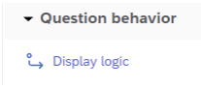
Display logic is the first item under question behavior in the question editing pane
Next, select the relevant options from the Display Logic interface. Multiple conditional elements can be implemented by using the green plus button to add conditions. Click Save.
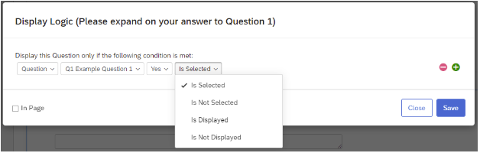
The display logic popup menu
If implemented correctly, a flag will appear on the question indicating that Display Logic is in use and what that logic is.
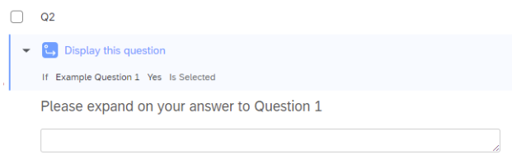
A survey question with display logic implemented
Note
For more details, see the Qualtrics Documentation on display logic.

2.5.2 Skip Logic
Skip Logic is used to conditionally jump respondents to a point further forward in the survey based on responses to questions. Skip logic allows for moving respondents forward to questions within the same block, to the end of the block, or to the end of the survey. It does not allow for moving respondents to points within a subsequent block.
To implement Skip logic, select the question that triggers the skip and choose “Skip Logic” from the “Question behavior” section of the “Edit Question” menu.
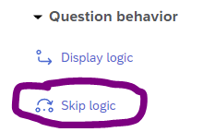
Skip logic is the second option under question behavior
Next, select the relevant options from the Skip Logic interface and save.
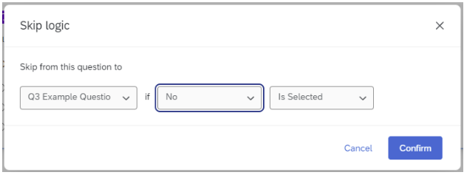
The skip logic popup window
Tip
In order to skip to a later question in the same block, there must be at least 2 questions after the question that triggers the skip logic – one question to be skipped, and one question to be the destination.
If implemented correctly, a flag will then appear on the trigger question indicating that Skip logic is in use and what that logic is.
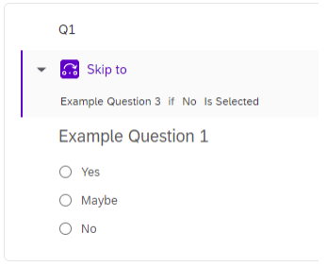
A question with skip logic implemented
Similarly, a flag will appear on the destination question indicating that Skip Logic is in use and where the skip originated.
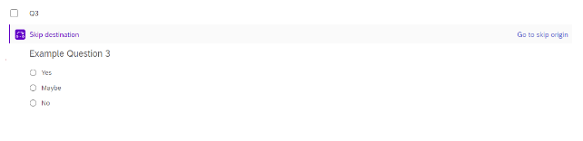
A question is marked “Skip destination” after skip logic was implemented in a previous question
Note
For more details, see the Qualtrics documentation on skip logic.

2.5.3 Survey Logic Cheat Sheet
Cheat Sheet of Where to Apply Survey Logic
Type | Purpose | Where to implement
Display Logic | Show a question or answer option based on answers to a previous question | In the question that should be conditionally displayed
Skip Logic | Skip to another question within the same block, the end of the block, or the end of the survey | In the question that triggers the skip
Carry Forward Choices | Pipe previous answers as possible responses in later questions | In the question into which the choices should be carried
Branch Logic | Show or hide an entire block of questions | In the Survey Flow interface

3. Survey Flow
This section is about the Survey Flow section of the Survey Builder tab of Qualtrics.

3.1 What is Survey Flow?
Survey Flow is the collective term for methods of broadly customizing the elements that respondents interact with inside the survey. You can use survey flow to display blocks of questions in a particular order, to make certain blocks of questions conditionally available to certain respondents, or to end the survey early for a particular group or once a quota is met.
Survey flow elements include:
- Blocks of questions (see Section 2.3.2 in the previous chapter)
- Branch (see Section 3.2 below)
- Embedded Data (see Section 16.3)
- Randomizer
- Web Service
- Supplemental data (enabled on an as-needed basis)
- Group
- Authenticator (see Section 3.4 below)
- End of Survey (see Section 3.3)
- Reference Survey
- Table of Contents

3.1.1 Utilizing Survey Flow
To utilize Survey flow elements, select the Survey Flow icon in the left-hand Survey Menu.
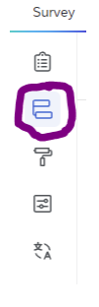
Select “Add a New Element Here”.
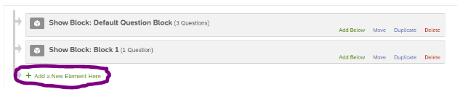
This will bring up the Survey Flow elements interface, where you can choose which Survey Flow element you want implement. Multiple Survey Flow elements can be implemented in a single survey. All elements, including question blocks, can moved around within the survey using this interface.
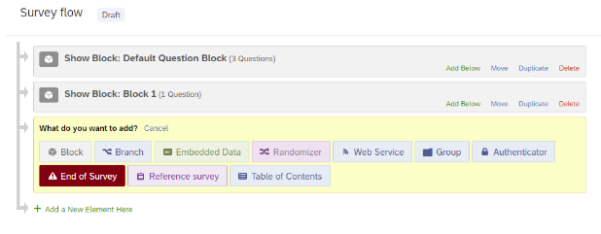
For additional details, see the Qualtrics documentation on survey flow

3.2 Branch Logic
Branch logic is a type of survey flow used to show users different blocks of questions depending on specific conditions. Branches can be triggered by participants’ responses to previous questions or by embedded data associated with the participant (see Section 16.3). Branches can contain multiple elements and can be nested within other branches.
To implement branch logic, go to Survey Flow, add a new element, and select the Branch element.
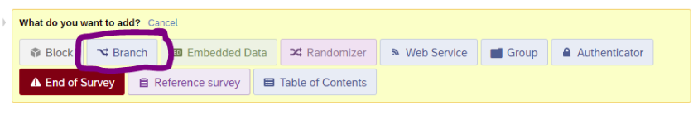
You will then be prompted to Add a Condition.
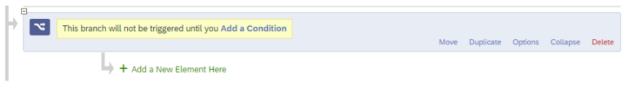
Chose the relevant question or other factor and select OK.
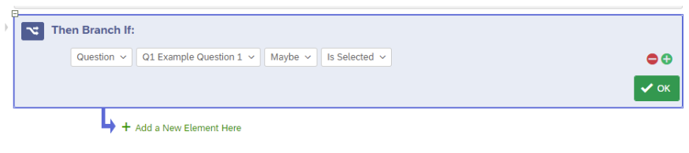
Finally, to move blocks or other elements under the branch logic, click and drag the elements where they say “Move.”
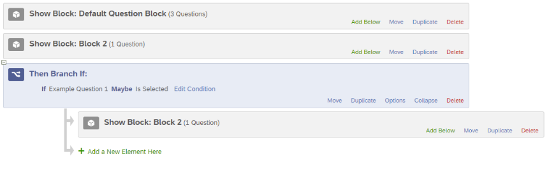
For additional details, see the Qualtrics documentation on branch logic.

3.3 Custom Thank-You Page
Qualtrics allows for customizing the End-of-Survey page for all respondents to your survey, or to certain populations based on their responses to questions within the survey using Branches (see Section 3.2).
To create a custom thank you page, go to Survey Flow, add a new element below the last block of the survey or desired Branch, and select the End of Survey element.
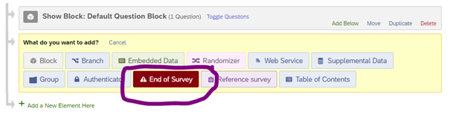
This will automatically add an End of Survey element to your Survey Flow. To create a specific message for your survey or survey Branch, select Customize.
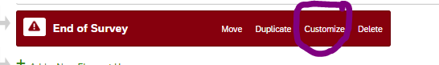
You will now see a dialog box that likely indicates that the element is using the “Default end of survey message.”
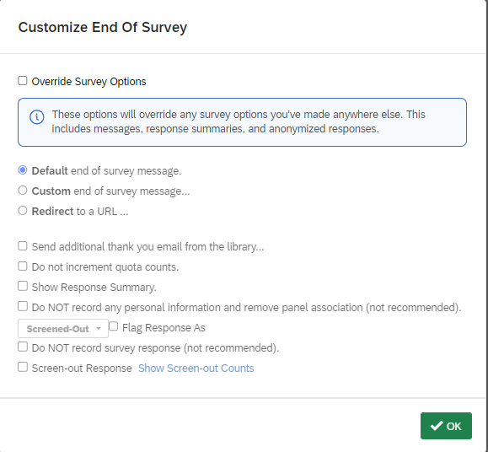
To implement a custom message, check Override Survey Options and change the radio button selection to “Custom end of survey message”.
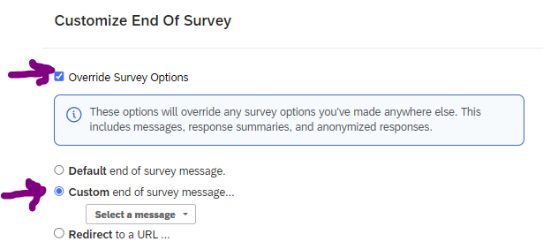
You will be prompted to Select a message. If you have previously created a custom message, or are a member of a Qualtrics group that has shared messages, you can select one here from either “My Library” or a “Group Library” here.
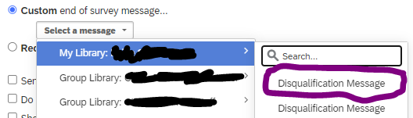
Otherwise, you can create a “New Message” in your own library.
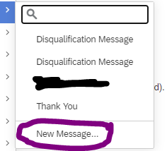
Tip
You may also be able to create messages in Group Libraries. For access to a Group Library, contact your Qualtrics division (in your college) or brand administrator (CITL Data Analytics).
You will now be prompted to create the content of your new message.
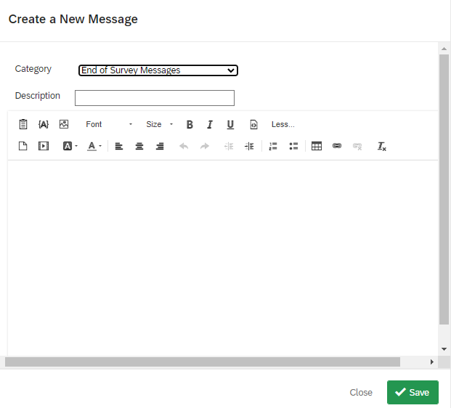
Name your new message in the description box and write and format the relevant content in the text field.
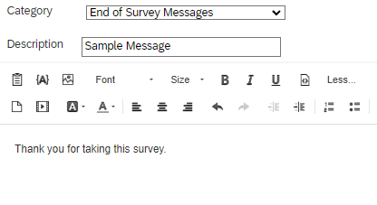
If you would like to show your respondents answers from their own surveys, you can use the Insert Piped Text field here as well (see Section 16.1).
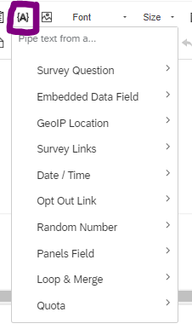
Once you have finished editing your message, select Save and you will be returned to the “Customize End Of Survey” dialog window. Here you can make other customizations such as showing respondents their own Response Summaries, though these options are less likely to be relevant to most users.
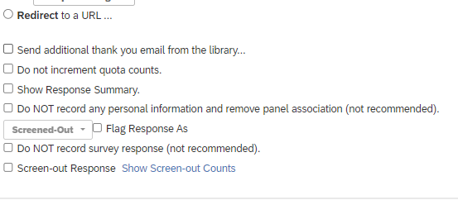
Select OK to finish the customization process.
You should now see a small check mark next to the Customize button on the End of Survey Element in the Survey Flow view.
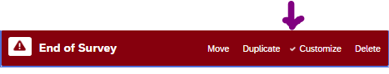
If you will be using separate End of Survey messages for different Branches, repeat the process for each Branch. Then select Apply at the bottom of the screen to apply the changes to your survey.
 Important
If you make changes to a previously published survey, you will need to publish these changes in order for them to take effect.

3.4 Authentication
Qualtrics surveys can incorporate Single-Sign-On (SSO) authentication as a way of adding identifying information to responses or as a condition for survey logic (Section 2.5 discusses survey logic).
To create a custom thank you page, go to Survey Flow, add a new element below the last block of the survey or desired Branch, and select the End of Survey element.

3.4.1 To Enable SSO Authentication on Your Survey
- Go to the Survey and click the Survey flow interface.
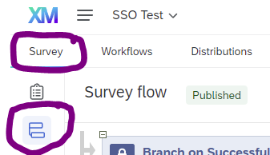
- Select “Add a New Element Here.”

- Choose “Authenticator.”
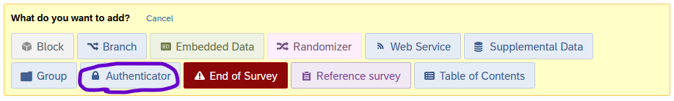
- Set up the Authenticator using the following settings:
  - Set the Authentication Type as “SSO”
  - Uncheck the “Associate Respondent with Panel” checkbox
    - Checking this option requires respondents to be member of a selected contact list and allows respondents to only reply once
  - Only check the “Capture Respondent identifying info” checkbox if you want to record respondents’ information (name, email, etc.; see below)
  - Set the SSO Type as “Shibboleth”
  - Leave the Connection as the default “InCommon SSO Connection”
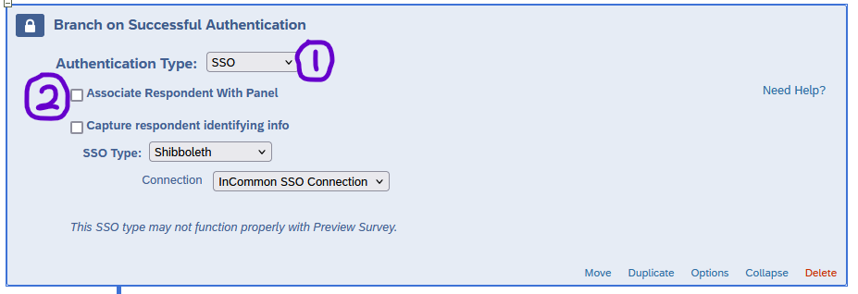
- Move the Authenticator block to the top of the survey flow so the authentication is triggered before the survey opens. Drag all blocks you want authenticated underneath the authenticator.
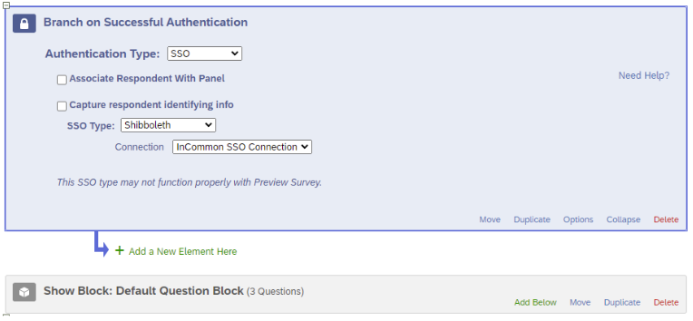
- Check “Apply” at the bottom right of your screen to apply the changes.
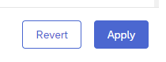

3.4.2 To Add Embedded Data from Shibboleth
- In the Authenticator block, select the “Capture respondent identifying info” box
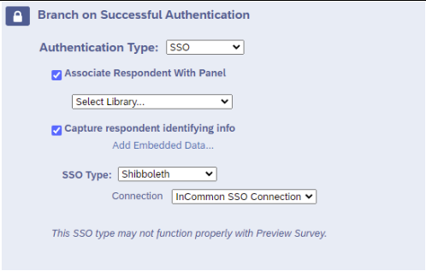
- Click on “Add Embedded Data…”
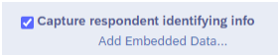
- You will now see an option to set your embedded data fields.
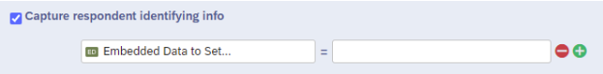
- In the first box, name the field as you want it to appear in your Qualtrics data.
- In the second box, use the relevant field names passed through from Shibboleth
  - Examples include First Name = givenName, Last Name = sn, and Email = mail
  - For a full list, see below.
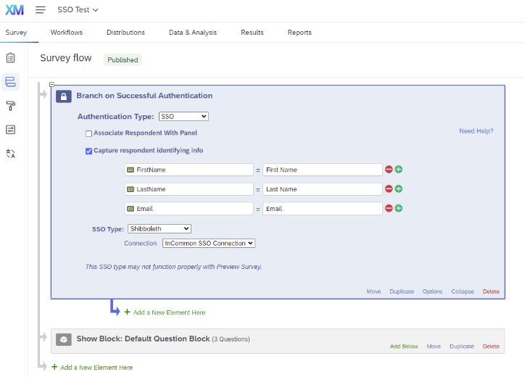
- Click on the green $+$ button to add fields as needed.
- Check “Apply” at the bottom right of your screen to apply the changes.
Fields that can be passed into Qualtrics from Shibboleth
Field | Shibboleth Field Name | Example
First name | givenName OR First Name | Philip
Last name/surname | sn OR Last Name | Nyman
Email | mail OR Email | nyman@illinois.edu
Primary affiliation | eduPersonPrimaryAffiliation | staff
iTrust Primary Org Code | iTrustPrimaryOrgCode | 1-KV-324

Note
Note that in the table, there are two ways to specify First name, Last name, and Email. Either one should work.
- If your authentication fields are set up correctly, depending on the selected pass-through variables when viewing individual responses in the Data & Analysis page you should see something like this below the survey question responses.
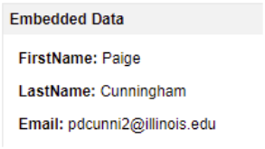
- Exported data should appear similar to the following:
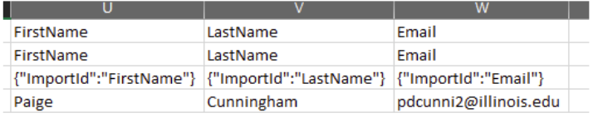

3.4.3 Using SSO Data in Survey Logic
It is also possible to use SSO data in other parts of the Qualtrics interface, such as as conditions for survey logic. For example, you could field one block of questions to staff and a separate block to students. Or, you could end the survey for anyone who does not have a .illinois.edu email address.
To use SSO data in survey logic, go to the Survey Flow menu and enable SSO authentication and set the survey to capture identifying information as described above. Choose the fields you wish to use in survey logic, as well as any other fields you would like to use in piped text or see in the dataset.
Then, add a New Element to the survey flow and choose “Branch”.
Click “Add a condition” and change the first drop-down menu from “Question” to “Embedded Data”.
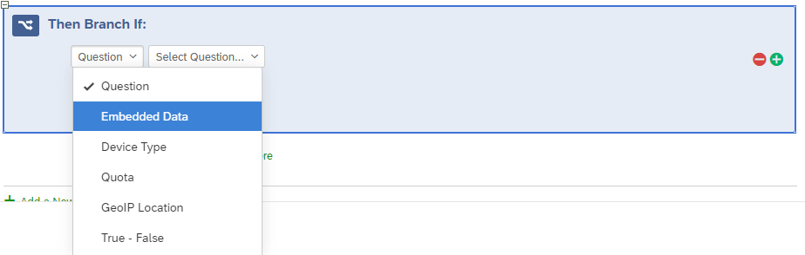
As usual for branch logic, impute the data to use in the logic and the condition. For example, you can branch based on whether Affiliation equals “staff”.
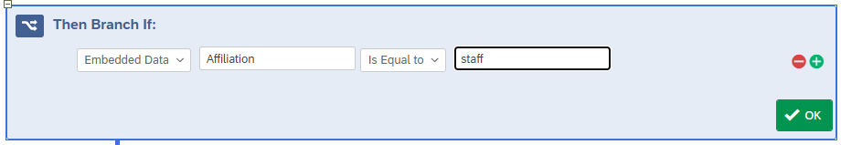
The following is a basic example using SSO authentication to capture affiliation. Staff members are shown the “Staff questions” block and their survey ends. All other affiliation types are shown the “Student questions” block and then their survey ends.
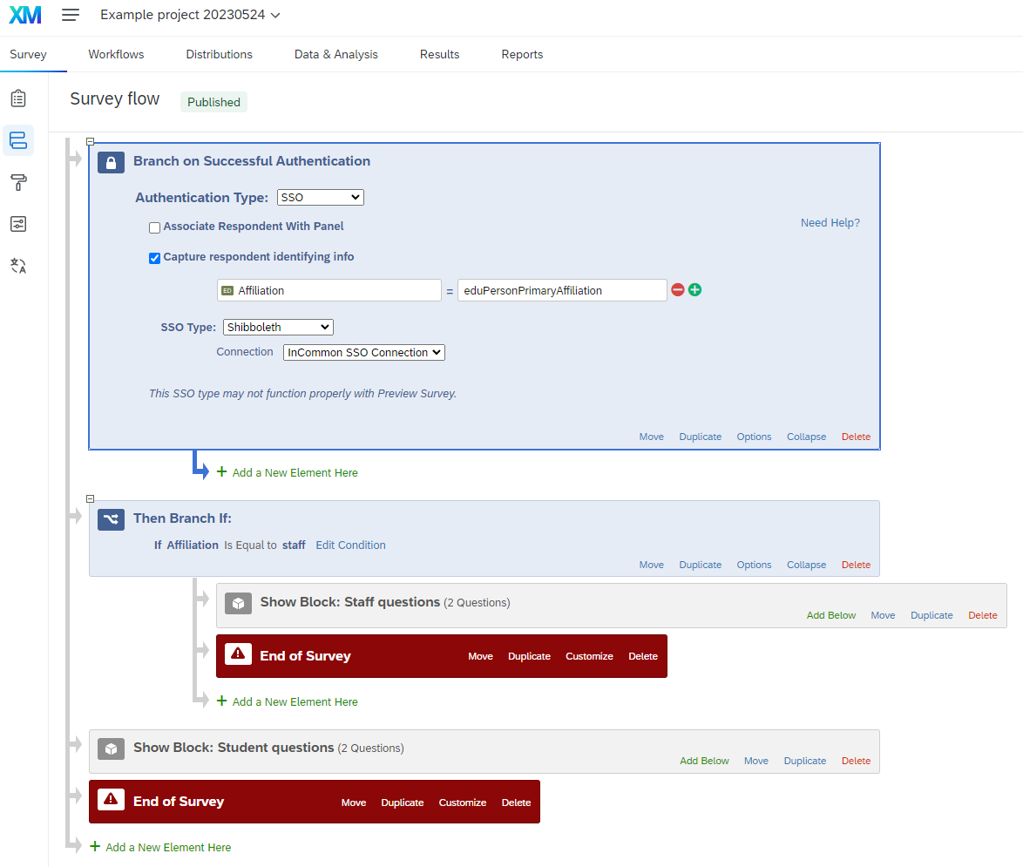

4. Ensuring Accessibility
Warning
In general, any digital content that the university creates, publishes, or shares broadly must be accessible. For details, please see this FAQ from the Office of the Provost or this article from the Office of the CIO.
This section includes tips for building accessible surveys, divided into sections on accessibility features that can be enabled in Qualtrics and accessibility standards to account for when designing your survey. For more information, you can also consult Qualtrics accessibility documentation.

4.1 Enabling Accessibility Features
Unfortunately, Qualtrics does not enable all of its accessibility features by default. The first step to ensure your survey can be perceived and operated by your survey takers is to switch to the New Survey Taking Experience, when possible. Keep reading for details on enabling this feature and alternatives for specific use-cases.

4.1.1 Enabling the New Survey Taking Experience
- Open the survey (or create a new one).
- In the survey toolbar on the left, click the paintbrush icon to go to the Look and feel section. 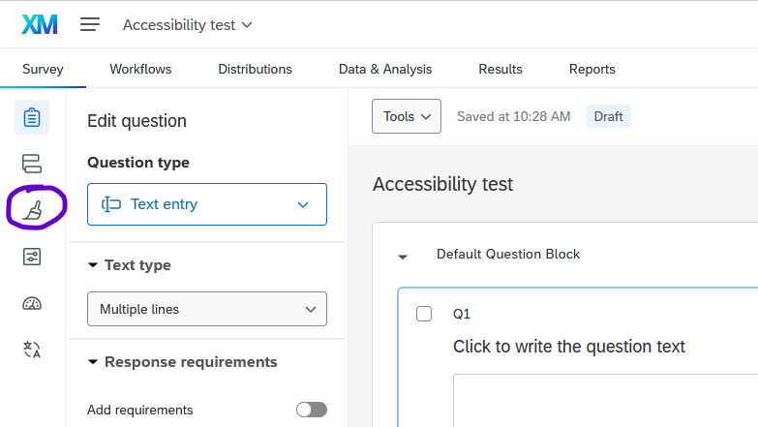
- A popup will invite you to switch to the New Survey Taking Experience. Click Upgrade. 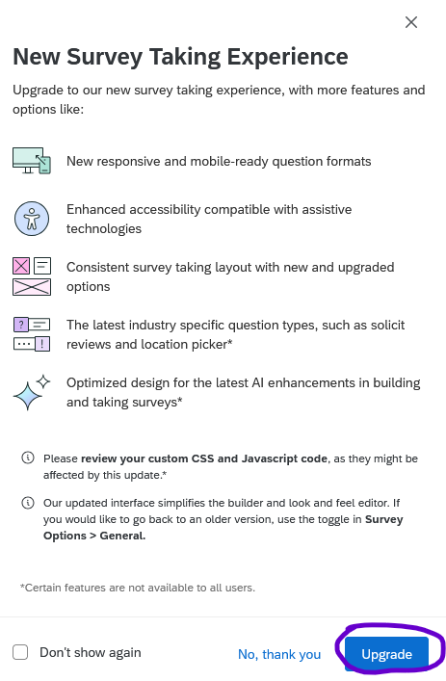
If the popup does not appear, you can enable it in one of the following locations:
- Under Look and feel, in the Layout menu, click Upgrade to the new survey taking experience. 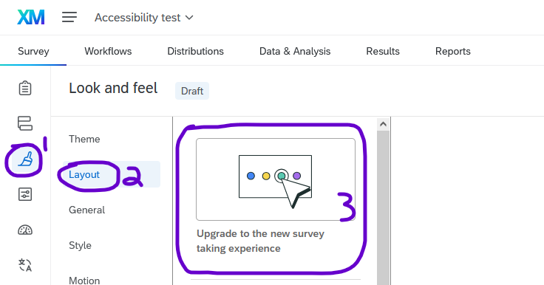
- Under Survey options, in the General tab, scroll down to the bottom of the list, and toggle the slider titled New survey taking experience. 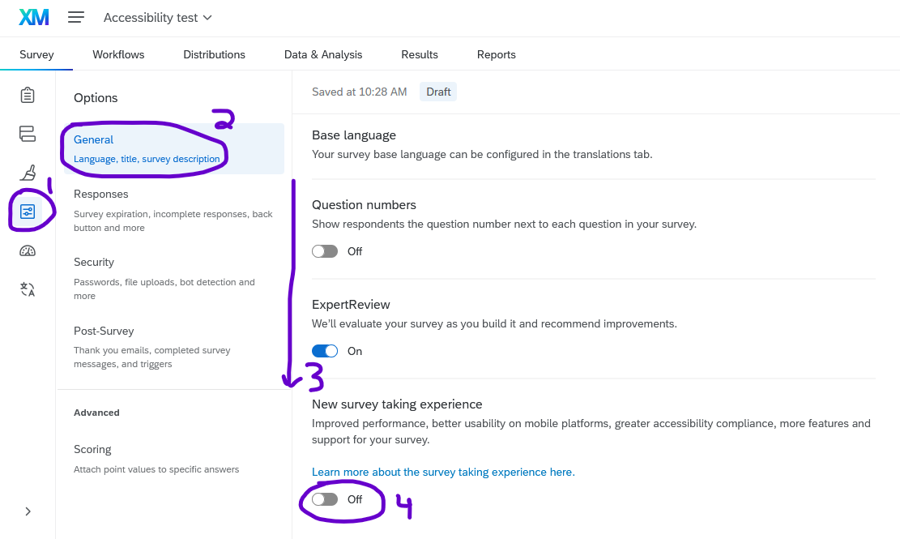

4.1.2 Details about the New Survey Taking Experience
Note
For a full overview, please see the Qualtrics documentation on the New Survey Taking Experience
The New Survey Taking Experience includes improvements for survey takers, including:
- Visual signals emphasizing where the survey taker is typing and which responses have been chosen.
- Better support for screen readers and keyboard users, especially with matrix questions.
- Clearer indication of questions that force a response see Section 2.4.1) with an asterisk. (The asterisk is read as “required” by screen readers.)
- Better display on mobile devices.

However, the New Survey Taking Experience does not yet include all features. Specifically,
- A few question types such as Hot Spot and Heat Map are not yet supported.
- If you are using custom Javascript, the jQuery library must be loaded manually.
- When the new experience is applied, you will not be able to change your survey layout in the Look and Feel menu (see Section 14.1.2).
See the Qualtrics documentation on unsupported features for a full list or instructions for how to disable the New Survey Taking Experience.

4.1.3 Alternatives to the New Survey Taking Experience
If you choose not or are unable to use the New Survey Taking Experience, you are responsible to make the following accessibility considerations, depending on the types of questions in your survey and your survey audience.

4.1.3.1 Matrix Questions
Most matrix questions are not initially accessible to users with screen readers. However, they can easily be modified to be made accessible.
By default, matrix questions are not accessible unless the survey uses the New Survey Taking Experience. Because of how Qualtrics implemented the HTML coding, screen readers cannot read the column headings, so users will not know what the scale points are.
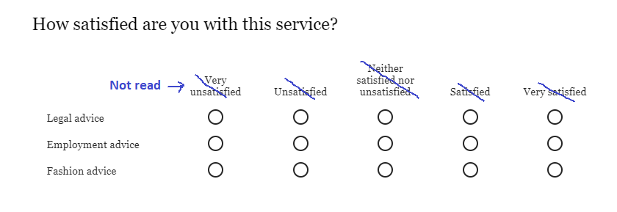
You can make matrix questions accessible by implementing any of the following solutions:
Change the Format to Profile
- After choosing the Matrix type as Likert, type the scale points across the top (i.e. “Very unsatisfied” through “Very satisfied”.)
- In the Question editing pane on the left, scroll down to Format and change from Standard Likert to Profile. 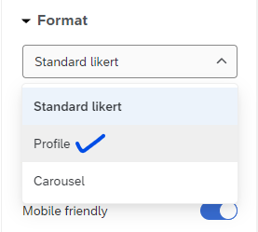
- Once the question is in “Profile” format, you can optionally change the text for any of the items. 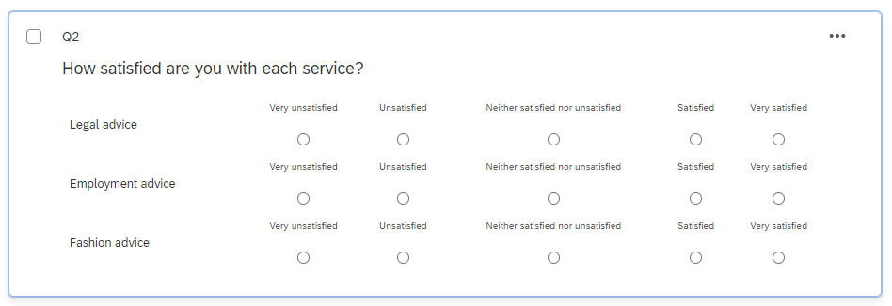
- When respondents see the question, they will see labels on each item, and screen readers will read the content correctly. 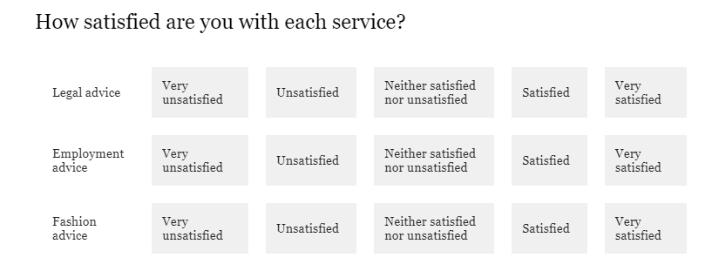
Add a bit of JavaScript to your survey heading
- In the Look and feel tab, select General and scroll down to see Header.
- In the Header field, click edit and in the editor, click the Source button to edit the source code.
- Paste the following code, then click Save.
<!-- make matrix questions accessible! -->
<!-- Load jQuery if it's not loaded -->
<script src="https://code.jquery.com/jquery-3.7.1.min.js"
integrity="sha256-/JqT3SQfawRcv/BIHPThkBvs0OEvtFFmqPF/lYI/Cxo="
crossorigin="anonymous"></script>
<!-- Fallback to load jQuery if jquery.com is down -->
<script>
if (typeof jQuery === 'undefined') {
document.write('<script src="https://cdnjs.cloudflare.com/ajax/libs/jquery/3.7.1/jquery.min.js"><\/script>');
}
</script>
<!-- Change 'aria-hidden' to 'false' to make the headers accessible -->
<script>
(function() {
if (typeof jQuery !== 'undefined') {
$(document).ready(function() {
$('.Answers').each(function() {
$(this).attr('aria-hidden', 'false');
});
});
} else {
console.error('jQuery is not loaded. Please check your CDN.');
}
})();
</script>
Warning
Matrix questions must also be “Mobile friendly” to be accessible (which is in the question editing pane); this option is enabled by default.

Tip
Whenever you change between question formats, double-check that none of the question text or answer choices have changed. Make corrections as needed.
Some less-common types of matrix questions, including rank order, constant sum, and text entry, are accessible by default.

4.1.3.2 Graphic Slider Questions
Graphic Slider questions have been disabled by default for everyone at the university because they are not accessible to blind users. They can be re-enabled on a case-by-case basis, especially for researchers working with sighted but non-literate participants. They are not compatible with the New Survey Taking Experience.
Graphic Slider questions include a slider bar next to a picture, and as the respondent slides the slider, the image changes. (The image has no alt text.)
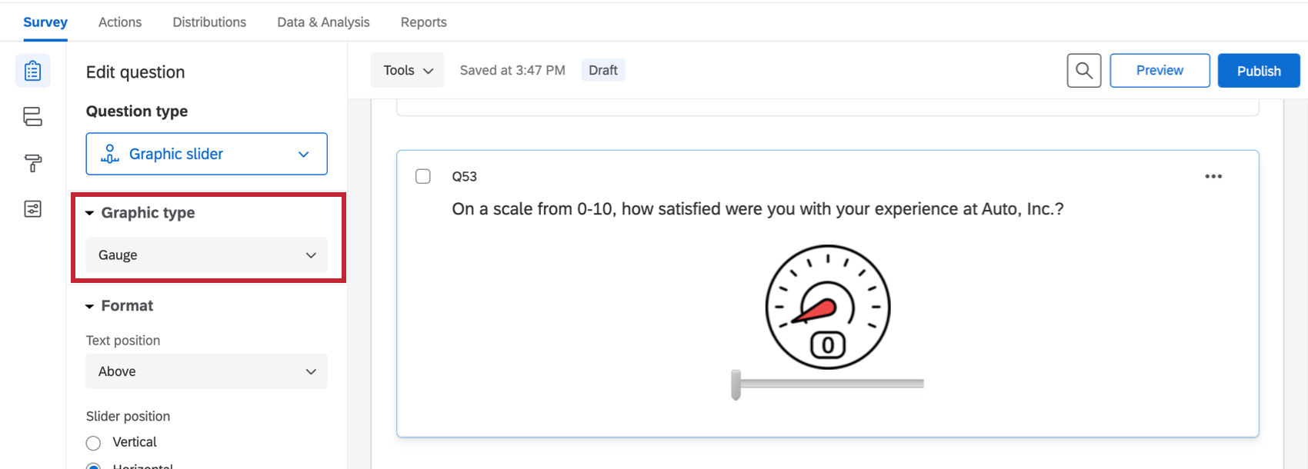
Example of a graphic slider question. The “Graphic type” can be changed in the menu on the left. Image from the Qualtrics documentation on graphic sliders
Warning
If a survey contains graphic sliders, unless you have permissions individually enabled by a brand or division administrator, you will not be able to copy that survey. To copy the survey, delete the graphic slider question, change it to a different question type, or contact CITL Data Analytics and we will be happy to help.

4.2 Other Accessibility Features
While the New Survey Taking Experience (or workarounds described above) is an important first step, there are also other options you can enable to increase the accessibility of your survey.

4.2.1 Back and Submit Buttons
- When possible, provide a back button so that respondents can go back and edit their choices. (See Section 14.2.1)
- Make sure the back and next buttons have readable text. (See Section 14.1.3.1)
- On the last block of the survey, change the final ‘Next page’ button to say Submit. (See Section 14.2.1)

4.3 Accessibiliy Standards
In addition to enabling certain Qualtrics features, creating an accessible survey requires paying some attention to the text and other content of your survey so that all survey takers can perceive, operate, and understand it. The suggestions in this section are consistent with best practices, but at the end of the day, you are responsible for your own survey content. Moreover, in some cases, such as surveying children, researching response times, or studying color perception, some of the standards below may not apply. If you have questions, consult an accessibility specialist on campus.

4.3.1 Text Size and Contrast
By default, text in surveys has sufficient size and contrast to be visible to survey takers with low vision. If you change the text color, ensure that it has sufficient contrast by using a contrast checker. If you change the font size, make sure it is large enough to be easily readable.

4.3.2 Timing and Autoplay
Whenever possible, avoid using auto-advance or other time limits, as they present issues for survey takers with motor or cognitive disabilities. If you include audio or video content, make sure that survey takers can pause, rewind, and fast-forward the content. (For details, see this WebAIM article on time limits.)

4.3.3 Alternative Text for Images
If you add images to a survey, it is your responsibility to add alternative text (“alt text”) so that users who cannot see the image can still understand the information that the image conveys.
Header Images
The Illinois wordmark included at the top of surveys by default includes alt text.
If you add a custom header image, please use HTML to center it or contact CITL Data Analytics for help.

4.3.3.1 Adding an Image in the Text of a Question
To add an image with alt text to question text, first create a text question and open the rich content editor.
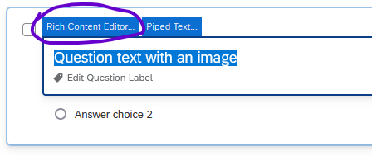
Graphic Question Type
Avoid using the Graphic question type because it does not (currently) allow alt text to be added. 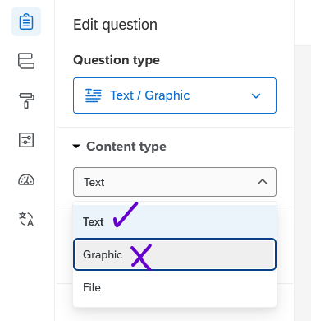
In the rich content editor, add text if you would like, then click the Insert Graphic icon on the top row.
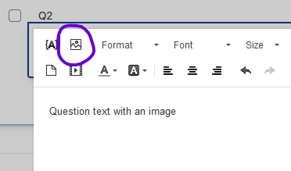
In the popup window, upload an image or choose one from your Qualtrics library.
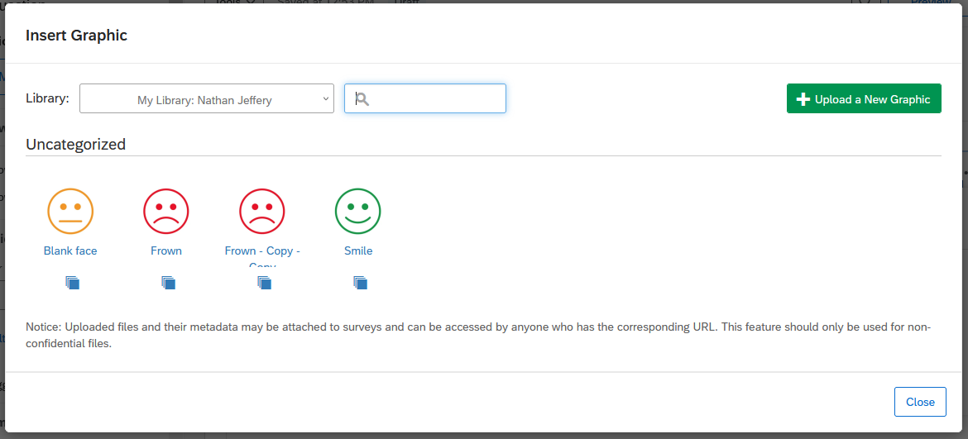
The image will appear inline with any question text, and you can click and drag to change its size or position.
Next, right-click the image and choose Image Properties.
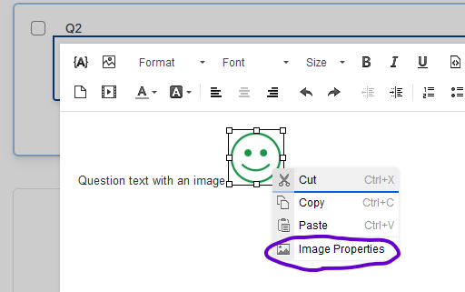
In the Image Properties popup window, type the alt text in the Alternative Text field, then click OK.
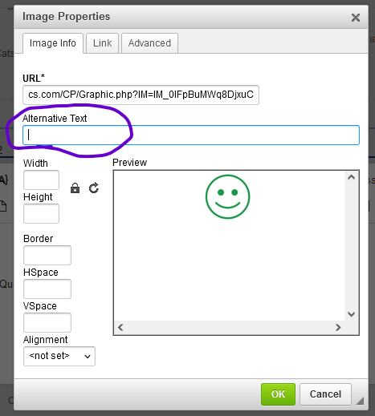
Graphs and Complex Images
For graphs, charts, and other technical images that convey detailed information, alt text may not be sufficient to covey the content of the image, especially since alt text should be succinct. In such cases, provide the information from the image in another way, such as by linking to a description hosted externally (such as cPanel or WordPress) providing a file download, or linking to a file or folder hosted on Box.
Avoid using the Long Description field in the Image Properties window because it has been deprecated.

Text vs Screenshotted Text
In general, text is more accessible than images because it can be zoomed in, read by screen readers, and set to high contrast by the viewer. If you have formatted text (colors, fonts, etc.), consider recreating the formatting in the rich content editor (using HTML markup if necessary) rather than taking a screenshot of the text.

4.3.3.2 Adding an Image in the Response Choices
To add an image with alt text to a response choice, click the response choice, then click the dropdown arrow that appears to open the menu.
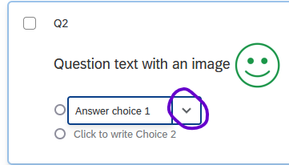
In the dropdown menu, choose Rich Content Editor.
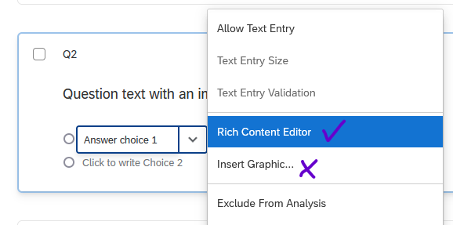
Graphic Question Type
Avoid using the Insert Graphic option because it does not (currently) allow alt text to be added.
In the rich content editor, insert the image using the steps described above. From this point, the process is the same as inserting an image in question text.

4.3.3.3 Alt Text Resources
For information about writing good alt text, see these resources:
- Alternative Text | University of Illinois Extension
- Write helpful Alt Text to describe images | Harvard University
- Alternative Text | Washington University in St. Louis

5. Survey Distribution
Qualtrics provides several ways to distribute your surveys.

5.1 Anonymous link
Perhaps the most common way to distribute a Qualtrics survey is through a so-called “anonymous” link that cannot be used to identify respondents.
To generate an anonymous link, under the Distributions tab click Anonymous link.
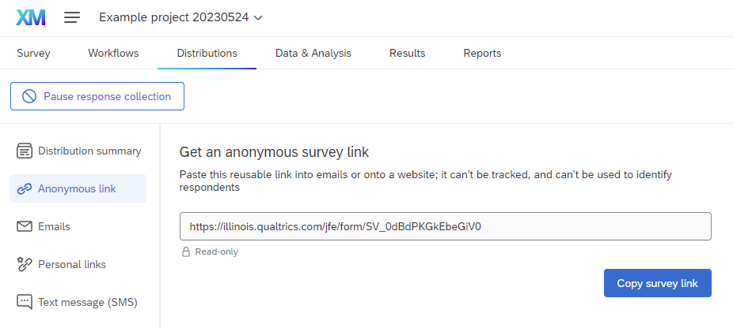
If it is your first time distributing a given survey, the screen may look different, and you can select either Email -> Get a single reusable link or Web -> Use Anonymous Link.
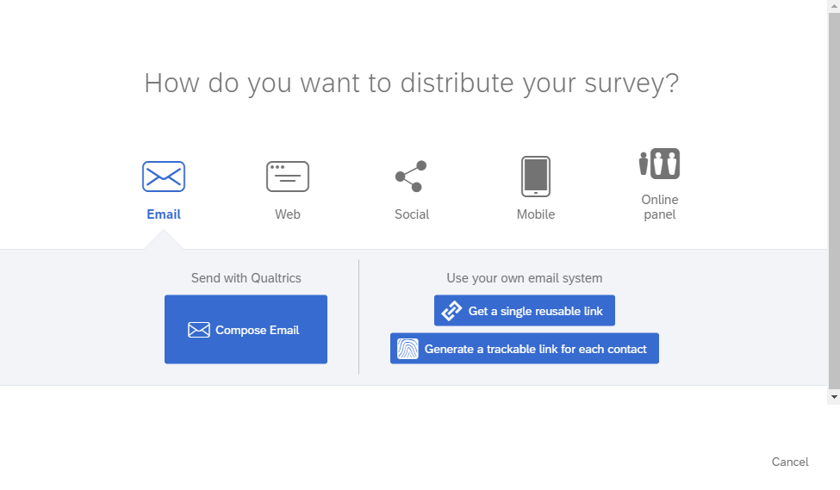
Warning
Using an anonymous link does not make responses completely anonymous. Please see Section Section 14.2.3 if you need to completely anonymize responses.
If you plan on updating your survey periodically, we recommend generating a ShortURL in Webtools that redirects respondents to the anonymous URL generated by Qualtrics. This way, if you relaunch your survey later (i.e., for a new year of data, a new cohort of students, etc.) you can maintain the existing link in your materials (course website, PowerPoint presentations, fliers, etc.)

5.2 QR Code
To generate a QR code that can be scanned to open the survey, we recommend that you create a ShortURL using Webtools, and then use Webtools to generate a QR code.
It is also possible to generate a QR code in Qualtrics by clicking QR code under the Distributions tab and downloading the QR code. Note that, like an anonymous link, the QR code does not track or identify respondents. However, their personal data can still be collected via IP address, SSO authentication, or other options in the survey itself.

5.3 Emails
It’s possible to distribute a survey either through your own email service (i.e., Outlook or Gmail) or inside Qualtrics.
To use your own email service, generate an anonymous link and copy-paste it into your email.
To compose an email within the Qualtrics web interface, you will first have to choose or create a contact list (see below). (Note that these contacts are stored within Qualtrics, which may not be appropriate for highly sensitive surveys.)
If you’re collaborating with others and trying to distribute a survey via email, please see the considerations in Chapter 13.

5.3.1 Contact lists
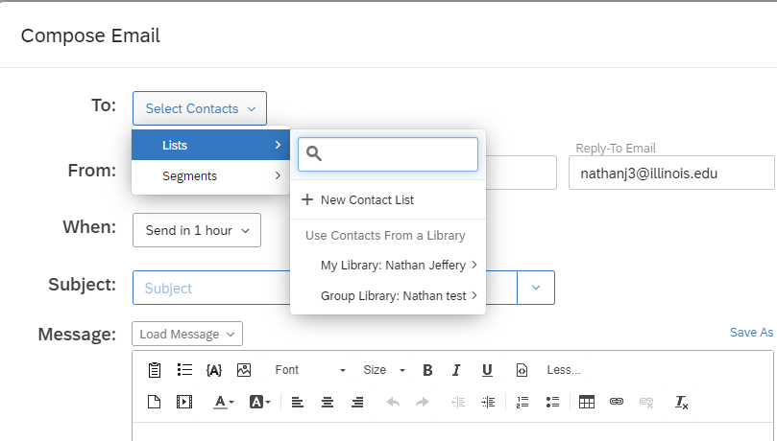
To create a contact list, choose Create Contact List and enter the email addresses and names of recipients.
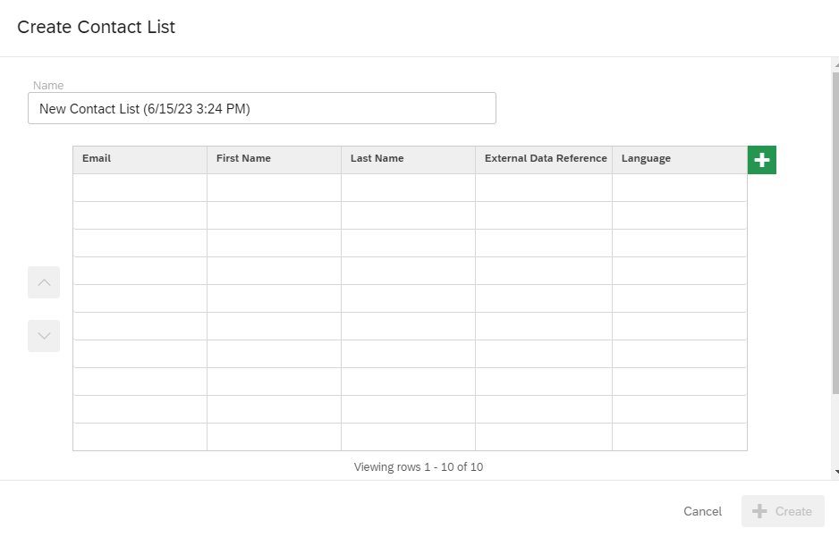
You can also create a contact list by going to Directories in the main menu (the three horizontal bars in the top left of the screen) and choosing Create a list.
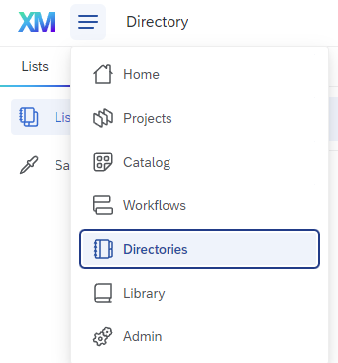

5.4 SMS Distribution
Qualtrics offers the ability to distribute surveys via SMS (text message), but charges an additional fee for doing so. At the University of Illinois, SMS Distribution Credits are available through the WebStore. They can be purchased by either credit card or CFOP (by shopping either the Personal or Unit purchases section), in packages of 50,000 responses for $550.
When a purchase is made, your receipt will have a linked form which you must fill out to have your SMS credits assigned to your account.

5.4.1 Phone number formatting
When distributing a survey via SMS, double check that the phone numbers in the contact list are in the correct format. Unfortunately, Qualtrics allows users to upload phone numbers in formats that cannot be used for text messages.
In the United States, the following formats can be used:
- 1(XXX)-XXX-XXXX
- 1-XXX-XXX-XXXX
- 1-(XXX)-XXX-XXXX
- 1XXXXXXXXXX
- 1-XXXXXXXXXX
- 1 (XXX) XXX-XXXX
- 1-(XXX) XXX-XXXX
- 1(XXX) XXX-XXXX
Note
All U.S. phone numbers must include the leading “1” for the country code.
For other countries or more details, please check the Qualtrics documentation on phone numbers.

5.4.2 One- and two-way distribution
All surveys distributed via SMS can utilize “one-way” distribution. In a “one-way” distribution, respondents are sent a single text message that says something like, “Hello (Name), Please take this survey. (link-to-survey) Reply STOP to opt out.” When the click the link, the survey will open in the browser on their phone.
Depending on the country where your respondents are located, you may also be able to utilize “two-way” distribution. In a “two-way” distribution, one text message is sent for each survey question, and respondents answer the question by replying to the text message.
Note
Two-way distributions consume SMS credits much more quickly than one-way distributions.

5.5 Website Embeds
Qualtrics surveys can be embedded into a webpage as an iframe if you have the ability to edit the html of that webpage. You will need the anonymous URL for the survey itself
(ex. https://illinois.qualtrics.com/jfe/form/SV_XXXXXXXXXXXXXXX) and the code chunk below.
<iframe src="your-survey-URL-here" height="800px" width="600px"></iframe>
Note
The exact instructions for this process will differ depending on the website editor.
Open the html editor of the webpage in question, pasted in the code chunk, replace the italicized text after src, retaining the quotations marks around the survey URL, and set the height and width to your desired size. If using query strings, you can also pass those through by including them in the survey URL.
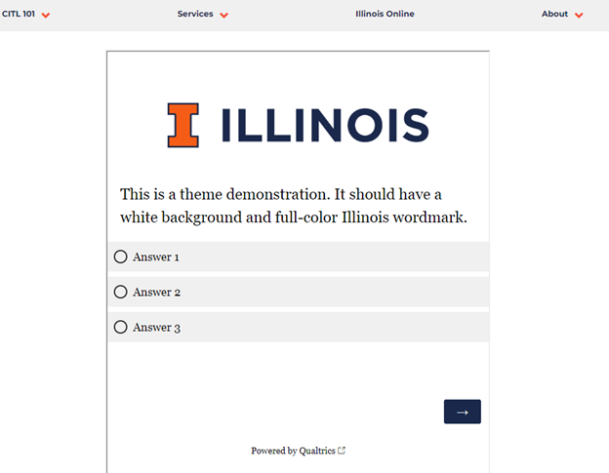
Example of a survey embedded in a website

6. Viewing & Exporting Data in Qualtrics
Work in Progress
This guide is a work in progress, and will be updated substantially as time allows. If you find an error, please let us know.
In the Data & Analysis tab under Data in Qualtrics, you can filter, classify, merge, clean, and analyze your data.
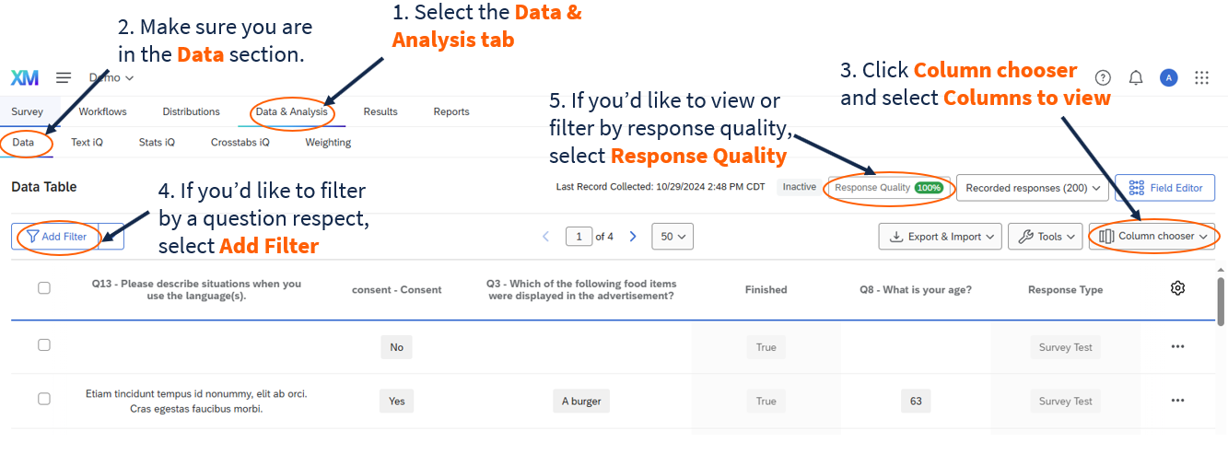
Figure 1. Data Table
By default, Qualtrics displays the data for all your “Recorded Responses” (i.e., responses marked as complete). You may also choose to view responses in progress (i.e., started but not completed surveys) by selecting the drop-down (as shown in Figure 2) and selecting “Responses in progress” (See Survey Options page for more information on incomplete survey responses).
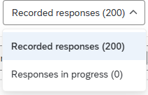
Figure 2. Viewing Recorded Responses or Responses in Progress

7. Data Analysis Overview
Work in Progress
This guide is a work in progress, and will be updated substantially as time allows. If you find an error, please let us know.
In the Data & Analysis tab in Qualtrics, you can filter, classify, merge, clean, and analyze your data.
As part of the University of Illinois Qualtrics license, you should have access to the following tabs:
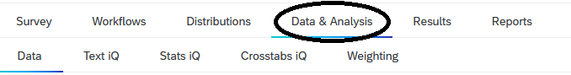
Figure 1. Data & Analysis tab
- Data: for filtering, classifying, merging, importing, and cleaning data
- Text iQ: for tagging text entry responses (i.e., open-ended responses) with topics for analysis
- Stats iQ: for performing statistical analyses on your data
- Crosstabs iQ: for performing multivariate analyses (i.e., analyzing two or more variables at a time)
- Weighting: for generating weights (i.e., raked or interlocked) for your data
Use Caution
This guide provides an overview of options for performing statistical analyses in Qualtrics, but please use caution when interpreting the results. Be sure that you have selected the appropriate statistical test for your data and have checked that your data has met the assumptions for that test. Please see Test Options or email us for a consultation if you are unsure what test to use.

7.1 Quantitative and Qualitative Data
In Qualtrics, you can collect both quantitative and qualitative data.
Qualitative data is a type of descriptive data and is typically unstructured. For example, in Qualtrics, you can collect open-ended responses to survey questions (e.g., ask respondents to provide feedback) or text-entry data (e.g., provide another answer to a multiple choice question).
Quantitative data is data that can be assigned a numerical value and can be used for statistical analysis. For example, multiple choice questions or yes/no questions that can have categories with assigned numeric values (e.g., race, voter registration status, political party, or agree/disagree questions).
Depending on the type of data you collect, you may approach the analysis of the data differently.

7.2 Descriptive Data Analysis
One approach to understanding your data is by performing descriptive data analysis. Descriptive analyses typically involve understanding patterns or characteristics in the data.
For example, if you were interested in understanding language fluency among college students, you may field a survey that asked a variety of questions involving the number of languages spoken, nativity, and fluency. To understand patterns in languages spoken, you may choose to calculate frequency tables (i.e., a type of descriptive analysis) to understand how many respondents speak a given list of languages. Moreover, you can create cross-tabulations (or, cross-tabs) to understand languages spoken by year in college. By generating this descriptive data, you can explore whether the number of languages spoken increases by year in college, or perhaps, the level of fluency in a given languages increases by year in college. This descriptive analysis can help discover patterns in the data before performing any statistical analyses.
As part of descriptive data analysis, you can generate descriptive statistics such as:
- Measures of central tendency
  - Mean: The average (the sum of items divided by the number of items).
  - Median: The middle-most observation after organizing data in an ascending order.
  - Mode: The value that appears most frequently in the data.
- Measures of variability
  - Range: The spread of the data from the lowest to the highest value in the distribution (subtract the data’s lowest and highest values).
  - Variance: The average squared departures from the mean.
  - Standard Deviation: The average level of variability in the data .

7.3 Inferential Statistics
Another approach to understanding your data is by performing statistical inference, or inferring properties about a population. As part of inferential statistics, researchers aim to generalize their findings from the sample to the population in question and generate hypotheses about the population based on the sample.
As part of inferential statistics, you can do hypothesis testing, regression analysis, or generate confidence intervals.
- Confidence intervals: This provides a range of values in which the true population parameter (e.g., means) is likely to fall given a certain level of confidence (e.g., 95%). Confidence intervals represent the uncertainty of model predictions or parameter estimates.
- Hypothesis testing: This is a statistical method used to test assumptions or claims about a population parameter, commonly used when evaluating the significance of results.
  - Null hypothesis (H₀): There is no effect (e.g., of x on y) or difference (e.g., between a and b).
  - Alternative hypothesis (H₁): There is an effect (e.g., of x on y) or difference (e.g., between a and b).
  - P-value: The p-value is the probability of observing a sample statistic that is at least as extreme as your sample statistic, given that the null hypothesis is true. In other words, it measures the likelihood of obtaining the observed data under the null hypothesis or how likely it is that the observed data would have occurred by random chance. The level of statistical significance is a p-value between 0 and 1. A common threshold to determine statistical significance (i.e., reject the null hypothesis) <= 0.05, though some disciplines might use 0.1.
Inferential statistics involves making inferences about a population based on a sample of data. Given the use of sample data, there is the possibility of error. There are two types of errors: Type I Error or Type II Error.
- Type I Error (False Positive)
A Type I error occurs when we reject the null hypothesis (H₀) even though it is actually true (i.e., it is a false positive).
- Type II Error (False Negative)
A Type II error occurs when we fail to reject the null hypothesis (H₀) even though it is actually false (i.e., a false negative).

7.4 Unsure of which test to use?
Here are a list of statistical procedures, depending on which question you are interested in.

7.5 Data
In the Data tab, you can view your data table. This Data Table will show you a select number of columns and rows. The Data Table will also inform you of how many responses you have recorded and how many responses are currently in progress.
In the Data Table, you can filter data by survey metadata, contact fields, embedded data, or by specific questions.
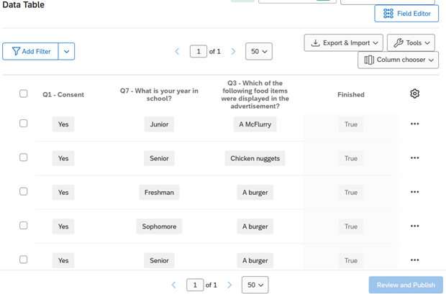
Figure 2. Viewing data

7.6 Text iQ
In your survey, you may choose to include open-ended or text entry responses. To analyze text responses (i.e., open-ended question data) from your surveys, you can use Qualtrics’ Text iQ tool. The Text iQ tool allows you to search and assign topics to your data (20,000 responses per survey limit). Please note that sentiment analysis and building widgets are not available with the current Qualtrics license.
Performing text analysis involves making sense of text data by classifying or extracting information and identifying patterns or themes within the data. Topics are one way to classify or group similar themes in the data. Topics are then added to your data for export, if you wish to do additional analysis.
Certain Text iQ data (i.e., topics, parent topics, topic hierarchy level fields) are available for use in Stats iQ. You may analyze these Text iQ variables (e.g., describe, relate, regression, etc.) as you would use other variables.
See (Chapter 9) for guidance on how to analyze your open-ended responses using Text iQ.

7.7 Stats iQ
In Stats iQ, you can perform the following analyses:
- T-test (2 Categories vs. Numbers)
- ANOVA (3+ Categories vs. Numbers)
- Games-Howell post hoc tests (3+ Categories vs. Numbers)
- Cohen’s f
- Correlation (Numbers vs. Numbers)
- Pearson correlation
- Spearman correlation
- Point Biserial correlation
- Cohen’s d
- Paired t-test (Numbers vs. Numbers)
- Fisher’s Exact Test (2 Categories vs. 2 Categories)
- Chi-squared (3+ Categories vs. Categories)
- Cramer’s V
- Z-test (Categories vs. Categories)
- Time-series analysis
- Difference in differences (DID, DD)
- Linear regression (OLS, M-estimation, Ridge)
- Logistic/logit regression
See (Chapter 8) for guidance on how to analyze your data using Stats iQ.

7.8 Crosstabs iQ
In Crosstabs iQ, you can create a cross tabulation (crosstab), a data table that compares the relationship between two or more categorical variables. A crosstab can be used to generate the frequency or proportion of respondents that fall into a particular row/column.
Qualtrics provides the Crosstab iQ tab that allows you to perform multivariate analysis on two or more variables, including z-tests, chi-square and analysis of variance (ANOVA) tests.
See (Chapter 10) for guidance on how to analyze your data using Crosstabs iQ.

7.9 Weighting
Work in Progress
This section is a work in progress.

8. Using Stats iQ
Work in Progress
This guide is a work in progress, and will be updated substantially as time allows. If you find an error, please let us know.

8.1 Data & Analysis
From your survey, you can navigate to the Data & Analysis tab to view your data. Using a campus-wide account, this tab contains five sub-sections: (1) Data, (2) Text iQ, (3) Stats iQ, (4) Crosstabs iQ, and (5) Weighting. For more information about each of these tabs, please see Chapter 7.
In Stats iQ, you can perform the following analyses:
- T-test (2 Categories vs. Numbers)
- ANOVA (3+ Categories vs. Numbers)
- Games-Howell post hoc tests (3+ Categories vs. Numbers)
- Cohen’s f
- Correlation (Numbers vs. Numbers)
- Pearson correlation
- Spearman correlation
- Point Biserial correlation
- Cohen’s d
- Paired t-test (Numbers vs. Numbers)
- Fisher’s Exact Test (2 Categories vs. 2 Categories)
- Chi-squared (3+ Categories vs. Categories)
- Cramer’s V
- Z-test (Categories vs. Categories)
- Time-series analysis
- Difference in differences (DID, DD)
- Linear regression (OLS, M-estimation, Ridge)
- Logistic/logit regression
Use Caution
This guide provides an overview of options for performing statistical analyses in Qualtrics, but please use caution when interpreting the results. Qualtrics will choose a statistical test, that it deemed appropriate for your data. Before interpreting the results, be sure that you have selected the appropriate statistical test for your data and have checked that your data has met the assumptions for that test. Please see (Section 7.4) or email us for a consultation if you are unsure what test to use.
To begin data analysis, select the Stats iQ tab.

8.2 Stats IQ
Stats iQ is another tool to analyze your data in Qualtrics using statistical analysis. Under the Data Analysis tab, you can access the Stats iQ section.
Within Stats iQ, there are three parts: (1) the variable pane where all the variables are listed, (2) the analysis options, and (3) the workspace where your analyses will appear.
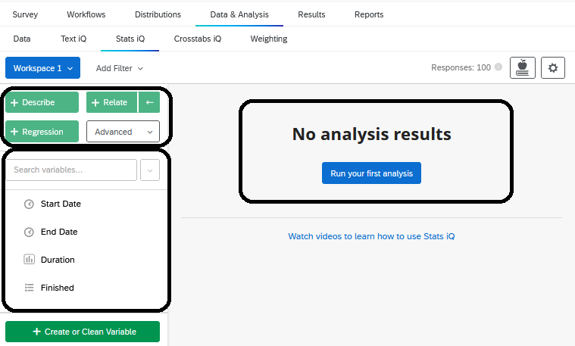
Figure 1. Stats IQ tab

8.2.1 Variable Pane
The variable pane includes all the variables (i.e., the questions) from your survey. You may use the search bar to search for a specific variable in your data set. You may also click the drop-down menu to search for specific variable types (e.g., check-boxes, numbers, etc.).
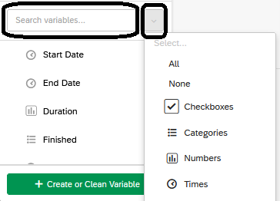
Figure 2. Searching & selecting variables
If you are unable to find specific variables, they may be ‘hidden’. Under the ‘variable settings’ you can ‘hide’ or ‘unhide’ variables.
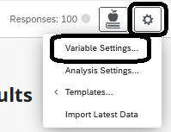
Figure 3. Variable settings
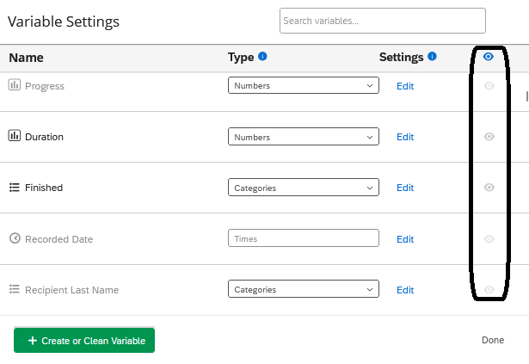
Figure 4. Hiding and unhiding variables

8.2.2 Analyses in Stats IQ
There are several types of analyses that you may choose to run in Stats iQ including: (1) describe, (2) relate, (3) regression, (4) pivot table, or (5) using custom R code. Please note that cluster analysis is not available in this Qualtrics license.
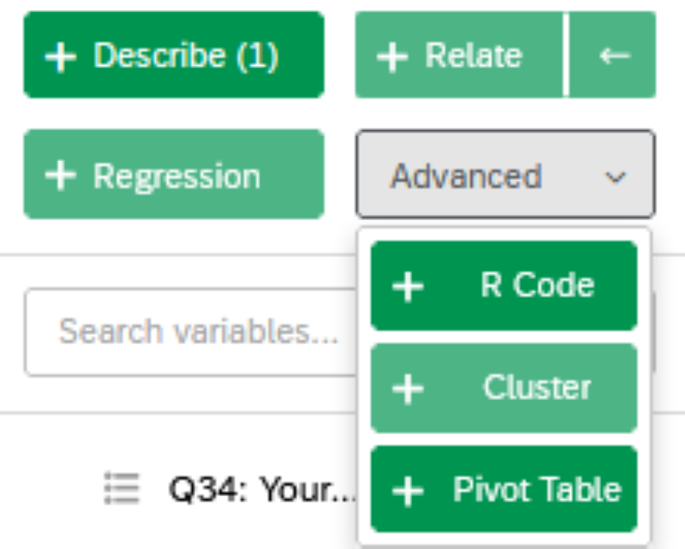
Figure 5. Analyses in Stats IQ
Once you have selected an analysis, it will appear in the workspace, where each result box is called a ‘card’. Please note that you may have up to a maximum of 750 cards in your workspace at a time.

8.2.2.1 Describing Variables
Once you have selected a variable, you may choose ‘Describe’ to summarize its results (e.g., count, percent, or mean, median, etc.). Describing a variable allows you to both summarize and visualize the results of a variable.
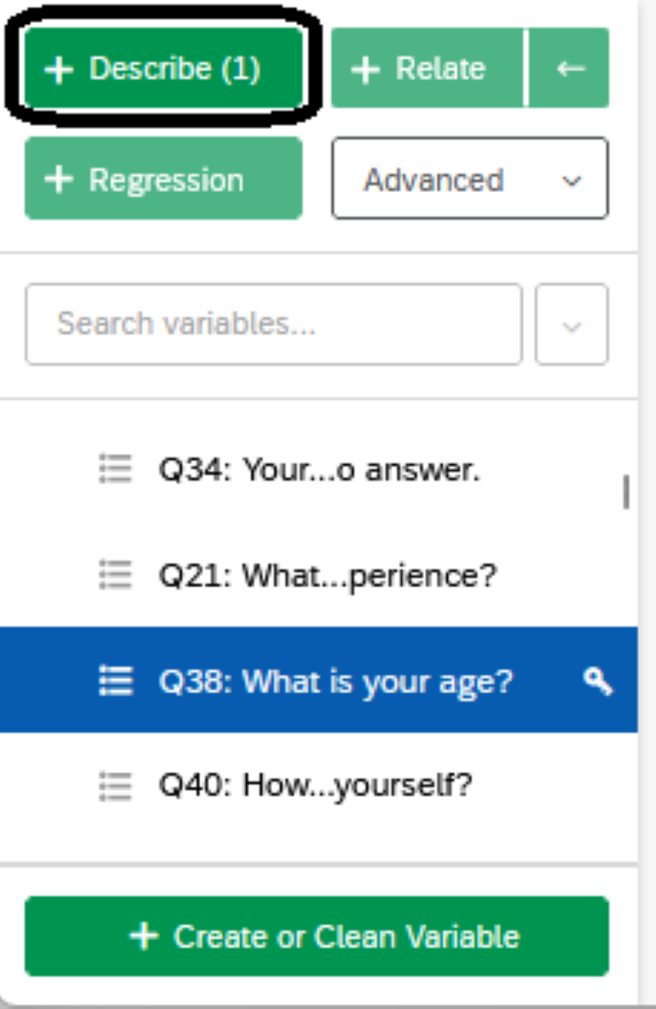
Figure 6. Describing Variables
If you choose a categorical variable, you will be provided with the count and percentage for each of the categories in the variable.
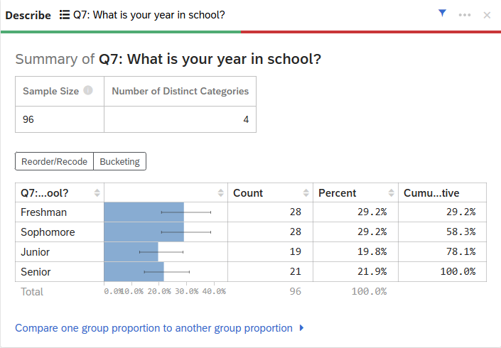
Figure 7. Describing Categorical Variables
Alternatively, if you choose a numeric variable, you will be provided with a summary consisting of the average, median, minimum, maximum, standard deviation, and the confidence interval of the average. Stats iQ also provides a chart that displays the distribution of your numeric data. You can toggle between count or percent, depending on how you would like to view the distribution.
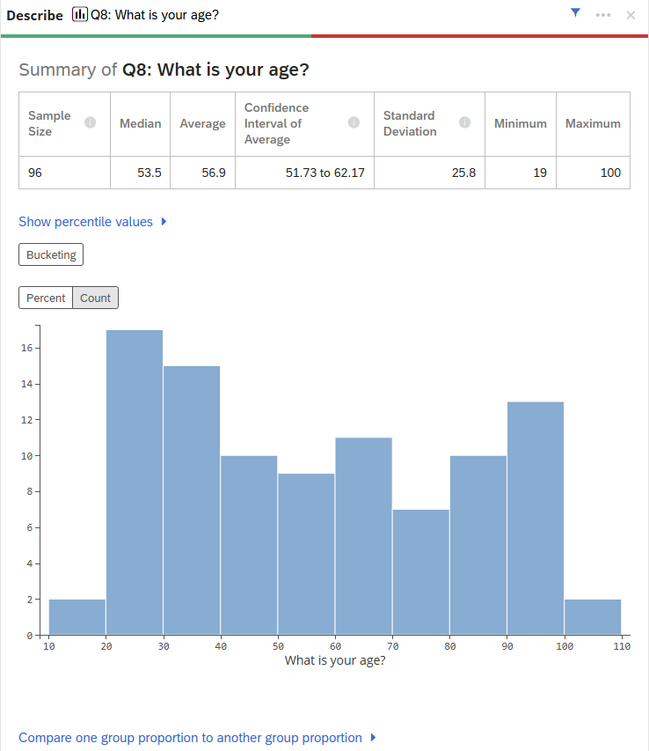
Figure 8. Describing Numeric Variables
Similarly, if you have a matrix type question with numeric ratings (e.g., feelings toward McDonald’s items), you will be provided with a summary for each item in the matrix question that includes the count, average, median, and the distribution.
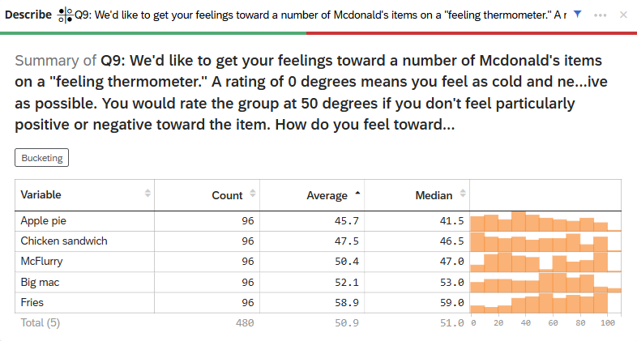
Figure 9. Describing Matrix Numeric Variables

8.2.2.1.1 Bucketing Variables
When you are describing variables, you may choose to “bucket” your variables into new groups or categories.
For example, you can bucket your “age” variable if you are interested in learning about different age categories in your data. Select the “Bucketing” button on the output and bucket your values accordingly (See Figure 10). If you wish to re-run your describe analysis with the bucketed values, check the box “Use the groups above to run bucketed calculations for this variable” and click save.
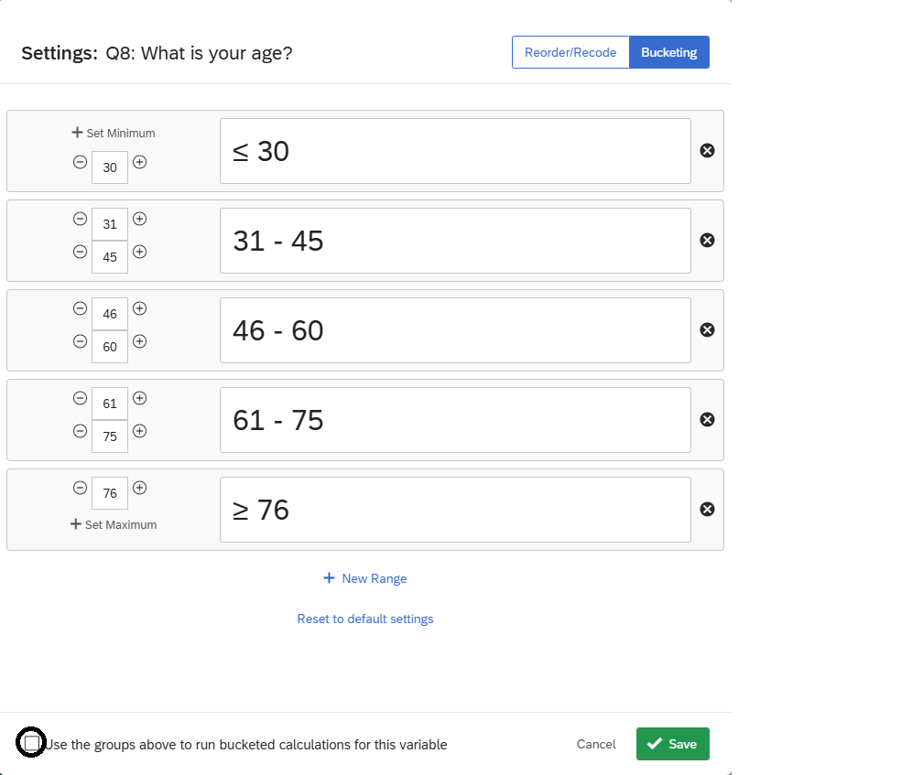
Figure 10. Bucketing Variables
The results should now show both the results after bucketing the variable and without the bucketing.
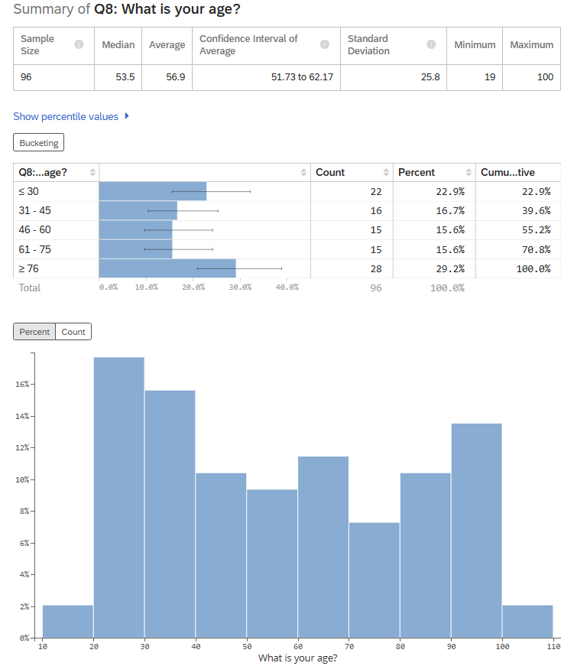
Figure 11. Bucketing Variable Results

8.2.2.2 Relating Data
The ‘Relate’ function in Stats iQ allows you to explore the relationship between variables. When you choose two variables to relate, Stats iQ will automatically select the appropriate statistical test depending on the structure of your data and display the results.
The first variable you select will have a ‘key’ displayed next to it, which indicates that it is the independent variable. After you select ‘relate’ the results will display in the workspace, including whether the results are statistically significant. To learn more about the statistical test, select “Show Statistical Test Results” where you can find information about the p-value, effect size, and which test was used. When relating two numeric variables, Stats iQ calculates a p-value and (for effect size) either a Pearson’s r or a Spearman’s rho.
For example, in Figure 12, the results of relating “Year in School” and “Feelings toward McDonald’s chicken sandwich” are shown. An ANOVA was selected as the recommended test, which compares the means of two or more groups by analyzing the variance. In this example, there is a statistically significant result, suggesting there is a relationship between Year in School and Feelings toward McDonald’s Chicken Sandwiches. In the ANOVA, we don’t know which groups are significantly different from one another, so you may select “Show Pairwise Statistics” to explore which groups have significant differences in their feelings toward McDonald’s chicken sandwiches. In this example, Freshmen and Seniors and Seniors and Sophomores have significantly different feelings toward McDonald’s chicken sandwiches.
For more details on how Stats iQ chooses the statistical test, visit the Statistical Test Assumptions and Technical Details page.
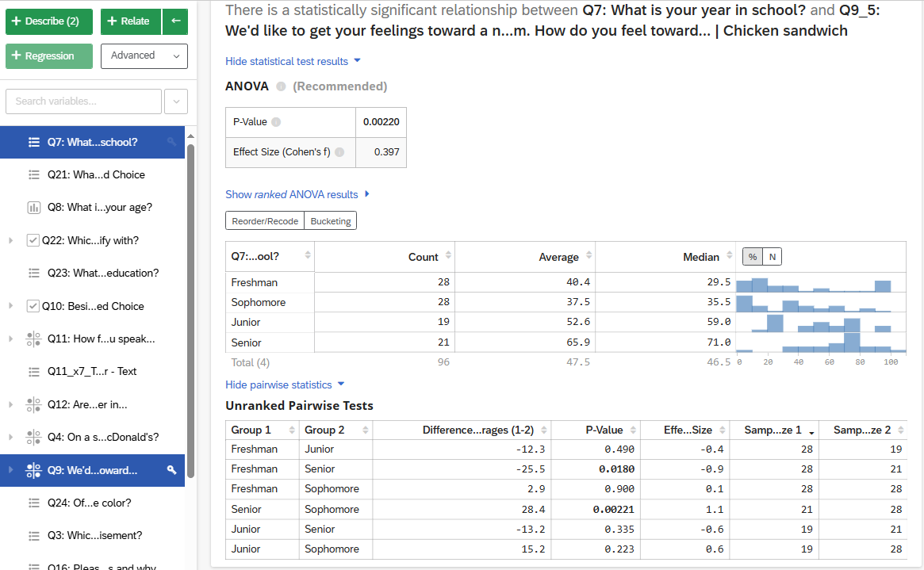
Figure 12. Relating Variables

8.2.2.3 Regression
The ‘Regression’ analysis in Stats iQ allows you to explore how the value of one variable impacts the value of others. For a regression, the variable with the key is the outcome or dependent variable, while the other variables that you select are the independent variables.
With the regression output, Stats iQ also displays ‘Relative Importance’. The relative importance calculates the proportion of the r-squared contributed by each independent variable (i.e., driver) in the model. It also accounts for situations where the input variables are correlated with one another (i.e., known as multicollinearity).

8.2.2.3.1 Types of Regressions
There are two main types of regression run in Stats iQ. If the output variable is a numeric variable (e.g., a score), Stats iQ will run a linear regression. If the output variable is a categories variable (e.g., binary yes or no responses), Stats iQ will run a logistic regression.

8.2.2.3.2 Running a Regression
After you select your variables, you can select ‘Regression’ to run the analysis. The results displayed include multiple parts.
Please note that Qualtrics will automatically impute missing data for your sample using the mean or median (for continuous data) or by creating a ‘missing’ category for categorical data, by default (e.g., see Figure 13). We recommend turning off this feature.
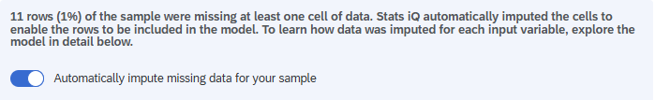
Figure 13. Turning off automatic imputation
Simple imputation can reduce the variation of your data and increase the degrees of freedom, which means that the significance may be artificially inflated. Under certain circumstances, multiple imputation may be appropriate, but in the case of this, we recommend using a more sophisticated statistical package rather than Qualtrics. You can read more about imputation here.
By default, regressions in Stats iQ use Johnson’s Relative Weights to calculate the relative importance of each variable in the model. First, Stats iQ will display how much the ‘drivers’ or the independent variables (also called explanatory variables) explain the proportion of the outcome variable. In this example, we included three independent variables: Age, Year in School, and Gender. You can select each variable to explore how much the variable accounts for the outcome: Feelings toward McDonald’s Chicken Sandwich. This relative importance is the proportion of the r-squared that is contributed by this variable. The r-squared is the proportion of the outcome variable’s variation that can be explained by the independent variable in the model.
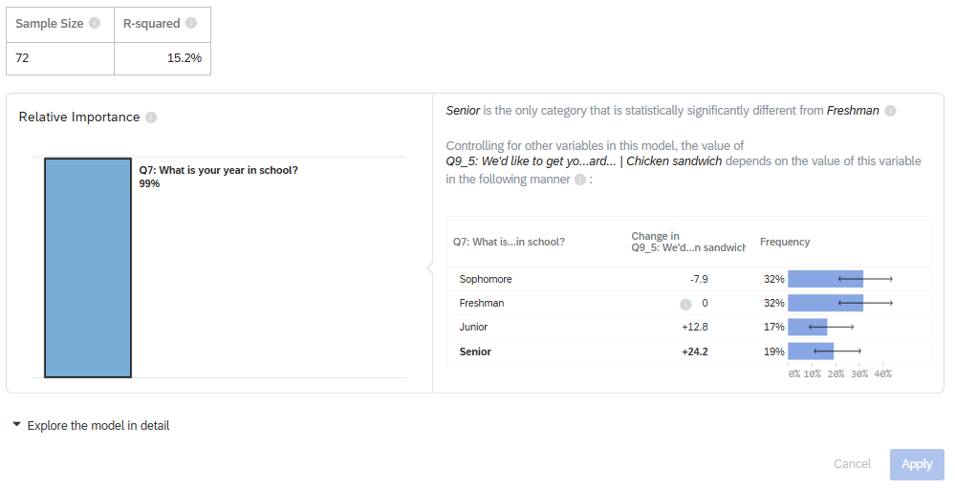
Figure 14. An example of a regression model
In the second part of the results, you can explore the model in detail. This provides the relative importance along with the coefficients (included standardized coefficients and confidence intervals), p-values (significant results are bolded), and frequencies. In this table, you can “toggle” to select which values you would like as the baseline. The coefficients from all the other categories are statistically tested against the baseline category’s coefficient.
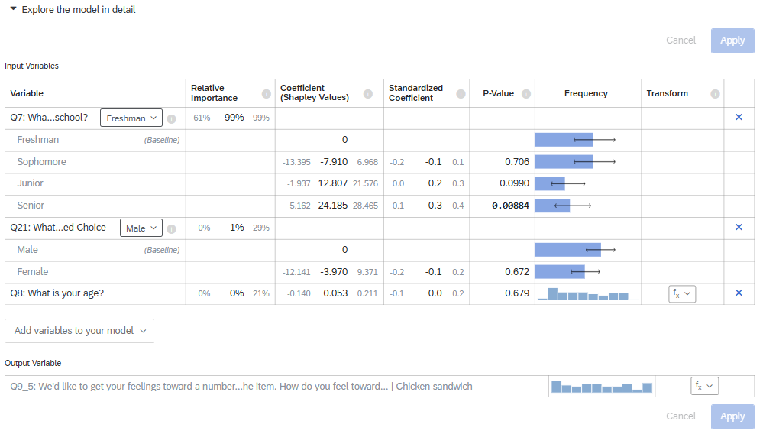
Figure 15. Exploring a regression model in detail
In the third part of the results, you can analyze the OLS regression diagnostics and residuals to improve your model. This includes the R-squared values, standard error, model fit (AIC), p-value, and the coefficient of variation. Plots are also included that visualize the predicted vs. actual values, residuals, predicted accuracy distribution, and a normal Q-Q residual plot.
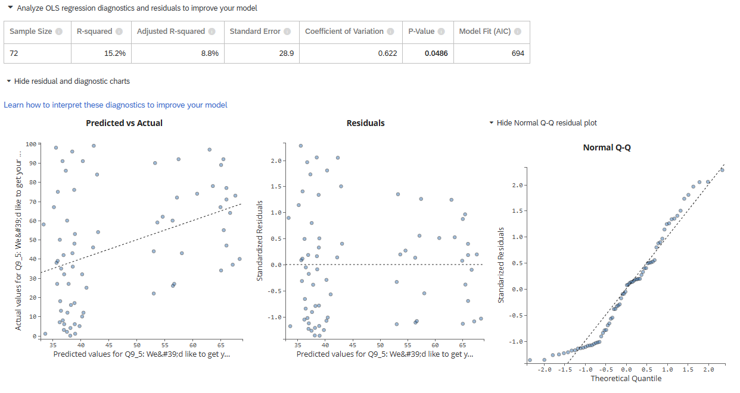
Figure 16. Analyzing regression model diagnostics and residuals

8.2.2.3.3 Regression Methods
By default, regressions in Stats iQ use Johnson’s Relative Weights to calculate the relative importance of each variable in the model. One advantage of this method is that it provides results that are easy to interpret: In the output, you can easily see which “drivers” or independent variables have the largest effect on the dependent variable. A second advantage is that the relative weights approach accounts for potential multicollinearity between the independent variables, meaning that even if you enter two variables that are highly correlated with each other (such as your mother’s education level and your father’s education level), the results can be trusted.
Many researchers may be more familiar OLS (“ordinary least squares”) regression than with relative weights. After running a regression in Qualtrics, you can choose between relative weights, M-estimation, OLS, or Ridge regression.
To change between regression methods, click Method in the top-right of the regression card.
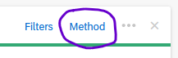
Then choose the appropriate method from the list.
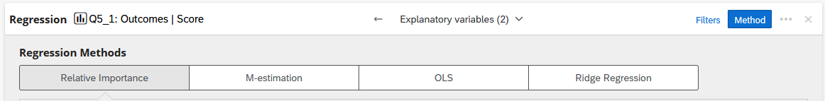
Details on Relative Weights
For those who need to cite Johnson’s Relative Weights or who would like more details about the underlying statistical procedure, we recommend the articles by Johnson & LeBreton (2004) or Tonidandel & LeBreton (2011).
In a nutshell, the relative weights procedure is conducted by (1) deriving an orthogonal set of predictors from the original predictors, (2) regressing the outcome variable on the orthogonal set, (3) regressing the predictors on the orthogonal set, and finally (4) calculating the “relative weight” of each predictor by summing the products of the relevant coefficients across the two models.
Outside of Qualtrics, relative weights can be computed in statistical packages using the steps described in this blog post or by using Tonidandel’s web app or the rwa R package.
For more on Stats iQ: - Stats iQ Overview - Stats iQ Variable Settings - Stats iQ Analysis Settings - Stats iQ Statistical Tests - Stats iQ Statistical Test Assumptions - Analyzing Text iQ in Stats iQ

9. Using Text iQ

9.1 Data & Analysis
From your survey, you can navigate to the Data & Analysis tab to view your data. In an Illinois Qualtrics account, this tab contains five sub-sections: (1) Data, (2) Text iQ, (3) Stats iQ, (4) Crosstabs iQ, and (5) Weighting.
To begin data analysis, select the Text iQ tab.

9.2 Text IQ
To analyze text responses (i.e., open-ended question data) from your surveys, you can use Qualtrics’ Text iQ tool. The Text iQ tool allows you to search and assign topics to your data (20,000 responses per survey limit). Please note that sentiment analysis and building widgets are not available with the current Qualtrics license.
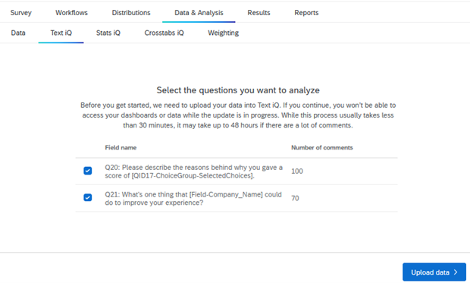
Figure 1. Getting Started with Text iQ
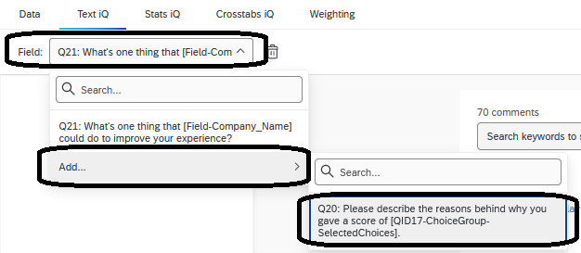
Figure 2. Selecting additional fields for Text iQ
More data can always be added by selecting the Field drop-down (Figure 2).

9.3 Creating Topics
Once the selected questions are uploaded, a ‘topic’ column is added to your data. Performing text analysis involves making sense of text data by classifying or extracting information and identifying patterns or themes within the data. Topics are one way to classify or group similar themes in the data.
Topics can be created from a top-down approach (i.e., pre-built topics are prescribed to the data) or a bottom-up approach (i.e., the data informs the topics).
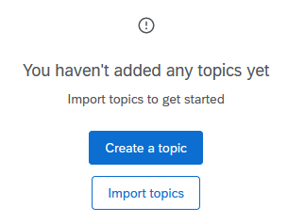
Figure 3. Creating or importing topics
For a top-down approach, topics can be imported by selecting the ‘Import topics’ option, where you can upload a JSON file (no more than 1,000 topics) and select from a Qualtrics topic library. Qualtrics provides up to 38 libraries to choose pre-built topics from.
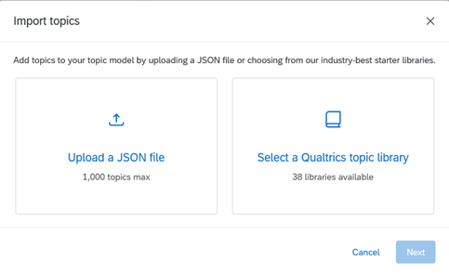
Figure 4. Importing topics
The JSON file should be formatted as shown in Figure 5. Please note that you should only update the version, topic ‘label’, ‘query’, ‘baseQuery’, and ‘rootNodes’. The topic ‘label’ refers to the name of the topic. The ‘query’ reflects the query of the topic, which may be different if this is a child topic (Ready more about Hierarchical Topics below), while the ‘baseQuery’ reflects the query of the parent topic. If there are no hierarchical topics, these queries should be the same. Finally, the ‘rootNodes’ represent the names of each of the topics. Formatting the JSON file incorrectly may give you an error when you upload the file to Qualtrics. Do not change other aspects of the JSON file.
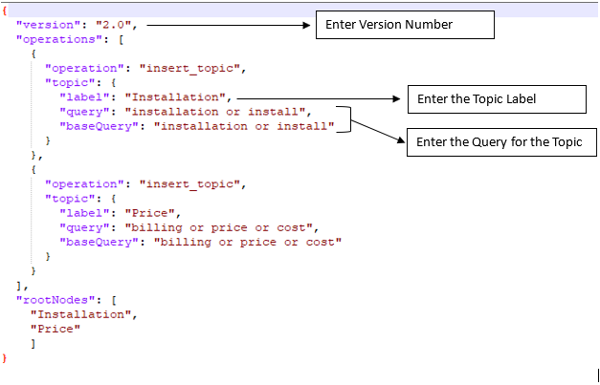
Figure 5. Screenshot of a JSON file example

9.3.1 Searching Text Responses
Alternatively, you can take a bottom-up approach and create topics based on the data. There are several ways to create topics: (1) searching text responses or (2) manually creating a topic. Please note that using recommended topics is not available in this Qualtrics license.
One way to create topics is by using the search function for specific key terms. The search function allows you to see how many text responses contain the term and lists each of the text responses. Please note that the text section includes a spell-checking system to ensure that all your responses are tagged with the topic correctly (e.g., checks capitalization and misspellings).
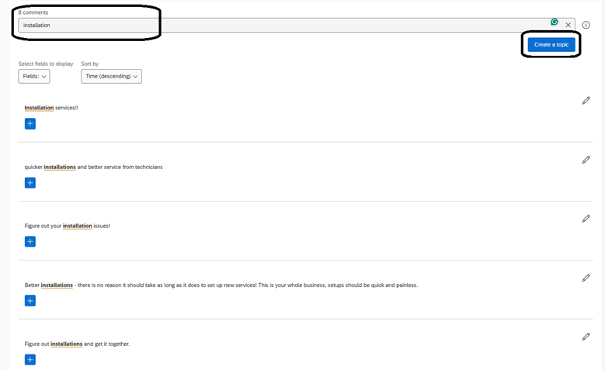
Figure 6. Creating topics from searches
The new topic that you create can be saved on its own, placed under an existing topic, or placing existing topics under a new topic. In this example, I am placing the topic ‘Installation’ under an existing topic called ‘Services’.
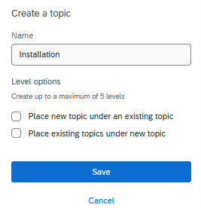
Figure 7. Creating a topic (under an existing or new topic)

9.3.2 Building a Query
In addition to searching for specific terms, you may also be interested in building a text query that searches in a specific manner. These can include: 1. Exact terms using quotes (e.g., “installation”) 2. Multiple terms together using ‘and’, ‘&’, ‘&&’ (e.g., technician and installation) 3. Variations of a term using ‘or’ ‘|’, ‘||’ (e.g., installation or service)
More information about query operators or commands can be found here and several examples are listed below in Figure 8.
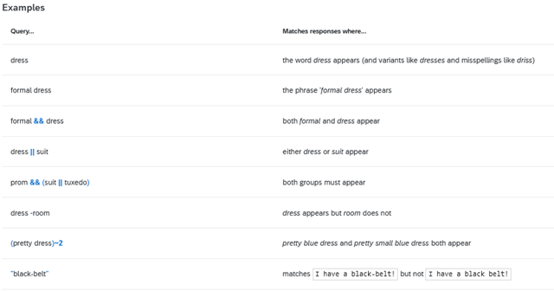
Figure 8. Building queries

9.3.3 Updating a topic
If you would like to update your query and update your topic, you can directly edit your query in the search bar and select ‘update this topic’. Qualtrics will inform you if there are additional comments that match the updated query and add them under your topic.
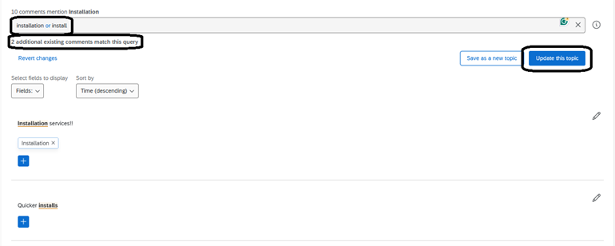
Figure 9. Updating topics
Alternatively, you may choose to ‘save as a new topic’ if you wish to create a new topic.

9.3.4 Hierarchical Topics
Topics can also be nested within one another to create hierarchies (max five levels). Any ‘child topics’ that are nested within a ‘parent topic’ inherit the query of the parent topic.
For example, I created the topic ‘Service’ for all service-related concerns. However, I would like to categorize different types of service-related issues, like service from technicians versus customer service. In this case, I use a query and ‘save as a new topic’ but select ‘place a new topic under an existing topic’ in order to nest the new topic ‘Technicians’ under ‘Service’.
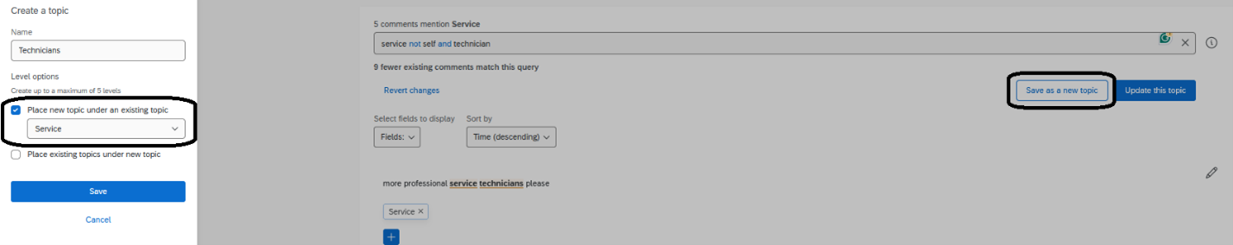
Figure 10. Topic Hierarchy
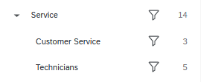
Figure 11. Example Topic Hierarchy”
You may also choose to ‘drag and drop’ existing topics under another topic.

9.3.5 Removing Topics
Sometimes text responses can contain multiple elements and tagging comments using the search function can give you imperfect results. For example, in Figure 12, one specifies providing self-service training resources, but it also includes the word ‘nothing’ which may not fit with the topic. In this case, you can remove the topic that is tagged in the comment by clicking the ‘x’ to remove.
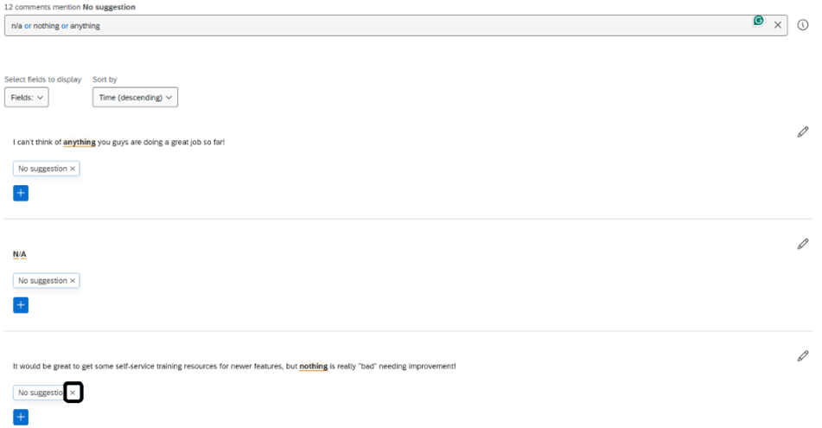
Figure 12. Removing Topics From Responses
Once you have started adding topics to responses, you will notice that the progress bar will show you how many of your total comments have been categorized or uncategorized. Hovering over this bar will show you both the percentage and number of comments that have been categorized. You may also select the ‘categorized’ side of the bar to filter by responses that have been tagged with topics or the ‘uncategorized’ side of the bar to filter by responses that have not been tagged.
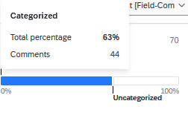
Figure 13. Progress Bar

9.3.6 Managing Topics
To manage your topics, you can select the three dots and (1) export your topics, (2) select topics to delete, or (3) view topic version history (e.g., a JSON file).
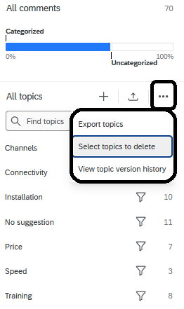
Figure 14. Managing Topics

9.3.7 Reviewing & Publishing
Once you are satisfied with the topics that you have created, you can select ‘Review and Publish’ to review a summary of your changes and publish once you are ready.
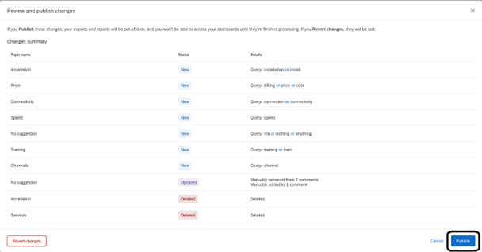
Figure 15. Reviewing & Publishing Changes

9.3.8 Viewing Topics in the Data Table
After you have created your topics, you can make your way to your Data Table under the Data tab to preview the newly created Topic column. Using the ‘column chooser’ you can scroll to ‘Topic Hierarchy’ and select ‘Topic Hierarchy Level 1’ which should show you your newly created Topics at Level 1. If you have multiple levels, these will show up in different columns.
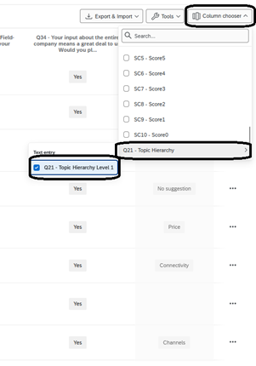
Figure 16. Viewing Topics in the Data Table
For more on Text iQ: - Text iQ Overview - Text iQ Functionality - Text iQ Topics - Text iQ Best Practices - Analyzing Text iQ in Stats iQ

10. Using Crosstabs iQ
A cross tabulation (crosstab) is a data table that compares the relationship between two or more categorical variables (e.g., gender and favorite fruit). A crosstab can be used to generate the frequency or proportion of respondents that fall into a particular row/column.
Qualtrics provides the Crosstab iQ tab that allows you to perform multivariate analysis on two or more variables, including chi-square and analysis of variance (ANOVA) tests.
To navigate to the Crosstab iQ tab, select the Data & Analysis tab and then Crosstabs iQ. 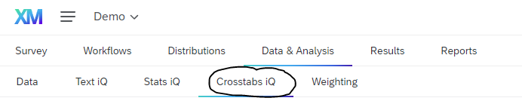
In the Crosstabs iQ tab, there is the Configuration Sidebar on the left including the Variable List, Columns/Banners, Rows/Stubs, Cells and the Output pane on the right. The Variable List includes survey questions, embedded data, metadata, and text analysis results.
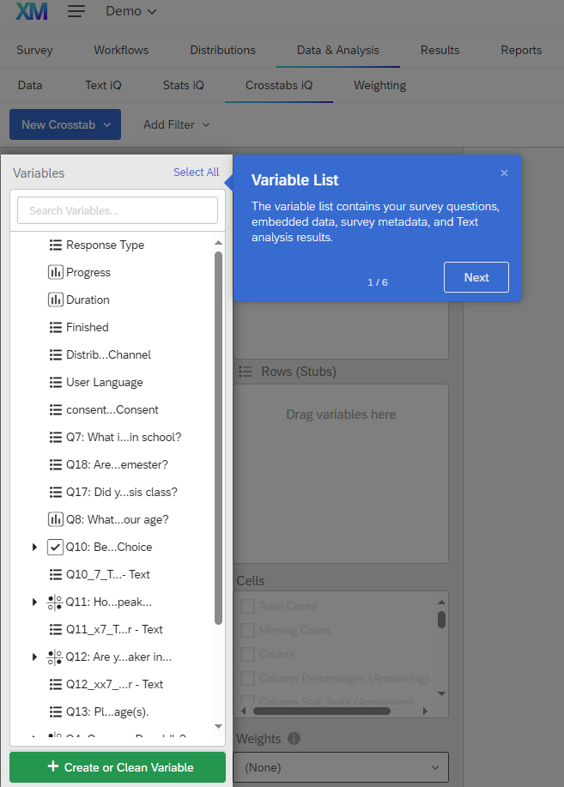
Figure 2. The Variable List
In the variable pane for Columns (also called banners), you may drag and drop variables from the Variable List. Variables inserted into the column pane are typically independent or input variables.
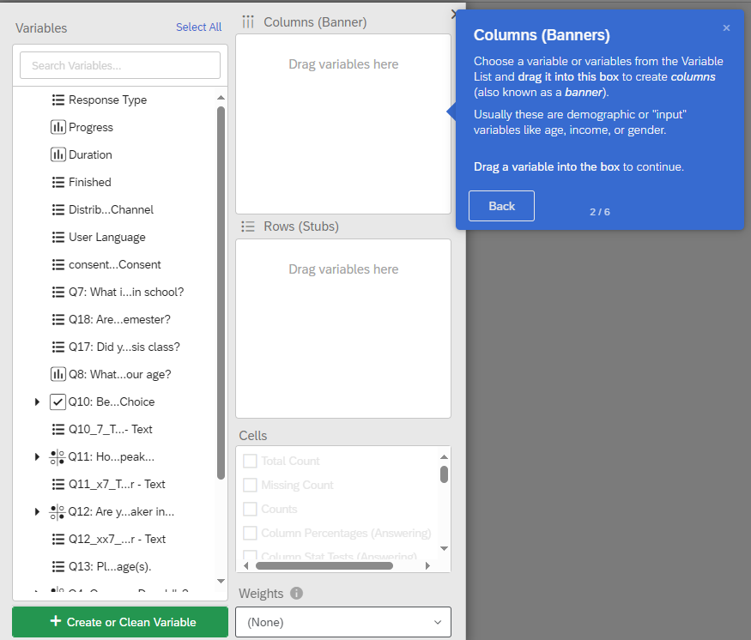
Figure 3. Columns/Banners
In the variable pane for Rows (also called stubs), you may drag and drop variables from the Variable List. Variables inserted into the row pane are typically dependent or output variables.
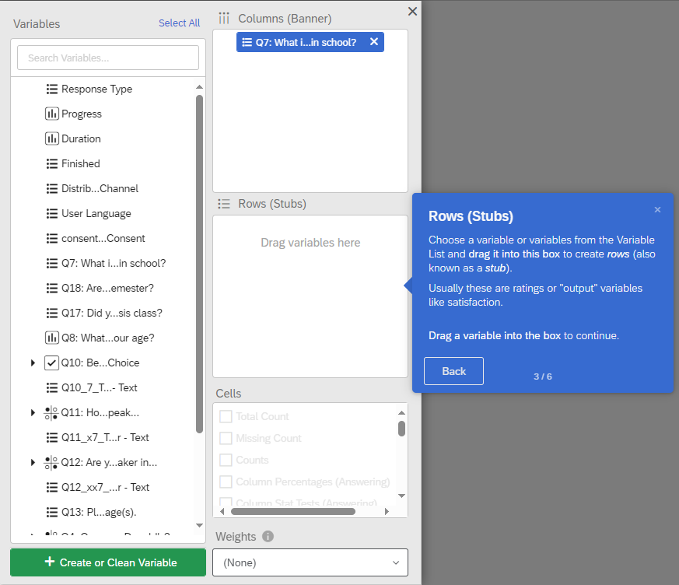
Figure 4. Rows/Stubs
In the variable pane for Cells, you may select the type of information or analysis you would like to see (e.g. counts/frequencies, column percentages, etc.)
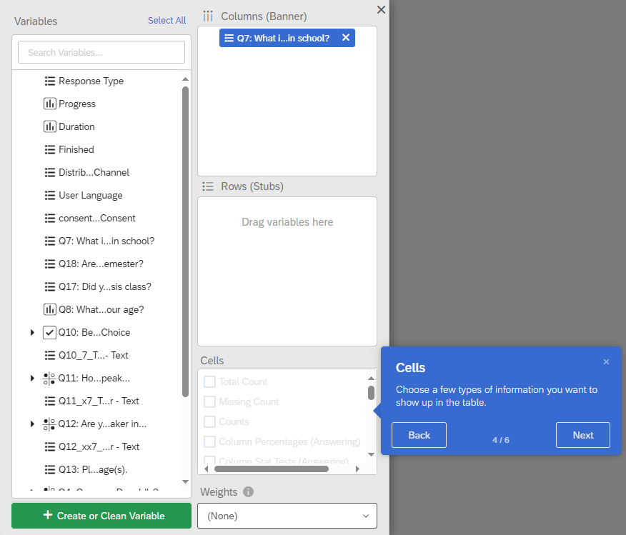
Figure 5. Cells
If you are actively collecting data or have added new data, be sure to import your latest data into your workspace under Settings.
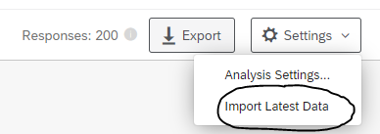
Figure 6. Importing Latest Data
In Crosstabs iQ: - Variables are automatically listed in survey order - Response items within variables are listed in survey order by default - Response items within variables are displayed with any extra HTML removed - Survey recodes are automatically imported into Crosstabs - For multi-selects behind skip or display logic, ability to show “Column Percentages (Answering)” - Banners can be bucketed (merged) in the same fashion as stubs - Many variables can be dragged to a different box at the same time - Checkbox stubs column percentages are calculated as a percentage of all survey takers, not a percentage of the total number of checkboxes selected - Changes made to one variable can be applied to all other variables - “Topline” crosstabs can be made with a stub and no columns

10.1 Descriptive Analysis
In Crosstabs iQ, you can perform descriptive analysis (e.g., summarizing your data) by creating a frequency distribution or by calculating descriptive statistics such as the mean, median, and mode (for numeric variables).

10.1.1 Numeric variables
To calculate descriptive statistics for a numeric variable, you can drag and drop a variable into the Rows (Stubs) pane. In the Cells pane, you can select which descriptive statistics you would like to calculate (e.g., count, median, average, etc.)
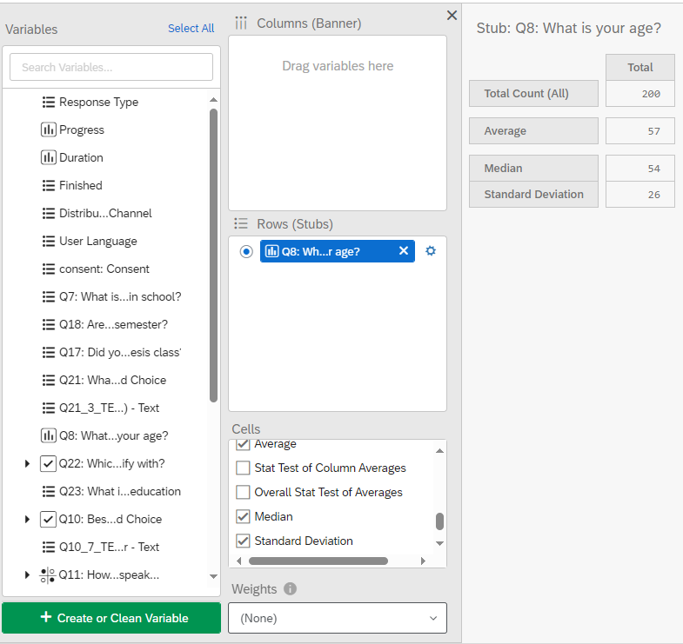
Figure 7. Descriptive Statistics: Age

10.1.2 Bucketing Numeric Variables
If you have a numeric variable whose values you would like to recode into new groups, you can choose to bucket the variable. For example, if you have a numeric variable for Age, but instead you would like to analyse age groups, you can bucket the values into different age groups.
To do so, first select the Variable Settings (gear icon).
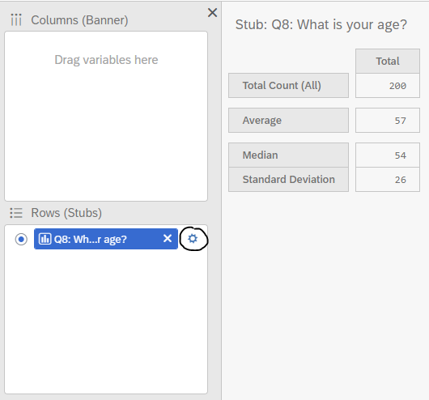
Figure 8. Variable Settings
Next, select Bucketing and set the buckets for the variable. I have also selected the checkbox If this variable is included in a banner (columns), also show unbucketed version. By default, the bucketed version is shown in the banner. Then, click save.
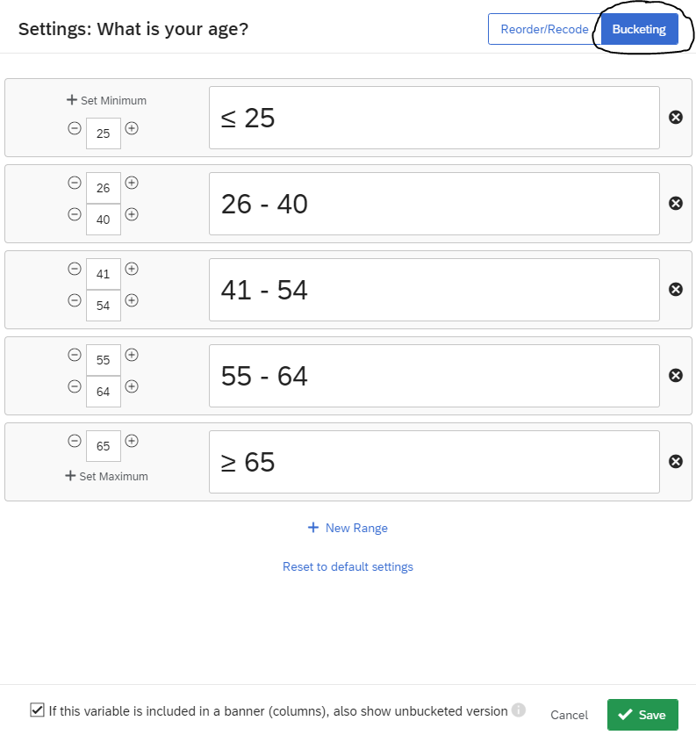
Figure 9. Bucketing: Age (Numeric Variable)
Now, the crosstab displays the buckets for age, while also computing the Average, Median, and Standard Deviation.
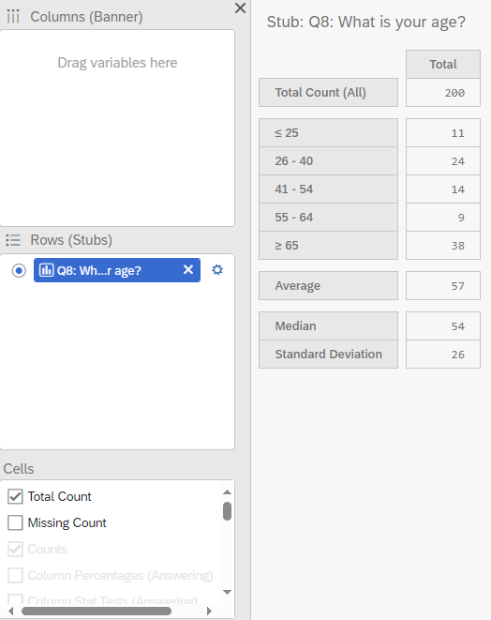
Figure 10. Counts for Age (Bucketed).

10.1.3 Categorical variables
To calculate descriptive statistics for a categorical variable, you can drag and drop a variable into the Rows (Stubs) pane. In the Cells pane, you can select which descriptive statistics you would like to calculate (e.g., count, column percentages, etc.). Being a categorical variable, statistics such as the mean, median, or standard deviation, are not possible to compute.
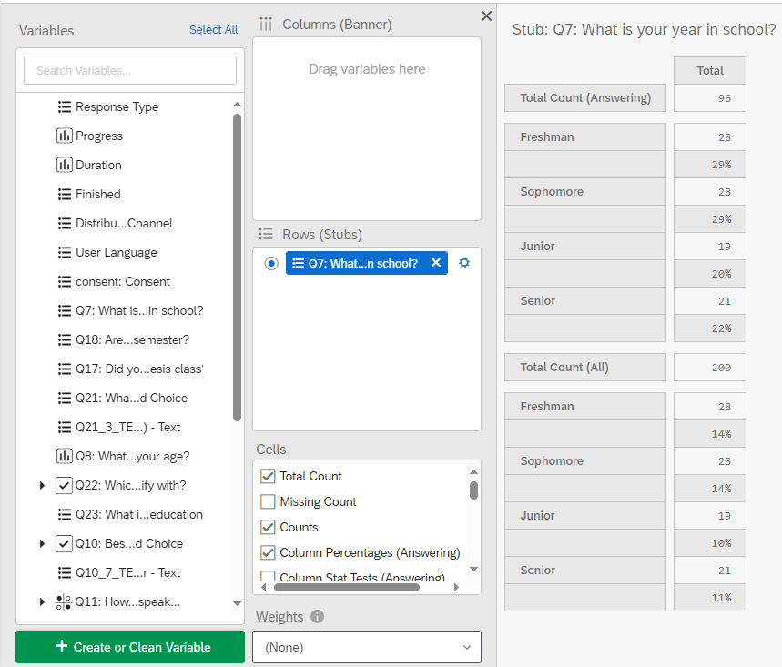
Figure 11. Descriptive Statistics: Year in school

10.1.4 Bucketing Categorical Variables
If you have a categorical variable whose values you would like to recode into new groups, you can choose to bucket the variable. For example, if you have a categorical variable for Education, but instead you would like to analyse fewer groups, you can bucket the values into different education groups.
To do so, first select the Variable Settings (gear icon). Next, select Bucketing and set the buckets for the variable. I have also selected the checkbox If this variable is included in a banner (columns), also show unbucketed version. By default, the bucketed version is shown in the banner. Then, click save.
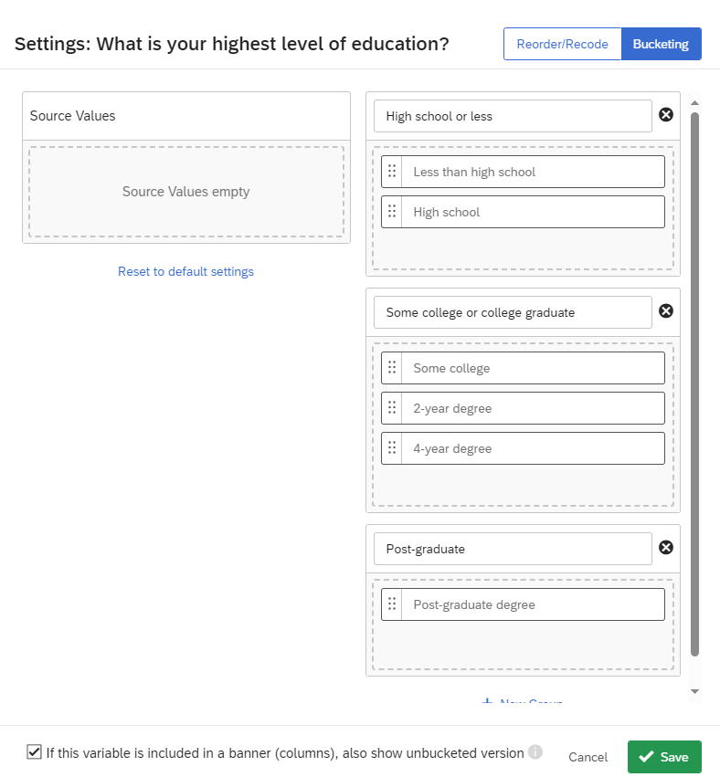
Figure 12. Bucketing: Education (Categorical Variable)
Now, the crosstab displays the buckets for education with the Bucketed Counts and Bucketed Percentages (All).
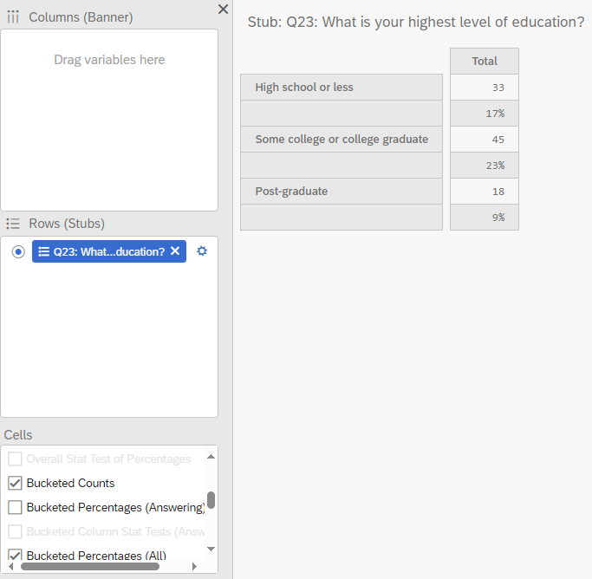
Figure 13. Counts for Education (Bucketed).

10.1.5 Crossabs
To generate a crosstab, drag your independent variable and drop it in the Columns (Banners) pane and then drag and drop your dependent variable in the Rows (Stubs) pane. For example, in Figure 13, I have selected the Year in School variable as my categorical independent variable and placed it under Column (Banner) and as my categorical dependent variable, I have selected the Languages variable. In my cross tab, I have generated the counts, total counts, and the column percentages (answering).

10.1.5.1 Counts
There are four types of counts you can calculate. - The Total Count generates the number of people (frequency) who responded to both the column and row questions. - The Missing Count shows the number of people who did not answer a given row question (who did answer the column question). - The Counts shows the number of people who answered in a given column category for the question in the row. - The Bucketed Counts shows the number of people from each category of the column variable that fit into each bucket in the row variable.

10.1.5.2 Percentages
There are three types of column percentages you can calculate. - The Column Percentages (Answering) calculates the percentages in each column category that gave each answer in the selected row. This is calculated using the total number of answers provided to the question, instead of total respondents. - The Column Percentages (All) calculates the percentages based on the total number of respondents to the survey. - The Bucketed Percentages (All) calculates the percentages based on those in each column category that fits into a particular bucket in the dependent variable (only if buckets are generated for this variable). This percentages is generated based on the total number of respondents to the survey.
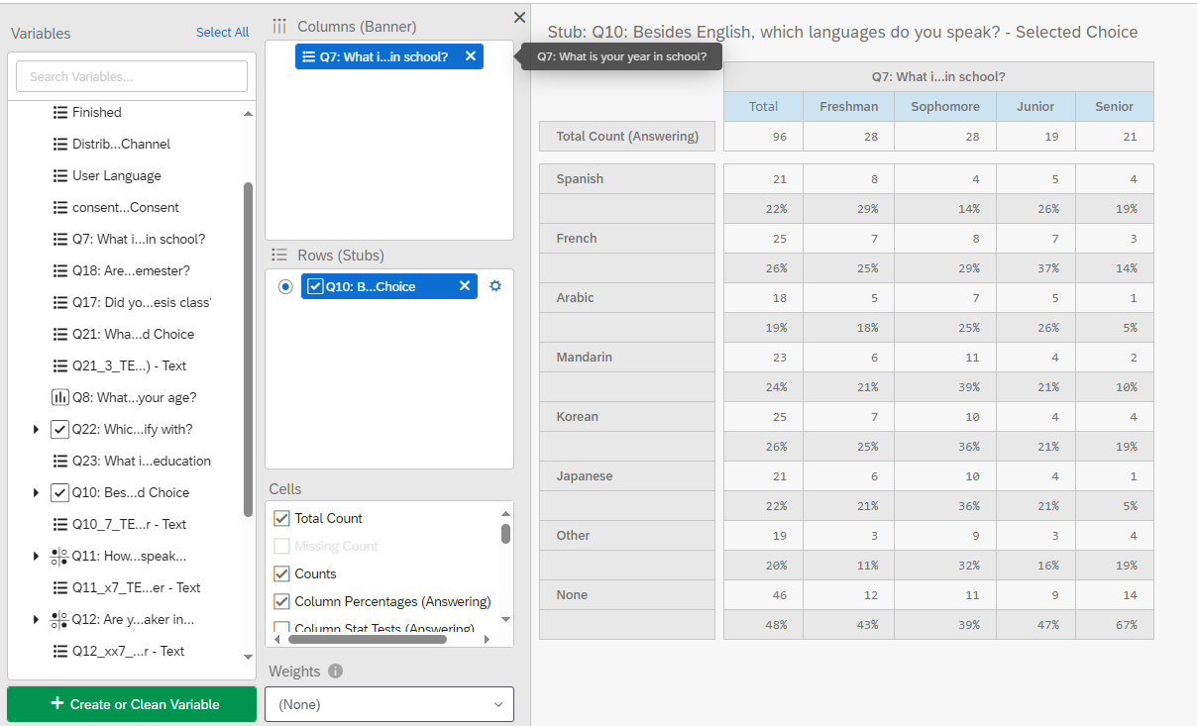
Figure 14. Crosstab: Year in School and Languages Spoken
You can add multiple variables in your columns and rows. However, you cannot view all the calculations for values added to the row all at once. For each variable you add, in your column, you can view the crosstab side-by-side.
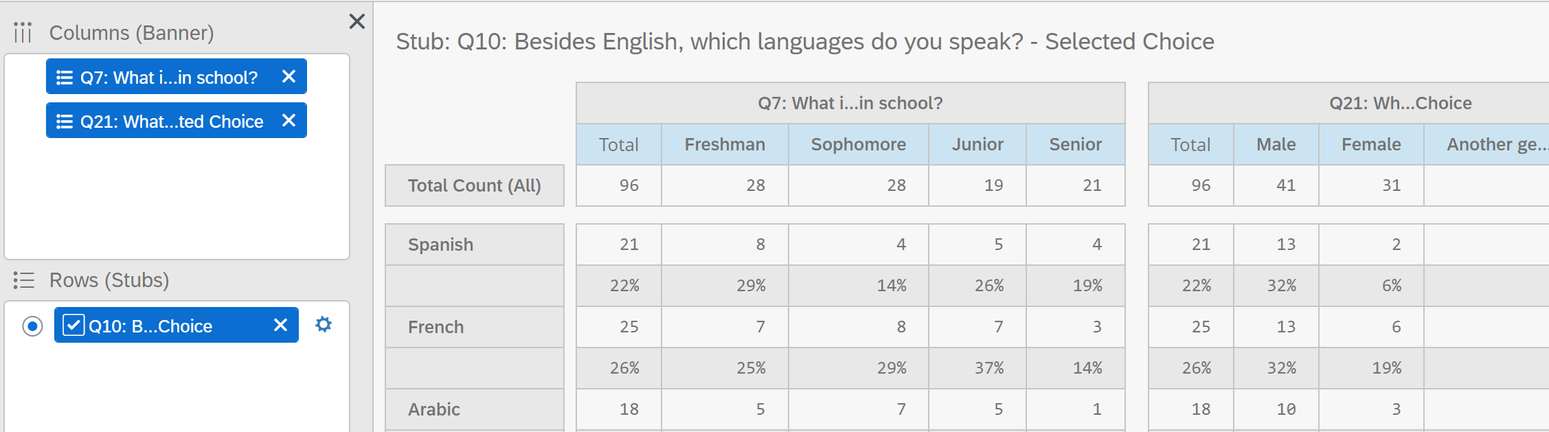
Figure 15. Crosstab: Year in School, Gender, and Languages Spoken
If you add multiple variables to your row, you can only generate the table for one variable at a time. You must select the row variable to generate a table.
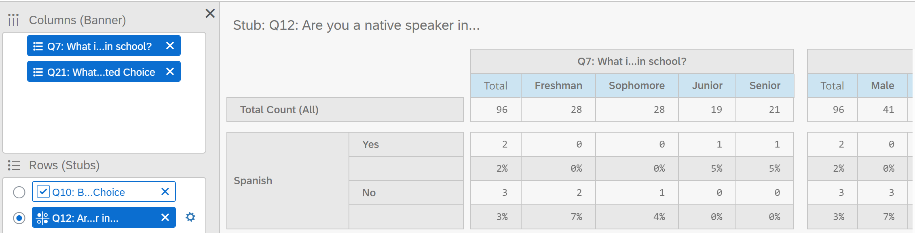
Figure 16. Crosstab: Year in School, Gender, and Native Language

10.2 Nesting
If you would like to view a breakdown of a variable within another variable, you can use nesting. Only columns can be nested, not rows. To nest a variable, first add your variable under columns and then drag your second variable over the first one. If successfully nested, the second variable should appear indented under the first variable. In Figure 17, gender is nested within Year in School.
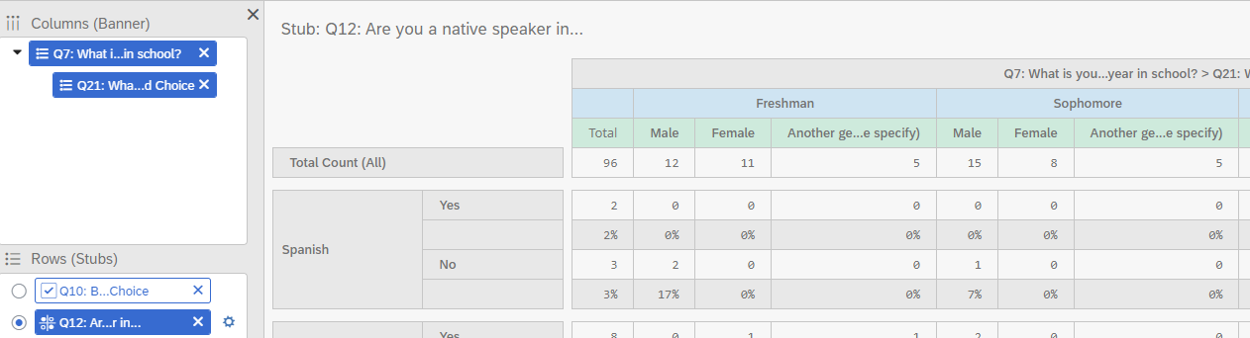
Figure 17. Crosstab: Nesting Gender within Year in School

10.3 Chi-Squared Test
To examine the relationship between two categorical variables, you can choose a chi-squared test. To do so, you must select the Column Percentages (All) and the Overall Stats Test of Percentages. The Overall Stats Test of Percentages acts as a Chi-squared test, which produces a p-value to determine whether the relationship between the two variables is significant or not.
As shown in Figure 18, I have selected Year in School as my categorical independent variable and Language Fluency as my categorical dependent variable to generate my crosstab. In this crosstab, I display the total count, count, and column percentages.
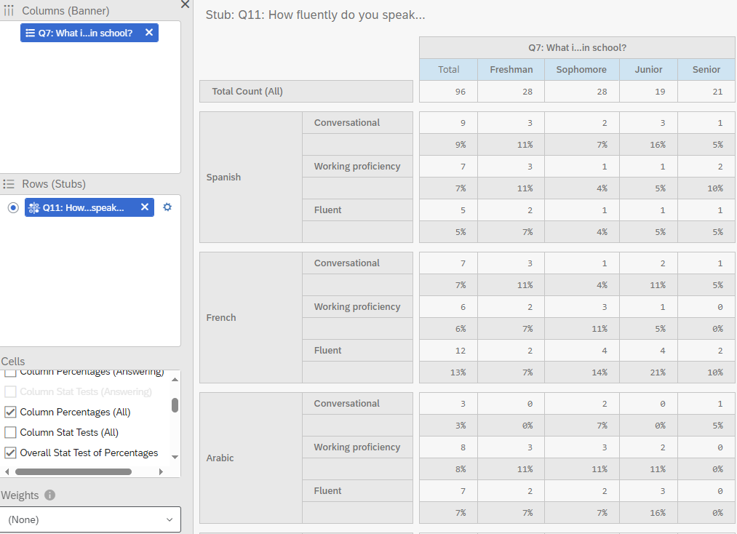
Figure 18. Crosstab: Year in School & Language Fluency with Column Percentages (All).
To perform the chi-squared test, I also selected the Overall Stats Test of Percentages. This generates a table that indicates whether the p-values are below 0.05. As shown in the table, none of the values are less than 0.05, therefore there is no statistically significant relationship between these variables.
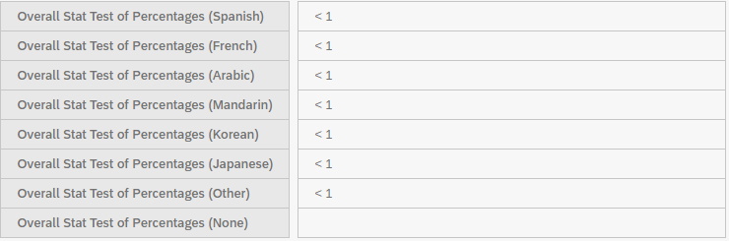
Figure 19. Chi-Square Test (P-values): Year in School & Language Fluency.”
By default, the primary confidence level is set at 95%, but this can be changed in the Analysis Settings, as shown in Figure 20 and 21. You can also change the number of decimals shown and separate counts and percentages into separate tables.
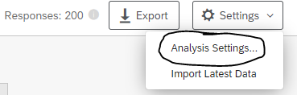
Figure 20. Analysis Settings.”
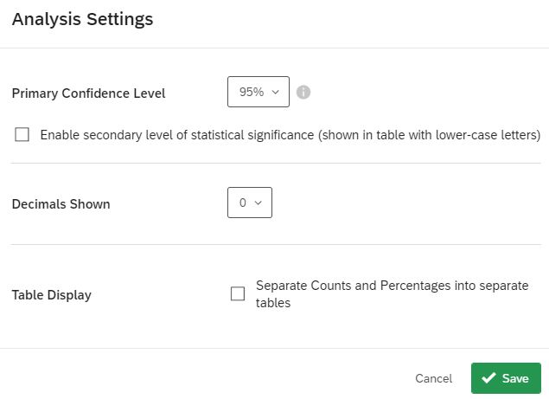
Figure 21. Editing Analysis Settings.”
Warning
If you would like to see the precise p-values instead of “< 1”, you must change the variable settings to show at least one decimal point.
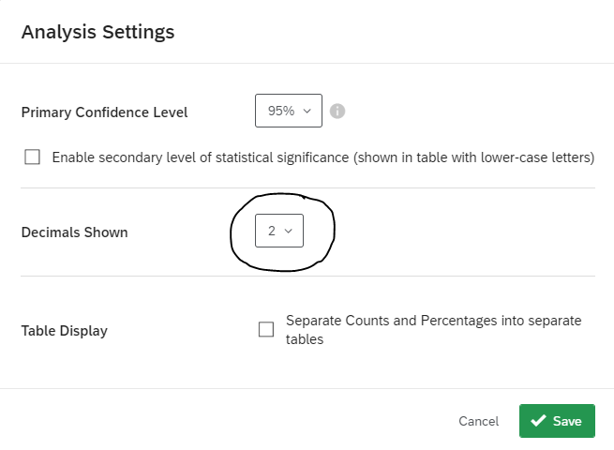
Figure 22. Analysis Settings: Two Decimals Shown”
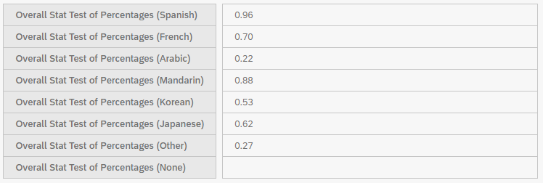
Figure 23. Chi-Square Test (P-values with Two Decimal Points): Year in School & Language Fluency”
Please note that in Crosstabs iQ, Chi-Square values are not displayed. The analysis only displays the p-values and whether there is a statistically significant relationship between the variables (bolded). In Figure 23, none of the relationships are statistically significant.

10.4 Analysis of Variance (ANOVA) Test
To test whether the differences in means between one or more categorical independent variables and a normally distributed continuous (i.e. interval or ratio) dependent variable is significant, you can choose an analysis of variance (ANOVA) test. To do so, you must select Averages and the Overall Stat Test of Averages
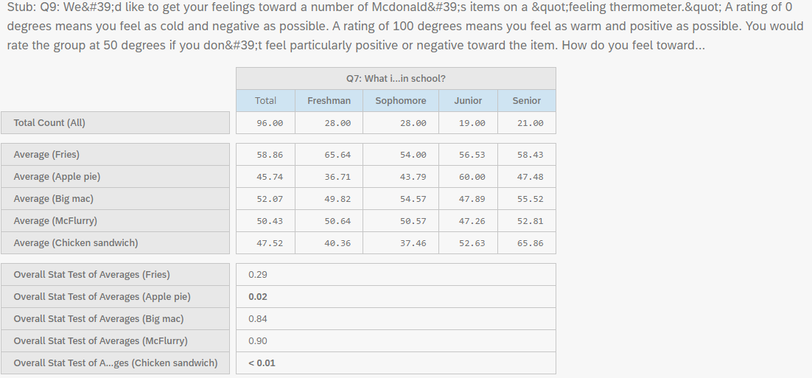
Figure 24. ANOVA Test: Year in School & Feelings toward McDonald’s items.”
As shown in Figure 24, there is a significant relationship between Year in School and feelings toward Apple Pie and Chicken Sandwich (bolded p-values).

10.5 Z-Tests
If you would like to determine whether two samples are different from one another, you may use a Z-test. Z-tests are similar to t-tests but z-tests are more common where the sample size is larger (generally over 30). Z- and t-test results converge as the sample size approaches infinity (i.e., or at about a sample of 120). Z-tests require you to know the population standard deviation, while t-tests use a sample estimate of the standard deviation. If your sample size is less than 25, please be aware that your p-value from a z-test may be slightly different than a t-test. Z-tests are sensitive to mean differences in smaller samples and can produce statistically significant results incorrectly (i.e., a type 1 error or false positive). When you have a sample estimate of the standard deviation, which is most of the time, the best statistical practice is to use a t-test regardless of the sample size. T-tests tend to be more conservative than z-tests and therefore are generally recommended.
To perform a pairwise z-test, you must select Averages and Stat Test of Column Averages. Please note that your outcome or dependent variable must be numeric.
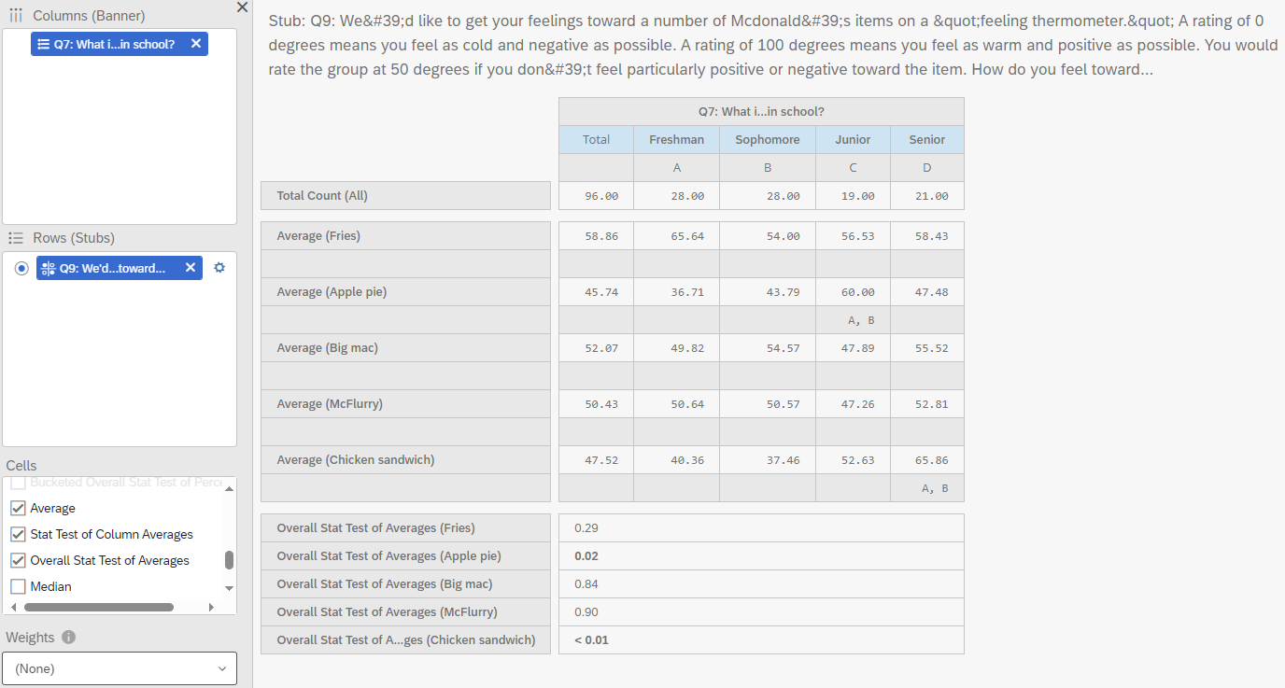
Figure 25. Z-test: Year in School & Feelings toward McDonald’s items.”
Below the column averages, letters appear in some of the columns. These letters indicate which columns are significantly different from the given column. For example, in column C, Juniors have significantly higher feelings (more positive feelings) toward McDonald’s apple pie compared to Freshmen (column A) and Sophomores (column B).
For more on Crosstabs iQ: - Crosstabs Overview - Crosstabs Options - Understanding Crosstabs Statistics

11. Using Weighting
Work in Progress
This guide is a work in progress, and will be updated substantially as time allows. If you find an error, please let us know.

11.1 What is Weighting?
Weighting is a technique that adjusts responses from a survey to be more representative of a target population. This technique is helpful because survey responses often do not accurately represent a target population due to sampling biases and varying response rates. In other words, the way a certain characteristic (such as age, education, race, sex, etc.) of your sample is distributed may differ from the way it is distributed in the population. For example, your sample may consist of 60 percent women, when women make up only 52 percent of the population. This introduces bias into any estimate you may obtain from your sample data because statistical procedures will give greater weight to those people who are overrepresented.
There are two common types of survey weights:
- Design weights: used to compensate for over- or under-sampling specific cases or for disproportionate stratification (e.g. by deliberately oversampling a small subgroup of the population).
- Post-stratification weights: A post-stratification survey weight is a value assigned to a given answer that accounts for the proportion of the population that they represent. It is called a post-stratification weight because you can only compute it after you have collected all your data. The stratification part comes from the fact that you use various known strata (such as age group or sex distribution) of the population to adjust your sample data to conform more to the population’s parameters.
In order to calculate a post-stratification weight, you need an auxiliary data set to which you can compare your sample data. For example, if you were conducting a survey of residents of Illinois, you would need census data or Current Population Survey data that show the demographic characteristics of the population of Illinois. You could then compare your sample to the auxiliary data file, to make sure that the distribution of demographic characteristics (such as age, education, race, sex, etc.) is similar to that of the auxiliary data. If the distributions are close enough, there is no need to calculate post-stratification weights. However, if they differ by more than a few percentage points, you will want to calculate the weights. Post-stratification weights are usually computed as follows:
$$\frac{PopulationProportion}{SampleProportion}=Weight$$

11.2 Data & Analysis
From your survey, you can navigate to the Data & Analysis tab to view your data. Using a campus-wide account, this tab contains five sub-sections: (1) Data, (2) Text iQ, (3) Stats iQ, (4) Crosstabs iQ, and (5) Weighting. For more information about each of these tabs, please see Chapter 7.
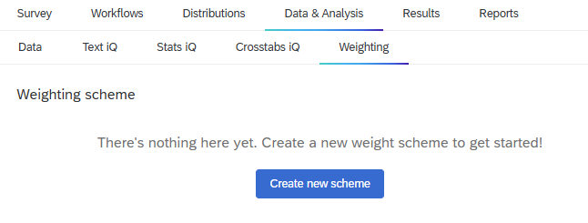
Figure 1. Weighting tab
Under Weighting, you can create three types of weighting schemes:
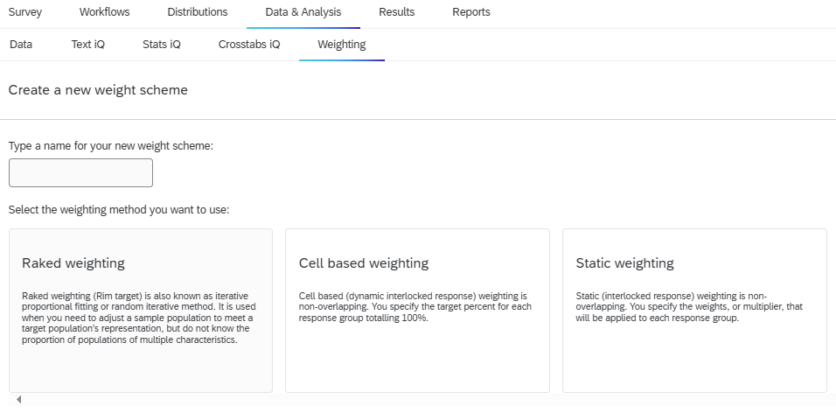
Figure 2. Weighting Schemes
- Raked weighting: Raked weighting (Rim target) is also known as iterative proportional fitting or random iterative method. It is used when you need to adjust a sample population to meet a target population’s representation, but do not know the proportion of populations of multiple characteristics.
- Cell based weighting: Cell based (dynamic interlocked response) weighting is non-overlapping. You specify the target percent for each response group totaling 100%.
- Static Weighting: Static (interlocked response) weighting is non-overlapping. You specify the weights, or multiplier, that will be applied to each response group.
In Qualtrics, you specify the target % and the weight will be computed for you.
Take cell based weighting for example (see Figure 3). First, select the variable you are interested in weighting (e.g., gender). In this example, I set the target % for Males as 46%, 62% for Females, and 2% for another gender identity. Qualtrics will then generate the cell weight based on these target percentages.
As you add weights, Qualtrics will generate a weight report that includes the variables being used in the weighting scheme, sample balance, weight efficiency, quality, and the cardinality limit. The cardinality limit is calculated by the multiplying the number of categories for each of the variables together (Note: the max is 5,000).
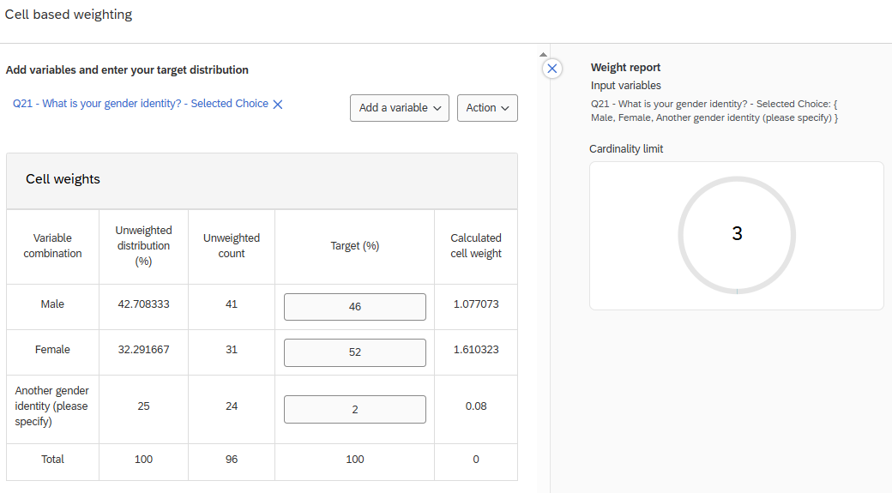
Figure 3. Cell Based Weighting
For each of these weighting schemes, you may also apply wave based weighting, which allows you to apply unique weights over different time periods or categories.
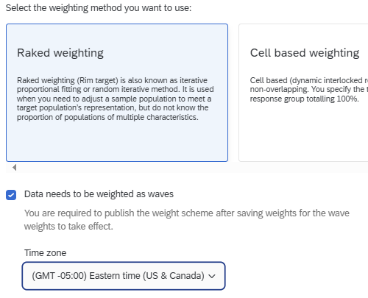
Figure 4. Weighting as Waves
For more on Weighting: - Weighting Overview

12. Libraries
From the main Qualtrics interface, you can access your libraries by clicking the menu icon in the top left corner, then clicking Library.
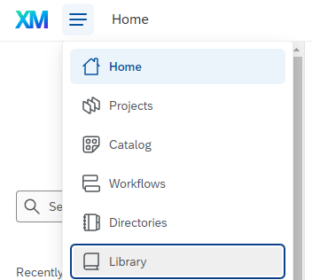
By default, you will see a Qualtrics Library that has template questions for all users, and a personal library with your name. Group and division libraries (e.g., “ACES Qualtrics Library” or “University Housing”) may also appear based on your group membership.
To be added to a group, contact your unit’s Qualtrics administrator or CITL Data Analytics.
Libraries can contain questions, files, images, and entire surveys. To add resources to your library, click “New resource” on the right side of the screen, then choose the appropriate type.
Warning
Images MUST be uploaded as the ‘Graphic’ type. If they are uploaded as ‘Files’, they cannot be used correctly in surveys and must be re-uploaded as graphics before they can be used.
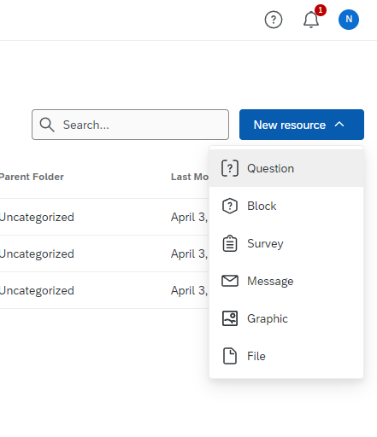

12.0.1 Moving Library Content
By default, things you upload are sorted into an “Uncategorized” folder, but you can move them into folders by clicking the Create new folder button at the bottom left of the screen.
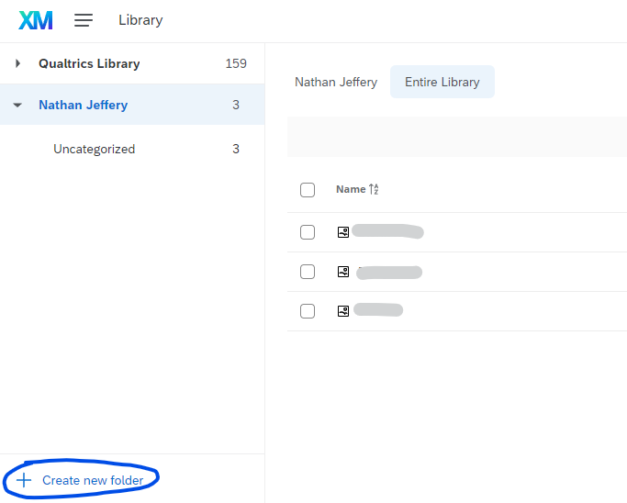
You can also move content into a Group library by clicking the “…” menu to the right of the item and choosing Copy (shown below for a graphic, which says “Copy graphic”). For more information about Group libraries, see Section 13.4.2.
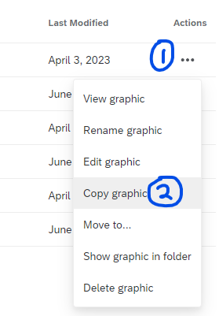
Choose the appropriate Library from the dropdown menu, a destination folder if desired, and type the name of the item. Then click save.
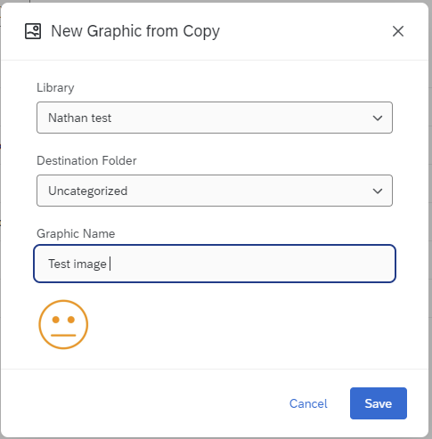
Tip
We strongly recommend keeping a copy of all library files on your own computer. If for any reason you need to batch download files from a Qualtrics library or transfer them to another account, please contact CITL Data Analytics.

12.1 Supplemental Data
Qualtrics has a Supplemental Data Sources feature that lets users pull external data into their surveys.
For example, a survey about on-campus housing could have a question, “Which housing complex do you live in?”, and then display follow-up questions based on the amenities and rent price at that complex.
However, Qualtrics has restricted the number of supplemental data sources that can be used across the entire university, so we enable the use of supplemental data sources on a case-by-case basis, subject to availability.
If you would like to use supplemental data sources, please contact CITL Data Analytics.

13. Collaboration and Groups

13.1 Collaboration
“Collaboration” is the Qualtrics term for sharing a survey with other people so they can view, edit, translate, activate, copy, and/or distribute it.
Note
For more details, see the Qualtrics documentation on collaboration
Inside a survey project, click Tools and then Collaborate.
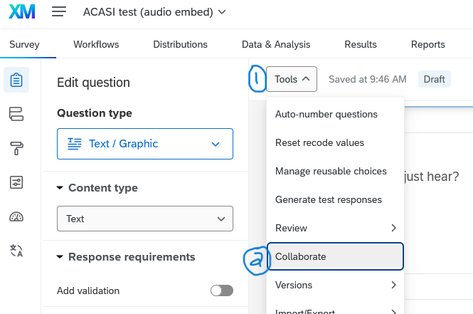
You can also collaborate from Projects screen. Click the “…” menu to the right of the project name, then click Collaborate.
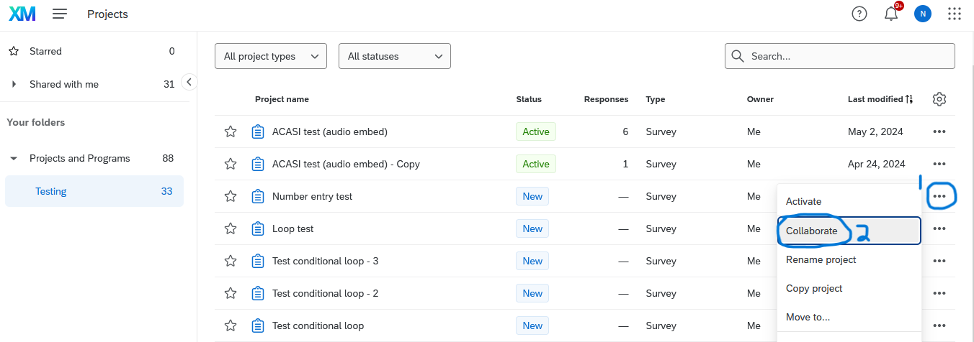

13.2 Collaborating with Others
Once you open the collaboration menu, start typing your colleague’s name or netid/email into the search field. Within a few seconds, if they have an Illinois Qualtrics account, it will autofill their name and netid@illinois.edu#illinois email address. Click their name, then click Add Selected to add them to the list of collaborators.
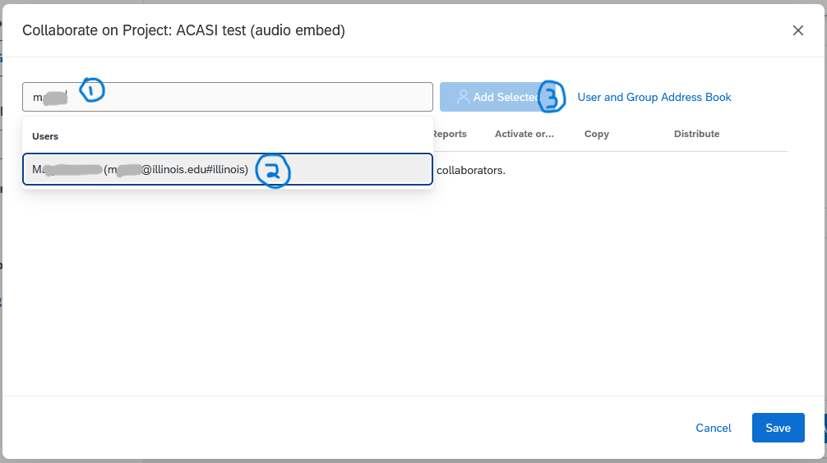
After adding the person to the list of collaborators, review which permissions you want them to have by checking or unchecking boxes as needed. When you are finished, click Save.
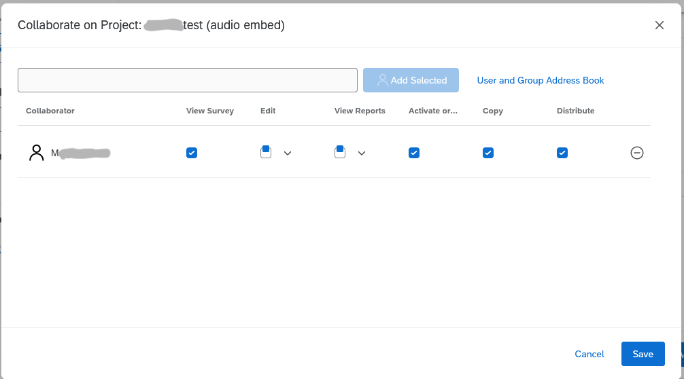
If it does not autofill your colleague’s name, it is possible that they have not yet activated their Illinois Qualtrics account, or you may be trying to collaborate with someone outside the University. In this case, you can type in their email, click Add Selected, and it will send them an email with a collaboration code.
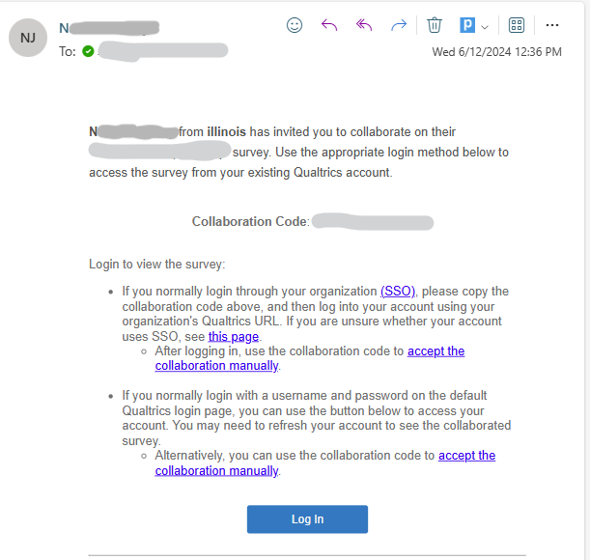
If they are from Illinois, they should log in at illinois.qualtrics.com (NOT at qualtrics.com; see Chapter 1).
Once they have logged in, they can go to Projects > Shared with Me and there will be an option to Enter Collaboration Code in the top-right corner.
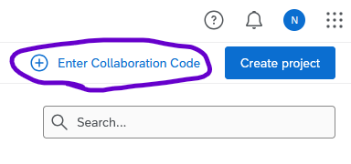
To un-share your survey with a group or user, go back into the Collaborate menu (just as if you’re adding another collaborator, see instructions above) and click the red minus button to the right of the group or user you would like to remove.

13.2.1 Collaborating Outside the U of I: Details
Collaborating with someone outside the University is similar to collaborating with someone who has an Illinois Qualtrics account, but some limitations apply that make the situation a little more complicated.
First - your collaborators will need to have Qualtrics accounts. These can be free accounts or accounts through their organization(s). (If they don’t have accounts, they can create free ones at qualtrics.com)
Second - you add them as collaborators to the survey.
Third - they receive an email with a collaboration code. (If they deleted the email, you can remove them as collaborators, click “Save,” then add them again and it should resend the email.)
Fourth - they log into their account. On the Projects screen they need to click Shared with me, then on the right side there should appear an option to Enter collaboration code.
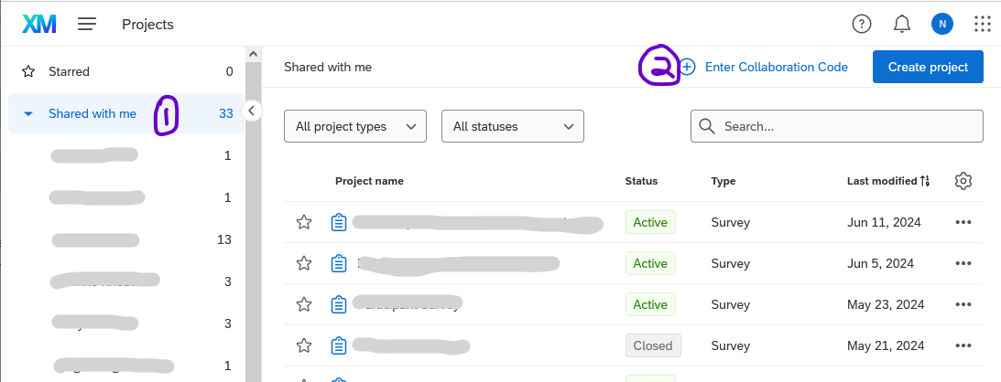
Then, they enter the code and click Submit. Now they should be able to see the survey.
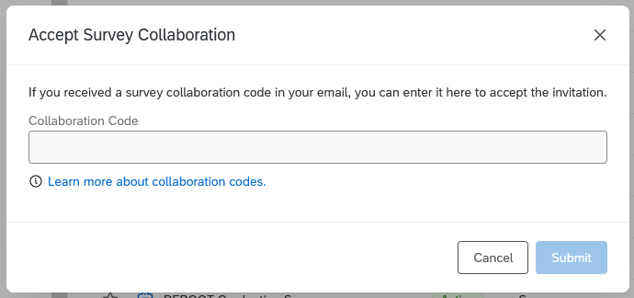

13.2.1.1 Notes about cross-brand collaboration
First, note that the survey still “lives” inside its owner’s account, which means that the owner’s account features apply, including distribution limits, question types, themes, images, library files, contacts, etc. For example, if you share a survey owned by your Illinois account with someone on a free Qualtrics account, paid Illinois Qualtrics features (such as question types, logic, quotas) will still be available in that survey.
Second, the collaborator will have reduced privileges when editing surveys owned outside their brand, including only being able to send 10 distribution emails per week. Emails should be sent by the survey owner or by another collaborator within the owner’s brand. For example, if a collaborator at Purdue shares a survey with you, and you want to distribute the survey via custom email links, you should ask your Purdue colleague to distribute it, and it will be limited by the number of email distributions that Purdue allows. If, hypothetically, Purdue doesn’t allow email distributions, you could copy the survey to your Illinois Qualtrics account, share it with your colleague, and then use the Illinois distribution limit of 50,000 emails/week.

13.3 Survey Ownership
When you share a survey with someone, you retain ownership of that survey–you are the only one who can delete it, and the survey instrument and data files still reside in your account.
If you or a colleague leaves the university, your surveys will continue to exist, but your collaborators will not be able to share them with other people. To request that ownership of a survey be transferred to someone else, you or they can contact your division administrator or a brand administrator.

13.4 Groups
In Qualtrics, it’s possible to share surveys, contacts, and library files with a Group of users, rather than a single person. For example, you may want to use groups to work with your research group/lab, office, unit, or other entity that changes its composition over time.
Tip
Need a group? Division administrators can create a group if its members are in the same division. If the group requires people from different divisions to have access, contact CITL Data Analytics.

Important
DO NOT collaborate a survey with the “University of Illinois” group – this will let everyone at the university see and/or edit it!

13.4.1 Division Libraries
A division library is a group library that is visible to all users within a division. For example, the College of ACES could create a division library with questions, U of I logos, or sample surveys that are visible to all users whose primary affiliation is with the College of ACES.
Coming Soon
This content has not been written yet.

13.4.2 Group Libraries
Coming Soon
This content has not been written yet.

13.5 Resource Accounts
It’s possible to log into Qualtrics using a resource account. Resource accounts (such as citl-data@illinois.edu) are given standard Qualtrics accounts and can own and collaborate on surveys as well as be part of groups.
Using a resource account, especially in conjunction with groups, can ensure that surveys stay available to colleagues regardless of people joining or leaving your unit.
To set up a resource account, ask your department’s IT person to do the following:
- Always use the campus standard when creating a new AD user account and make the name meaningful to the project or group. Ex. DEPT-EPONYMOUS.
- Email the campus Exchange admin and request the email account be email enabled and Azure enabled.
- If the users want to actually use this resource account for email, change the Display Name to DEPT-EPONYMOUS@ILLINOIS.EDU and get an email alias request.
  - Note that the actual Azure login will be DEPT-EPONYMOUS@AD.UILLINOIS.EDU but DEPT-EPONYMOUS@ILLINOIS.EDU should work after setting up an alias and changing the display name.
- Right click AD user account you created AFTER it’s been mail/azure enabled > go to Properties > click on Attribute Editor tab > scroll down to extensionAttribute2, make sure it is set to O365 and you’re all set.
Once those steps are complete, you need to:
- Ensure you’ve been provided with the email password for the new account.
- Log into Qualtrics using the DEPT-EPONYMOUS@ILLINOIS.EDU email as the username and the assigned password to activate the AD account’s Qualtrics account.
  - Note: you should not be prompted to use Duo authentication on this account.
  - If you’re already logged into your own account, you can log out or use an incognito window.
- After you’ve logged in for the first time, email citl-data@illinois.edu with the name of the new resource account and the campus division/unit to which it should be assigned.

14. Survey Options
Coming Soon
Much of the content in this chapter not been written yet.
This section includes details about how to customize the way your surveys look and behave. Eventually, it will include details the Look and feel, Survey options, Quotas, and Translations tabs.

14.1 Look and Feel
Look and Feel is the third option in the survey toolbar.

In the look and feel tab, you can apply a pre-built theme, change the appearance of the “Next” or “Back” button, change the text size, or apply other customizations.

14.1.1 Themes
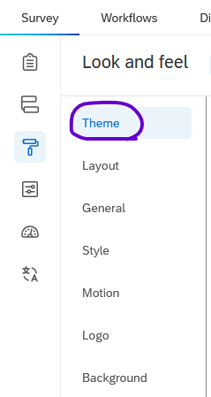
Currently, there are three default themes that meet accessibility and branding guidelines and are available for all Illinois users.
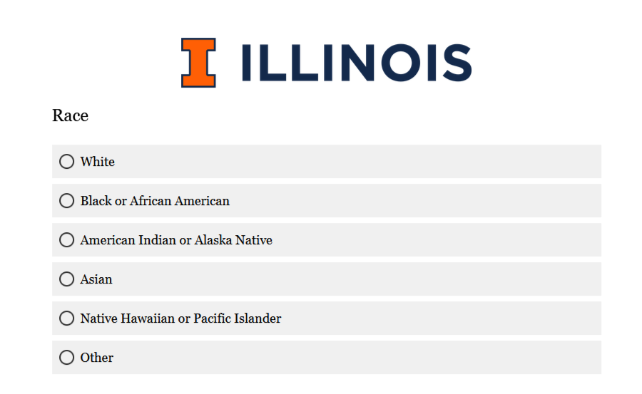  Illinois Default Theme | 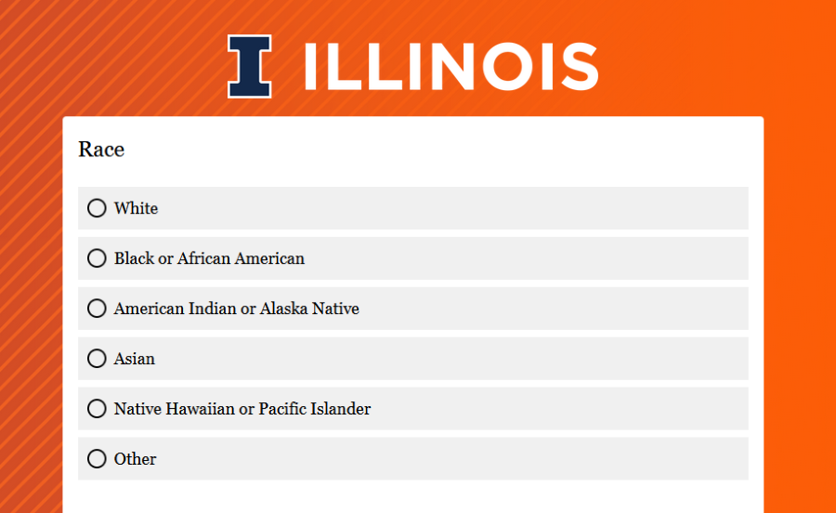  Ascending Lines Orange | 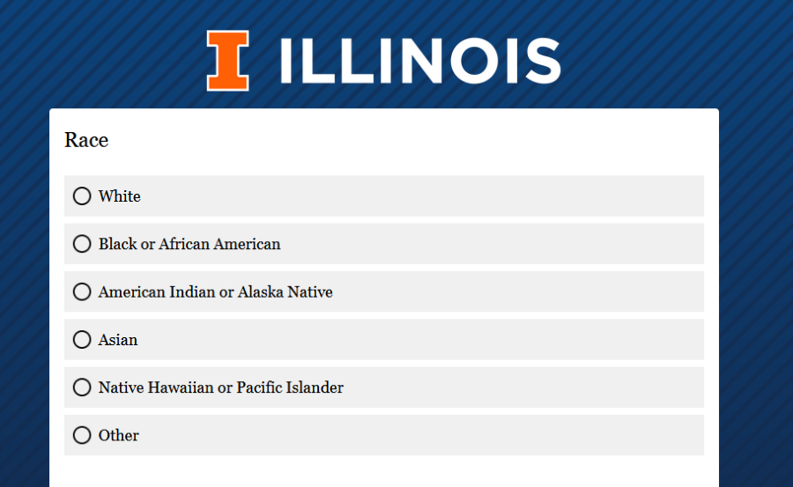  Ascending Lines Blue

14.1.2 Layout
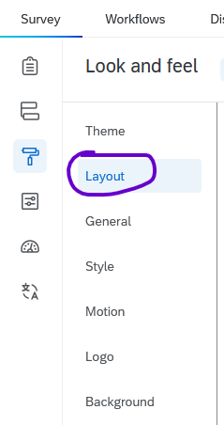
The Layout tab lets you customize what the question text and answer options look like from a list of preset options.
Simple layout
While most layout changes are merely aesthetic, the “New Survey Taking Experience” (previously called the “Simple layout”) reformats the underlying code that Qualtrics uses to present the survey. This results in better accessibility–especially for matrix questions–but a few question types are currently unsupported, and custom JavaScript may break if the new experience is used.
If you use the New Survey Taking Experience, you will not see the Layout tab.
See Section 4.1.2.
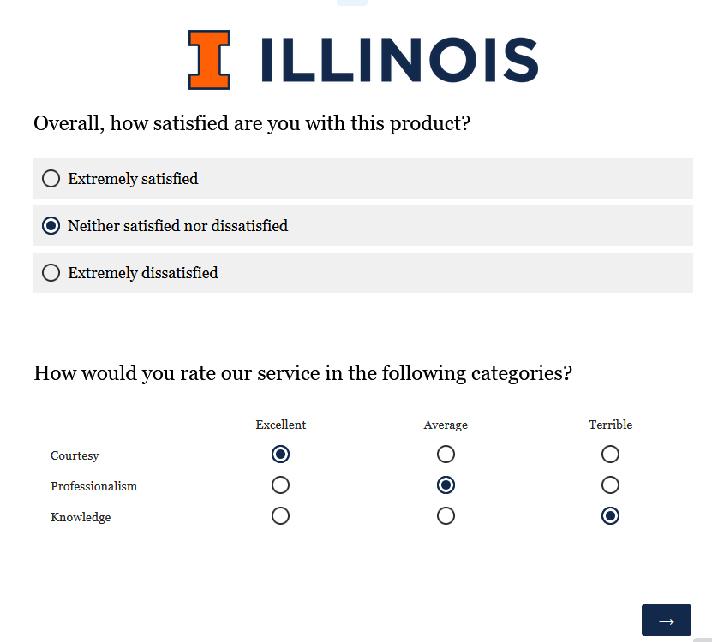  Flat (default) | 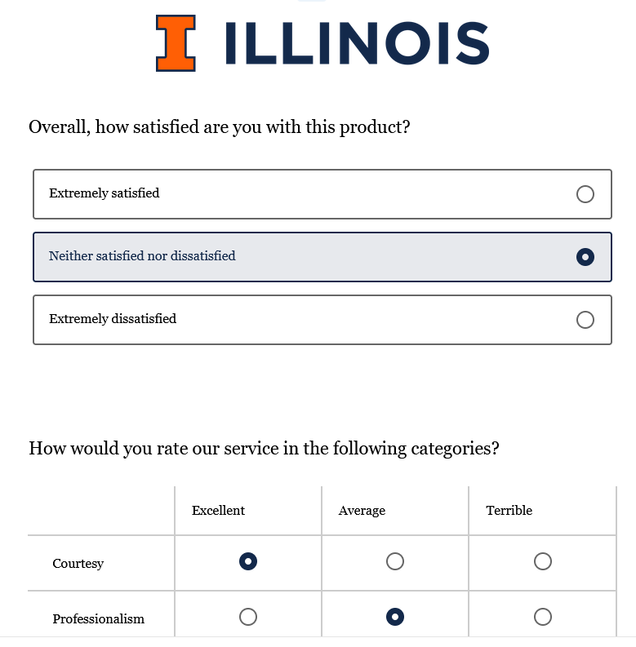  Modern | 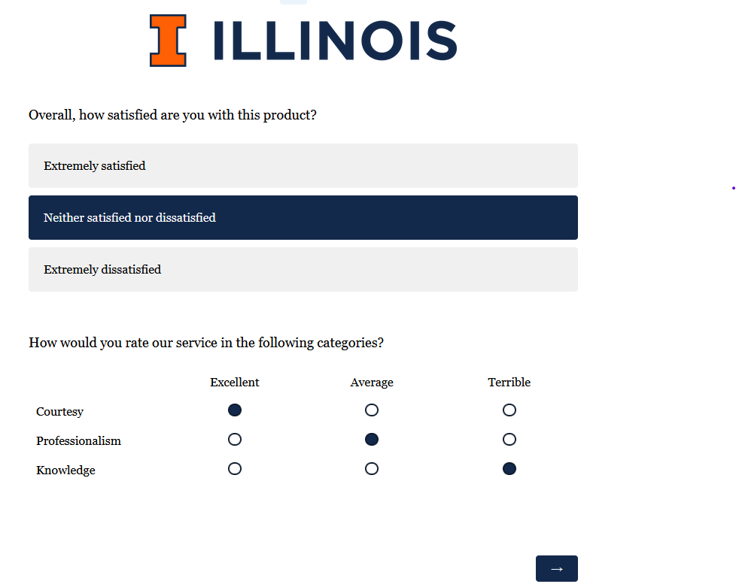  Classic

14.1.3 General
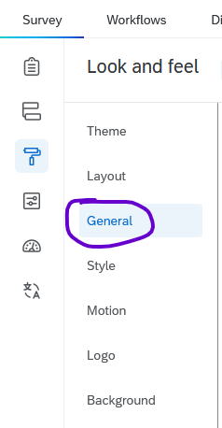
The General tab lets you customize the Next and Previous button text, display a progress bar, specify how many questions should be displayed per page, and add a custom header or footer.

14.1.3.1 Next and Back Buttons
To make your surveys accessible to screen readers (and clearer for all survey-takers) we recommend using descriptive next and previous button text.
In the New Survey Taking Experience, the next button is titled Next page. However, in the default layout, the next and previous buttons use arrows ($−>$) instead of text fields, which are harder to interpret, especially for survey takers using screen readers. If you aren’t using the New Survey Taking Experience, consider changing the arrows to say Next and Back, Continue and Previous, etc.
Note
Changing the previous button text does not add a back button to a survey, it merely changes the text of the back button (if that button is set to appear). To add a back button, see Section 14.2.1 below.
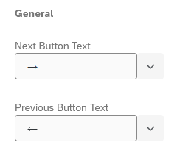  Default | 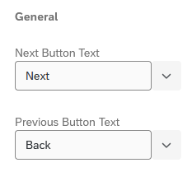  Customized
You can also change the next and previous buttons

14.1.3.2 Progress Bar
For accessibility, the progress bar displays at the bottom of the screen by default and should not be changed. See Section 4.2 for details.

14.2 Survey Options

14.2.1 Back button
Under Survey options > Responses, the first option is to add a back button.
Note that if your survey uses certain kinds of survey logic, the back button will not let participants go back past the logic.
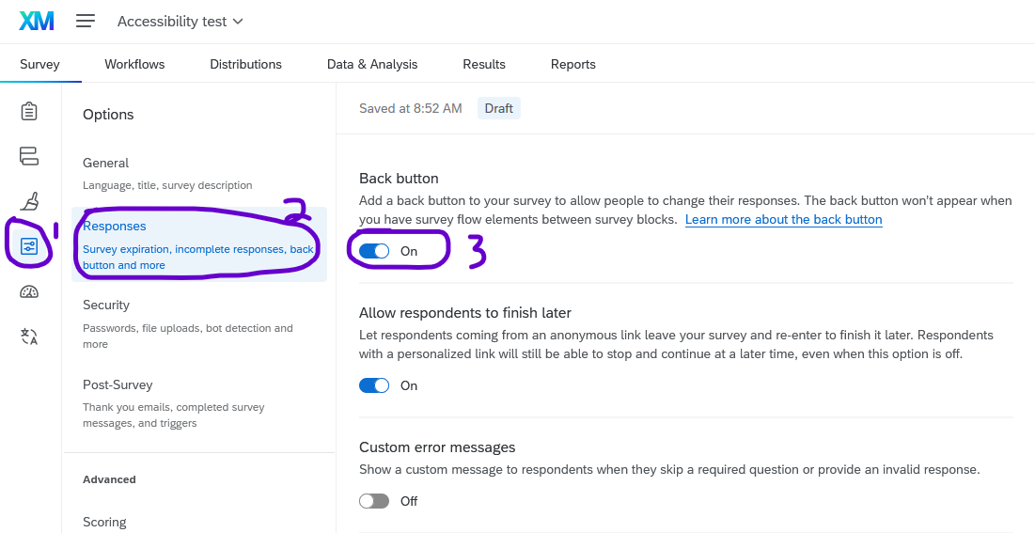
You can also customize the next or previous button for a specific block, which is recommended so that the last block says Submit.
To do so, click on the block, then click Next/Previous button text in the question editing pane.
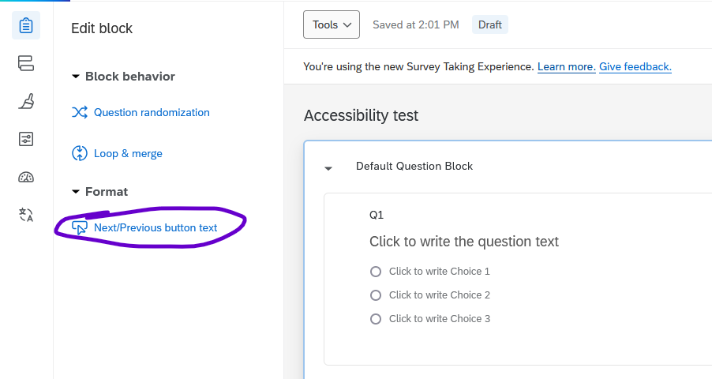

14.2.2 Incomplete survey responses
Also under Survey options > Responses, is what to do with incomplete survey responses (surveys that have been stated by not submitted). You may choose to “record” or “delete” incomplete survey responses and set how much time should pass before they’re considered incomplete (i.e., 24 hours, 1 week, 1 month, etc.). You may also choose which respondent activity determines when to start the timer: “survey start timer” or “last time they edited a response.” Finally, you can choose to automatically close the survey by turning this setting on, which collects/deletes any incomplete responses and closes survey access.
Note
You can change the settings for incomplete survey responses at any time, even with an active survey. However, be sure to publish your changes so they take effect.
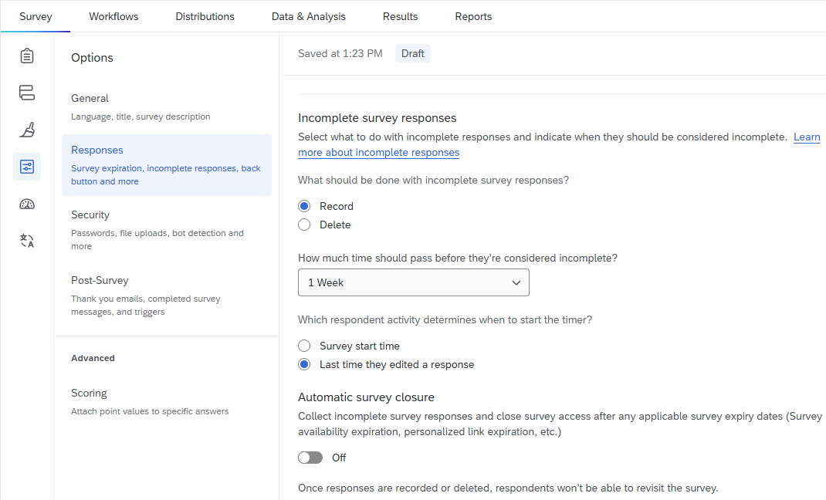

14.2.3 Anonymous vs. Confidential Responses
When surveys contain questions on sensitive topics, it is often necessary to guarantee survey takers that their responses will be anonymous or confidential. Here, “confidential” means that any personally identifying information is known only to the research team, whereas “anonymous” means it is impossible to tell who took the survey. In other words, confidentiality is implemented by the research team (and possible non-disclosure or IRB agreements), whereas anonymity is implemented in the survey itself.
For most projects, confidentiality is preferable because it allows researchers to present aggregate demographic information and run more advanced analyses on the data. Researchers can easily strip identifying information from the data before presenting their findings.
Anonymity is mostly reserved for extremely sensitive surveys, such as those dealing with illegal activities, where retaliation could be a concern. It is impossible to run certain analyses that track change over time (i.e., a repeated measures ANOVA) if no identifiers are included in the data.
To anonymize a survey, go to Survey options, click Security, and enable Anonymize responses. Please see the Qualtrics documentation on anonymizing responses for more information.
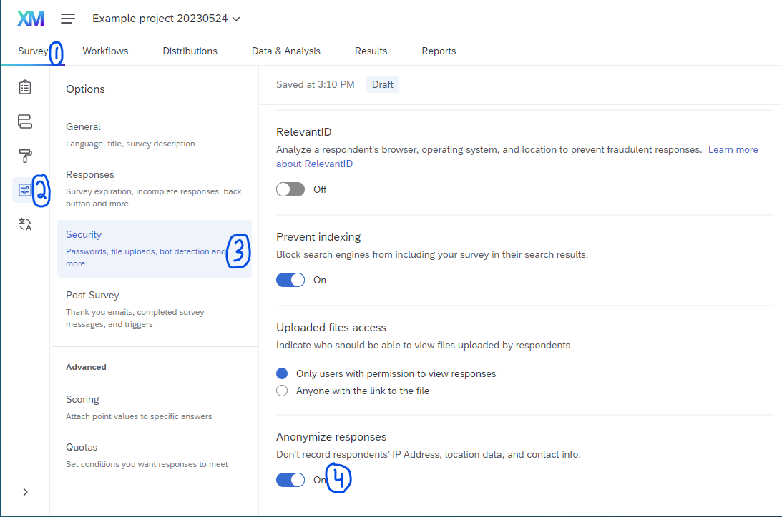

14.3 Translations
The Translations tab is mainly used for translating your survey, which lets speakers of multiple languages easily take the same survey. This tab is also used to indicate the language of a survey.

14.3.1 Set the Survey Language
By default, surveys created in Illinois Qualtrics are assumed to be in English. This language setting is encoded into the survey html and made visible to respondents’ web browsers.

14.3.1.1 How to set the survey language
To set the survey language:
- Go to the Translations tab.
- Under Base Language, select the correct language from the drop-down menu.
- The language will be saved automatically, but (as with all Qualtrics edits) the change will not be visible to respondents until the survey is (re)published.
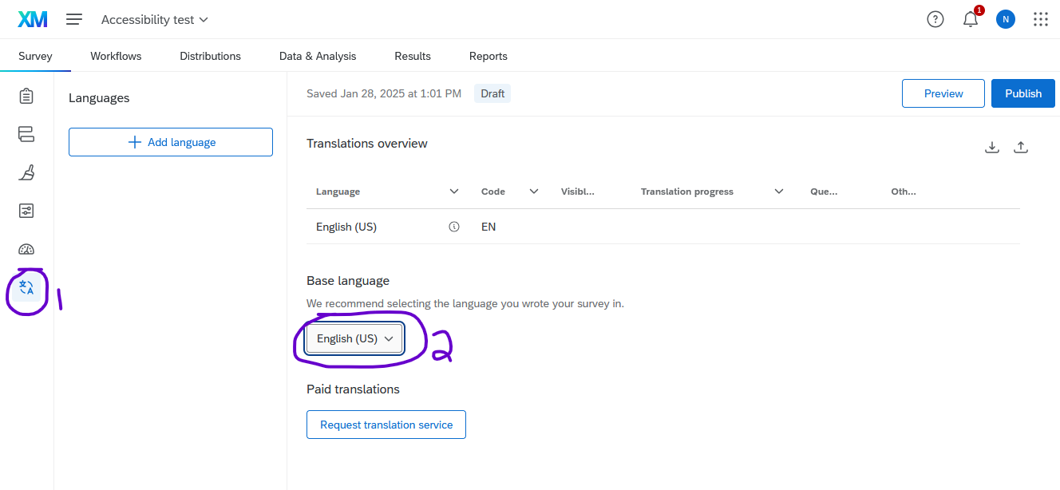

14.3.1.2 Importance of setting the survey language
If the survey language setting is different than the respondent’s device language, their browser may offer to auto-translate it, regardless of the language the questions were written in.
For example, if you write your survey questions in Spanish, but leave the survey language set to English, browsers may offer to auto-translate it.
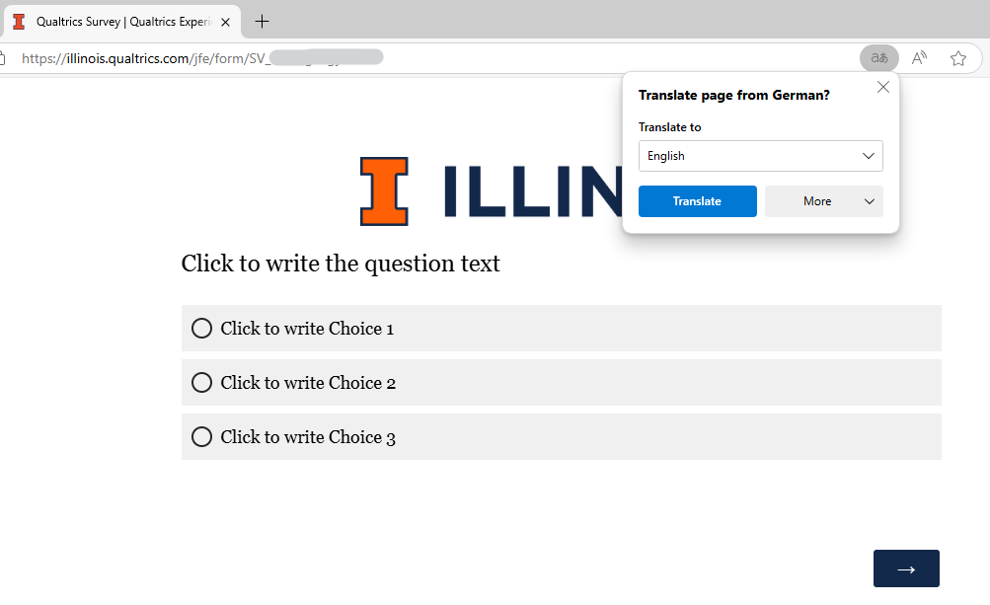
In this example, the survey language is set to German, but the question is in English. Because my device is set to English, the browser offered to translate the page.
Warning
If a survey is autotranslated, the question wording may be inaccurate. For best results, always set your survey language to the language of the questions, and use the Translations option below if you anticipate responses in multiple languages.

14.4 Translate a Survey
Qualtrics makes it easy to publish the same survey in multiple languages and to download the data in a clean format where everybody’s answers line up, regardless of the language they answered the question in. In your data, there will be a field called UserLanguage that will let you sort or filter by language to further analyze the responses.
To start, navigate to the Translations tab in the survey toolbar on the far left of the screen.
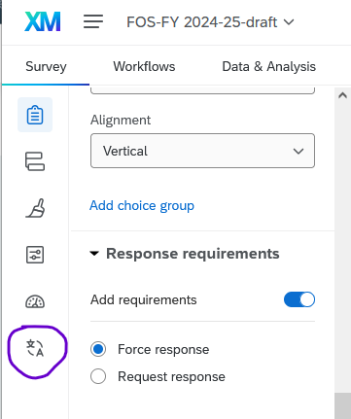
In the Translations tab, click Add language.
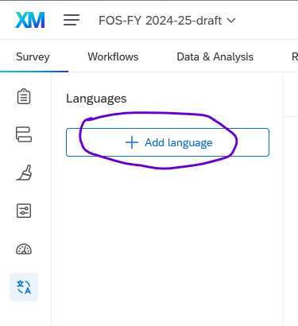
In the pop-up menu, select the correct language and click OK. For this example, we’ll use Spanish.
Warning
If you’re translating a survey into Spanish and would like to use Google Translate, be sure to select Spanish and NOT “Spanish (Latin America)”, regardless of which locality you intend to use in the translation. For some reason, the Google Translate plugin doesn’t currently recognize “Spanish (Latin America)” correctly.
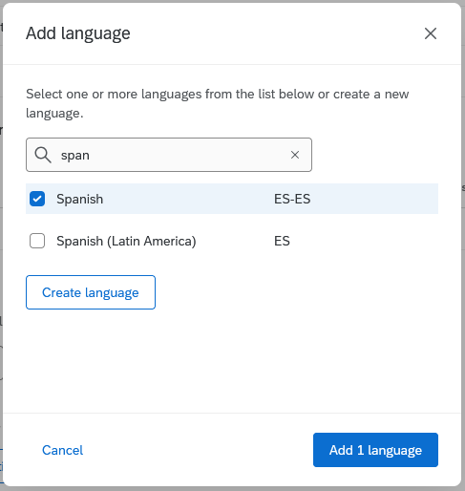
Then, in the sidebar, click the language to start adding translations to the questions and other parts of the survey.
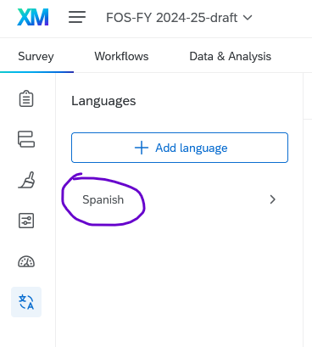
The window will now display your original survey questions on the left and let you enter the translations on the right.
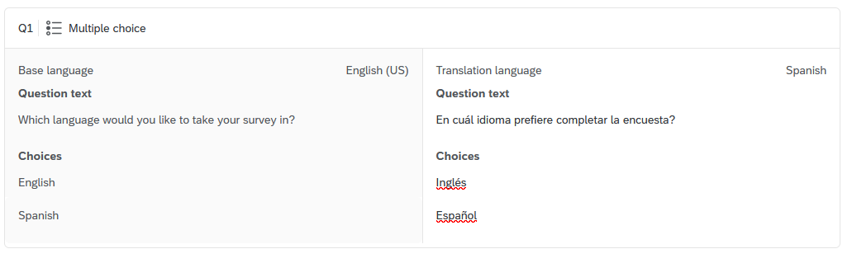
Changes are saved automatically. When you’re done, you can return to the survey editor.
When people take the survey, they’ll see a dropdown in the top right corner of the window that lets them switch languages.
If you’d like to include a question that asks people which language they’d like, and updates the survey language automatically, it’s possible but requires a bit of custom Javascript. See Section 16.5.1.

15. Workflows
Important
Workflows have replaced the older email trigger feature, as they have more options and are easier to debug when something goes wrong.
Workflows consist of a trigger and a task. When the trigger occurs, the task is performed automatically. Workflows offer a lot of flexibility, so this section will be a general introduction rather than an exhaustive list of everything that is possible.
For example
A common setup is that when someone responds to the survey (this is the trigger), the workflow sends them an email containing a summary of their responses (this is the task).
Common triggers:
- When someone responds to the survey
- At a set time (e.g., every Tuesday)
Nomenclature
The Qualtrics documentation on workflows uses the terminology “scheduled workflow” (e.g., every Tuesday) and “event-based workflow” (e.g., someone responds to the survey).
Common tasks:
- Send an email (to you or to the respondent)
- Update a contact list
- Populate an Excel or Google Sheet (may not be appropriate for sensitive data)
- Send a message in Microsoft Teams

15.1 Setting up Workflows
Workflows can be set up within a survey project by clicking the Workflows tab.
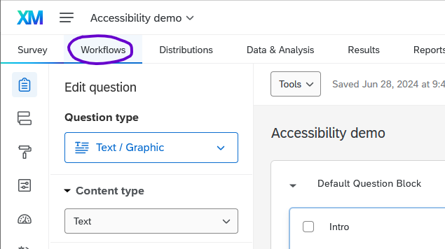
Note
It’s also possible to set up standalone workflows (i.e., that aren’t connected to any specific project). Standalone workflows are appropriate for scheduled events that are not tied to somebody responding to your survey.
If there are no existing workflows in the project, you will see text that reads “Welcome to workflows” and a button to create a new workflow. When you click the button, there is an option to browse existing templates or create a workflow from scratch.
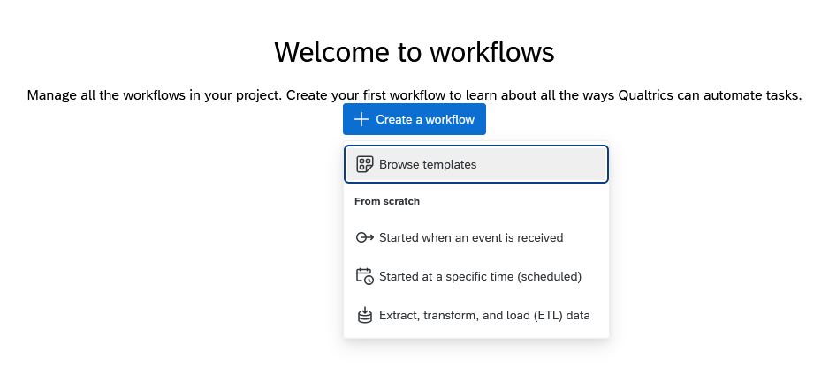
If you choose to use a template, you will see options that you can select, as well as the choice to create from scratch if none of the templates meet your needs.
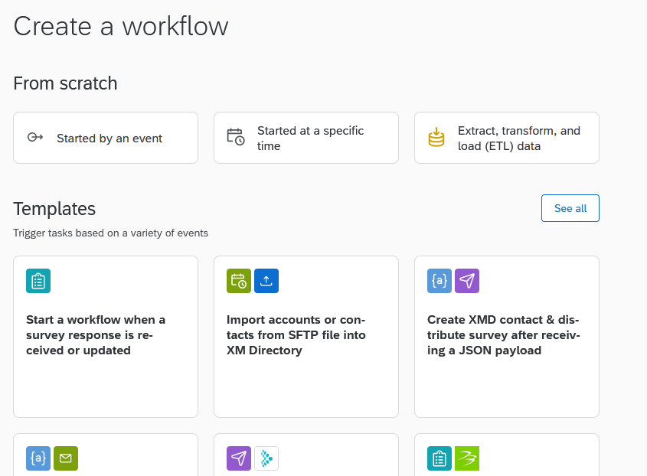
After deciding, you’ll see a screen (somewhat similar to the survey flow screen) where all elements of the workflow will be listed. When the workflow runs, it will start at the top and proceed sequentially through all elements.
The first element of the workflow is the trigger. (In this example, “Survey response” is the trigger.)
Below the trigger, you can add other elements, including tasks that should run when that trigger occurs, and conditions that filter when/how the tasks occur. Press the ‘+’ button to add an element to the workflow.
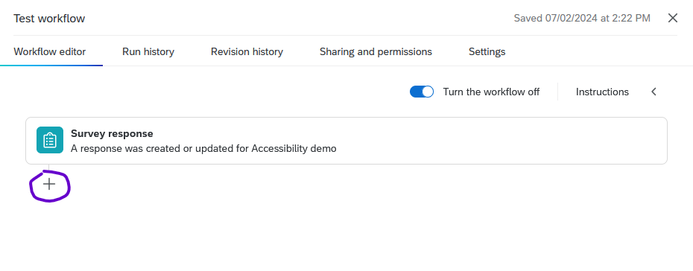
Then, choose whether to add a task or a condition.
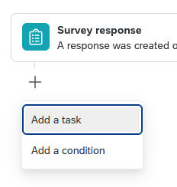

15.1.1 Conditions
Conditions are similar to branch logic in the survey flow. You can use embedded data, responses, questions, and other data from the survey response in your conditions.
For example, you could write a survey question that asks respondents whether they want to be sent some pdf resources. Then in workflows, you could use conditions to select only those respondents who said yes, and send those people an email with the resources.
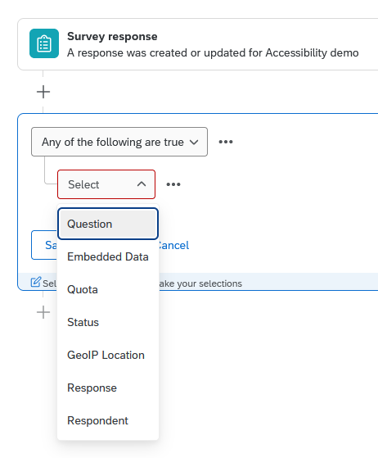
Note
For more details, see the Qualtrics documentation on conditions.

15.1.2 Tasks
There are many kinds of tasks available; the most common is to send an email. When you add a task, pick the option from the menu that appears. You can use the search bar to narrow down the choices.
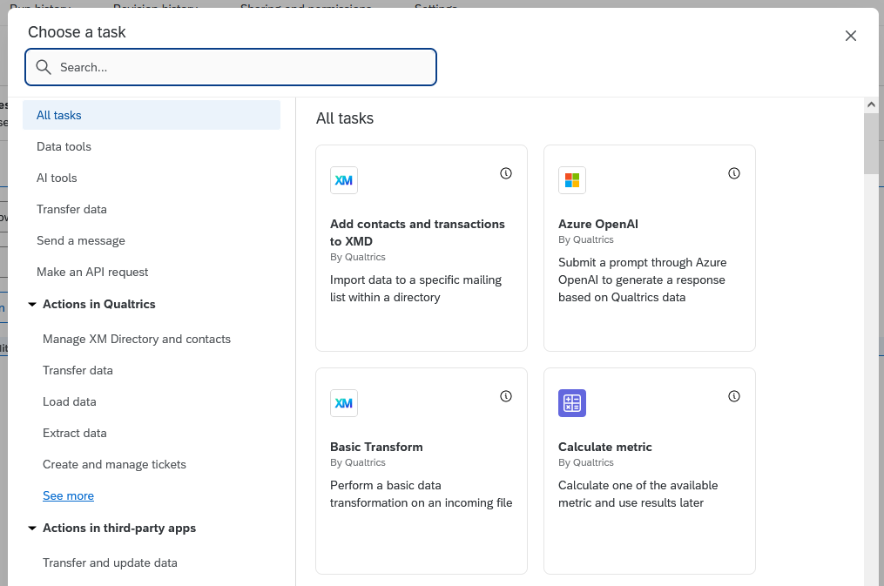
After selecting a task, specify the options that you would like. For example, with an email task you will need to specify the recipient, sender, and message text. In these fields, you can use piped text (see Section 16.1) to insert the respondent’s email address, name, or other information such as a summary of their survey responses. You can change the “from” email address to be from “qualtrics-research.com” or “qualtrics-survey.com”. An example is shown below.
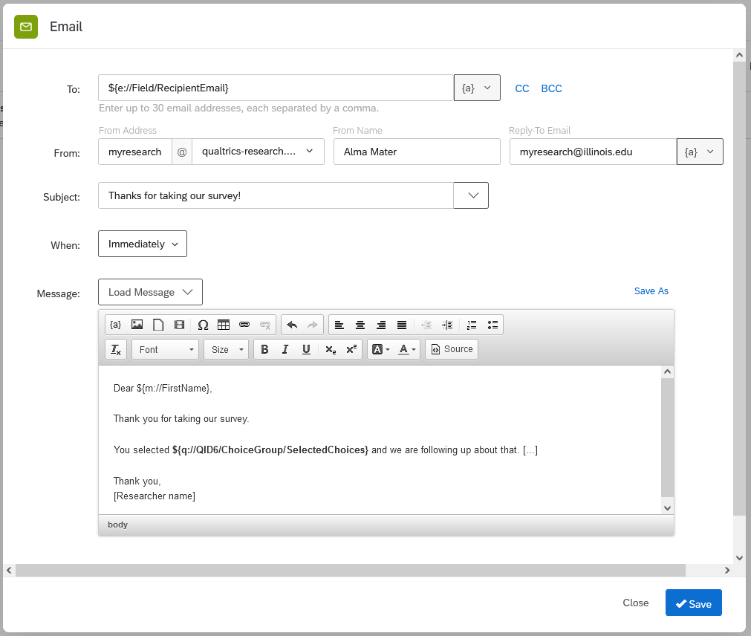
Tip
You can add more than one task to a single workflow. For example, you could send one email to respondents and a separate email to yourself.

Note
For more details, please see the Qualtrics documentation on workflow tasks in general or email tasks specifically.

15.2 Troubleshooting Workflows
Workflows include Run history and Revision history tabs that show edits to your workflows, when those workflows ran, and if any errors occurred. Note that this data only includes runs and revisions in the last 30 days.
For more details, see the Qualtrics documentation on Run and Revision History.

15.3 Use Cases
Beyond the basics of workflows, there are many things you can do. Here are some examples:
- If the same students submit the same feedback form every week, you can use a workflow to calculate their average scores on certain questions (i.e., number of clients seen, number of projects finished, etc.) and send them an email that contains their average alongside responses to select questions.
- You can set a workflow to notify you in Teams every time someone registers for an event or workshop.

16. Advanced Survey Building

16.1 Piped Text
Piped text lets you use text from one part of your survey elsewhere. It functions kind of like an instruction to Qualtrics to copy and paste the text (or, for those with some programming experience, it’s a way of storing and printing text variables.)
This section will mainly discuss using piped text inside a survey question, but the same procedure applies if you use piped text in the survey flow (Chapter 3), embedded data (Section 16.3), display logic (Section 2.5.1), or elsewhere. For more details, see the Qualtrics documentation on piped text.
In this example, let’s use a set of two questions. The first asks, “Which video game is your favorite?” and the second asks why they prefer that game.
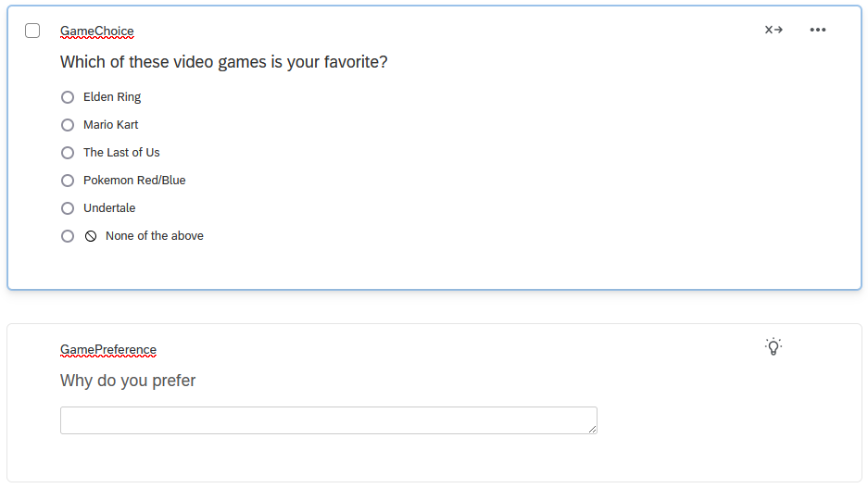
We can use piped text to personalize the follow-up question, so that it says (for example) “Why do you prefer Mario Kart?” rather than a generic “Please explain why that game is your favorite.”
To add piped text to the question, click the text of the question and then select the **Piped Text” button that appears.
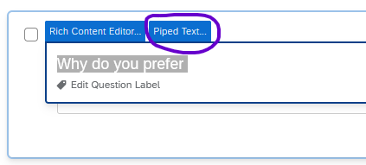
In the piped text menu, select the source where the text comes from. In this case, we want to pipe in their response to the previous survey question, so select Survey Question > GameChoice (the name of the question) > Selected Choices.
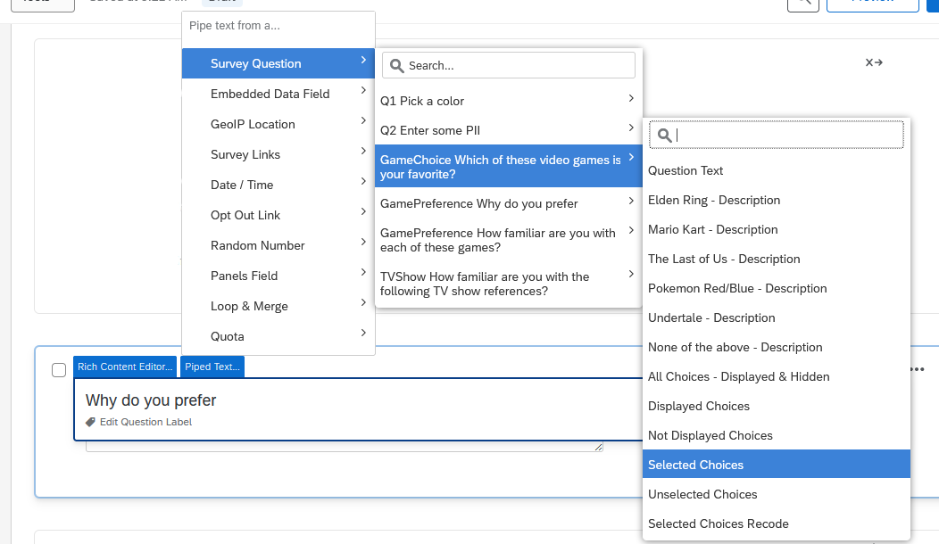
When you add piped text, it will appear as a line of code, prefaced by a dollar sign ($) and enclosed in curly brackets { }. You can edit the text before or after the code, such as by adding a question mark at the end, just be sure not to change the code itself if you want it to work properly.
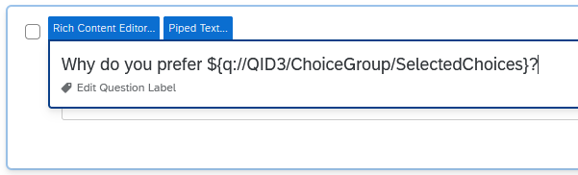
Finally, while it’s not part of piped text itself, you may want to add display logic or skip logic (Section 2.5) to the question so that it’s not displayed to people who answered “None of the above” in the previous question.
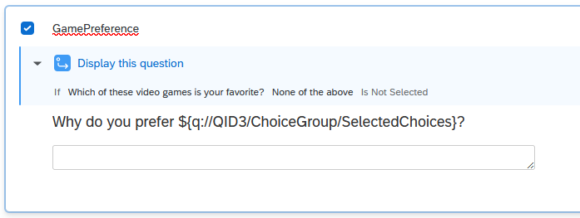
When someone takes the survey, the piped text code is replaced with the correct text. You can double-check this behavior by previewing the survey.
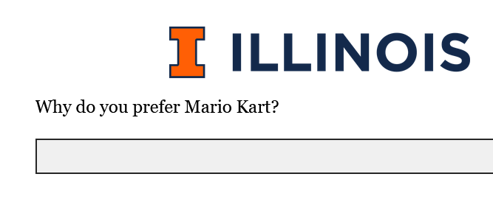
Note
Note that piped text doesn’t work correctly with display logic if the display logic is set up “in page.”

16.2 Carry Forward Choices
Carry Forward Choices allows you to pipe specific answer choices into future questions so that respondents only see options that apply to them. Depending on the type of question, values can be carried forward as choices, statements, or scale points. Additional answer choices can also be provided in questions that feature carried forward choices.
To implement Carry Forward Choices, select the question into which the choices should be carried and choose Carry forward choices from the “Question behavior” section of the “Edit Question” menu.
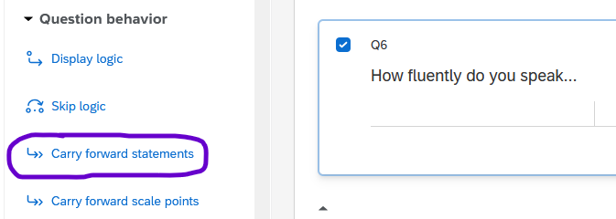
Note
For matrix questions, the text may say “Carry forward statements” (instead of “choices”).
Then select the question the choices should be carried forward from and the choices that should be carried forward. Usually, you will want Selected Choices, but you can select other options depending on your needs.
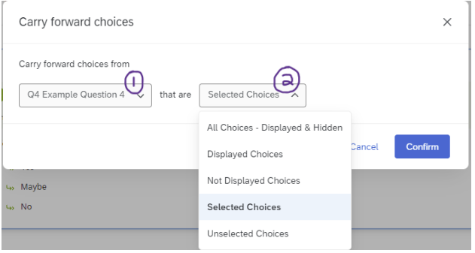
If implemented correctly, a flag will then appear on the target question indicating that carry forward choices is in use, which question the choices are being carried forward from, and which choices are being carried forward. When taking the survey, respondents should now only see the relevant options based on their responses to the trigger question.
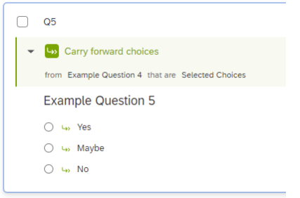
If desired, you can also add additional non-carried-forward response options to the target question in addition to the carried-forward options by increasing the number of choices in the Choices menu from 0 and then manually adding the additional options.
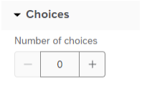
The carried forward choices will be marked with a green arrow, while the manual additions will be marked with a black circle with line across it.
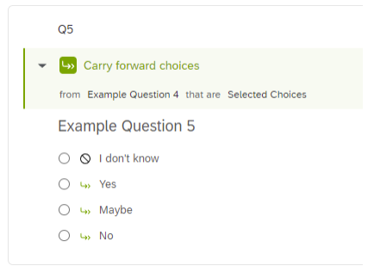
Respondents will now see both the selected response from the previous question (“No” in the example below) and the manually added option.
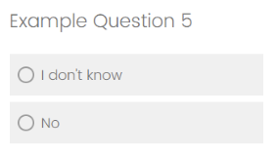
Note
For additional details, see the Qualtrics documentation on Carry Forward Choices.

16.3 Embedded Data
Embedding data allows you to record information about your survey respondents, which you can then use inside the survey and/or when you analyze the results. For example, if you upload a contact list that contains students’ names and majors, you can embed their major into the survey, which would let you personalize questions (i.e, “How well do you like [your major]?” and auto-fill their major), ask specific questions to certain groups (i.e., “Which instrument do you play” is only shown to music majors), as well as have their majors listed in the survey results.
To add embedded data to a survey, go to the survey flow (see Chapter 3), add a new element, and choose Embedded data.
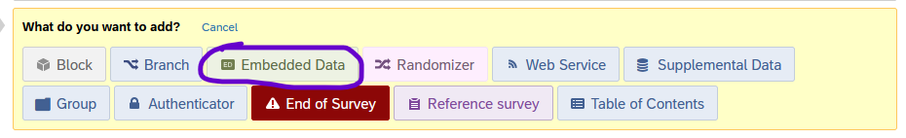
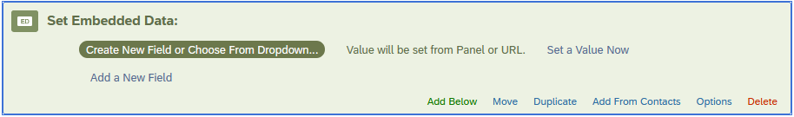
In the embedded data element, name the embedded data on the left, then determine what data should be included (the “value”) on the right.
- For query strings (see below), leave the “value” to the default that says “Value will be set from panel or URL.”
- For most other uses, click Set a value now.
  - Most often, you’ll use the dropdown menu and insert piped text (see Section 16.1 above). In this context, piped text can insert random numbers, today’s date, etc. as well as the normal options to insert responses to survey questions.
  - If you’re working with a more involved survey flow, you might branch participants who meet certain criteria and set a value manually for their embedded data.
Example of embedded data, where the variable “Univ” is set to “ILLINOIS”
Once you’ve set embedded data, it can be used in branch logic, piped text, display logic, and other places throughout your survey.
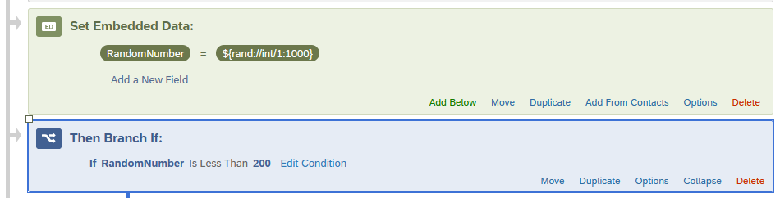
Example where the variable “RandomNumber” is set to a random number between 1 and 1000, followed by a branch that branches if RandomNumber is less than 200.
When you look at the survey responses (in the Data & Analysis tab, by downloading the file, etc.), the embedded data will show up next to the respondents’ answers.
To use embedded data in visualizations in Qualtrics Reports, they must be set as “Text Set” in the options.
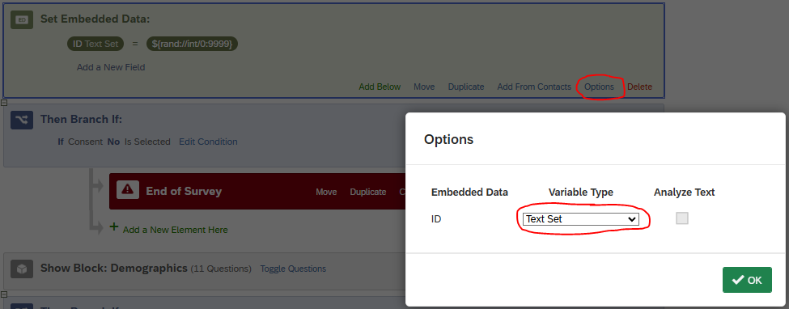
Example where the variable “ID” is set to a random number between 1 and 9999 and Variable Type is Set to “Text Set”

16.3.1 Query Strings
Query strings are a way of embedding data based on the URL that somebody used to take the survey. For example, you could generate an anonymous link to take your survey, and use a query string to record whether participants found it through Facebook, Instagram, or TikTok.
There are two steps to set up a query string.
First, add an embedded data element using the instructions above. Leave the value blank so it will be set “by panel or URL.” Move the embedded data to the top of the survey flow so it will be recorded before respondents start the survey.
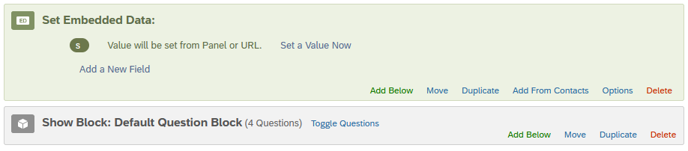
Example where “s” is embedded data that will be set “from panel or URL”
Tip
The embedded data field will be visible in the URL bar when respondents take the survey, and savvy respondents are able to delete it. So, consider short and innocuous names and values for your query string, such as “s” for “source” or “o” for “organization.”
Second, you’ll need to create the URLs that contain the embedded data.
Start by generating an anonymous URL. (It will look something like: https://illinois.qualtrics.com/jfe/form/SV_something-or-other/)
In a text editor, make a list of the different values you’d like your query string to take. For example, if you want to track social media platforms, list out Facebook, Instagram, and TikTok (as well as any others you may need). Consider using Notepad, TextEdit, or Excel – Word works but isn’t ideal because of how it tries to format the links for you.
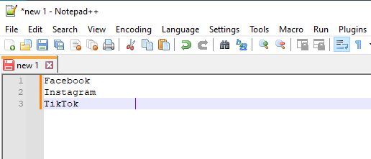
Copy and paste the anonymous link into the text editor.
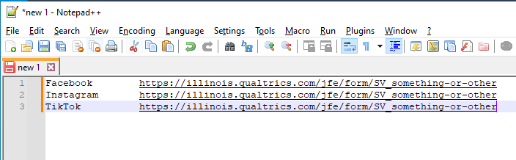
At the end of each URL, add the following pieces in order:
- a question mark (?)
- the name of your query string (s in this example)
- an equals sign (=)
- the value you would like to be stored in the data set.
  - In this example, I’m using f for Facebook, i for Instagram, and t for TikTok.
  - You can use numbers, letters, or entire words, but avoid spaces and punctuation.
Altogether, it should look something like this: ?s=f When it’s appended to the end of the URL, it should look approximately like this: https://illinois.qualtrics.com/jfe/form/SV_something-or-other/?s=f
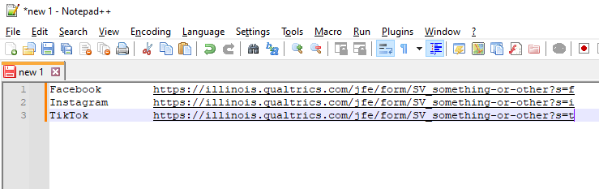
Remember to SAVE this file so that (a) you can distribute the URLs to people and (b) you can make sense of the query strings when they appear alongside the responses.
Multiple query strings
To add multiple query strings to a URL, separate them with an ampersand (&).
For example, I could embed year, semester, and course using the following: ?y=2024&sem=FA&crs=LAS100 which would set year (y) to 2024, semester (sem) to Fall (FA), and course (crs) to LAS100.

16.4 Dates
By default, survey responses record a Start date, End date, and Recorded date that are properly formatted, so it is easy to see when people started and finished taking the survey. However, it’s also possible to include date entry questions in a survey.
Below, we describe two relatively easy ways to add date questions. However, other methods exist, and are described in detail in Chapter 18.
Warning
If you download survey responses and re-upload them into Qualtrics, the Recorded date will be set to the day you re-uploaded them. (This also applies if a survey was migrated from another Qualtrics account.)

16.4.1 Text Entry Question with Validation (Easiest)
The simplest way to obtain a date is for respondents to type it in.
As outlined in the image below, you can create a text entry question, then add validation by content type, then select the appropriate “Date format” option (e.g., mm/dd/yyyy, dd/mm/yyyy, or yyyy/mm/dd).
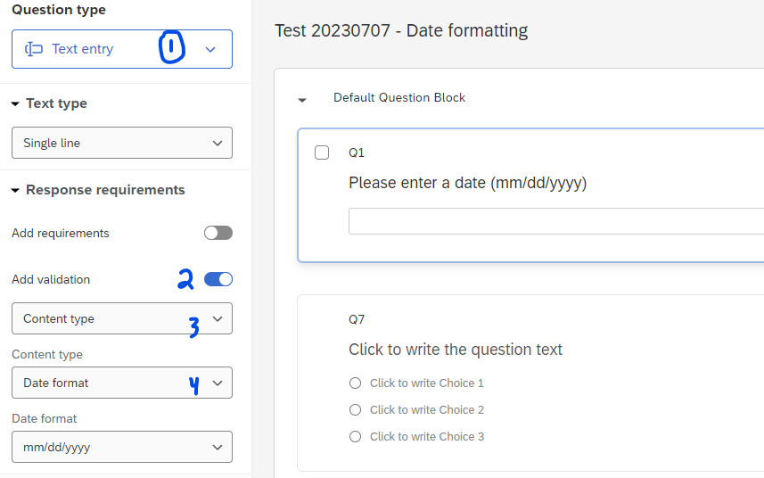
This method requires respondents to enter leading zeroes (e.g., 01/01/2020 instead of 1/1/2020) and prevents invalid dates (e.g., February 30th).

16.4.2 Text Entry Question with JavaScript
After creating a text entry question, instead of adding validation, you can choose to add a JavaScript element that will provide the “mm/dd/yyyy” template as well as a clickable date picker.
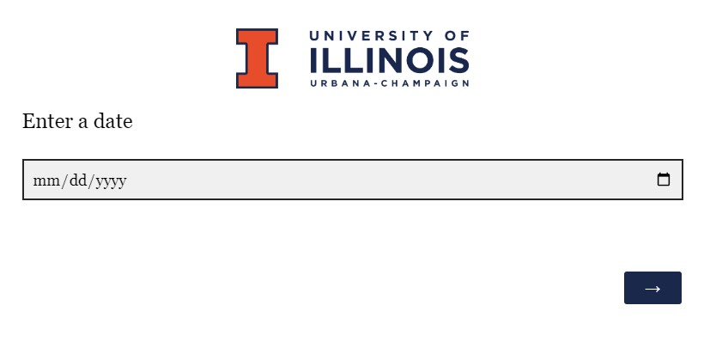
When clicked, the date picker displays a small popup calendar.
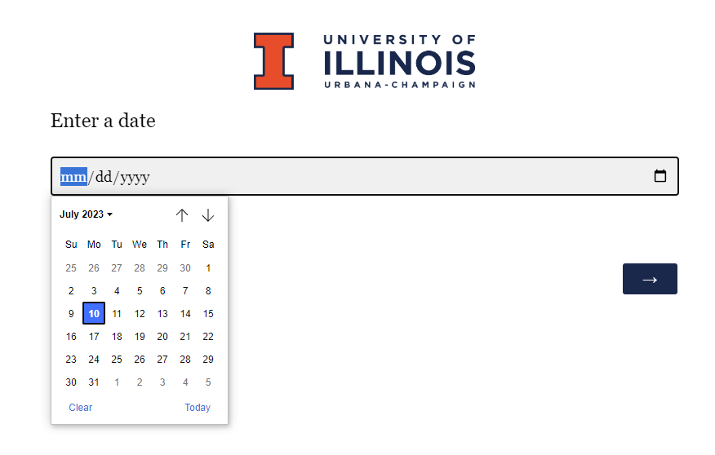
To add the JavaScript, select the question, and in the “Edit Question” pane, scroll all the way down to the “Question Behavior” section and click “JavaScript.”
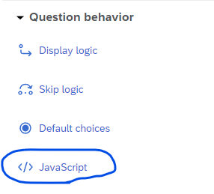
The pop-up window will contain 3 small chunks of code. Replace the first chunk of code with the following:
Qualtrics.SurveyEngine.addOnload(function() {
var textInputs = this.questionContainer.querySelectorAll('input[type="text"]');
if (typeof textInputs[0] !== 'undefined') {
textInputs[0].type = 'date';
}
});
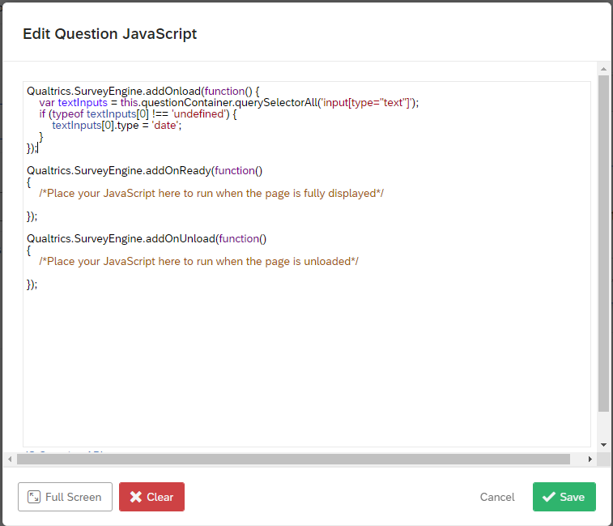
Then click “Save.”
JavaScript code comes from Curt Grimes on StackOverflow
Warning
Adding the JavaScript does not in itself validate dates, and it also complicates the formatting used by the date validator. So, we recommend picking validation or JavaScript. If you need both, see Chapter 18.

16.5 Custom JavaScript
It’s possible to add JavaScript into Qualtrics questions to add functionality that isn’t originally present. While some CITL consultants may have JavaScript experience, it’s not one of our core consulting services, so some requests may fall outside our ability to help.
In Qualtrics, Javascript functions fall into three main categories: those that run when the page loads (addOnload), those that run when the page is fully displayed (addOnReady), and those that run when the page is unloaded (addOnUnload). When you edit a question’s Javascript, you’ll generally write (or copy-paste) the code into the appropriate section of the editor, leaving the other two sections untouched.
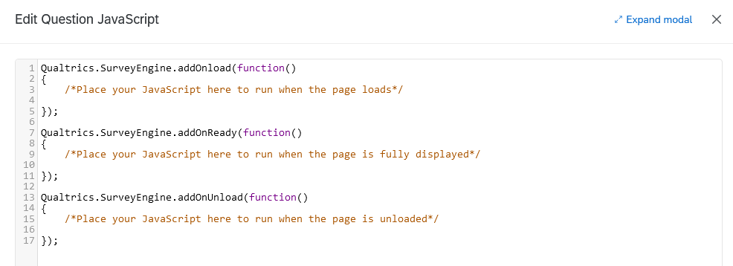
Though it’s not practical to keep a record of everything that JavaScript can do in Qualtrics surveys, this section contains some short code snippets to do common tasks. Those with coding experience can check out the Qualtrics JavaScript API details for further implementation details.
Note
For custom dates, see Section 16.4.

16.5.1 Language selection question
To make it easy for people to change the survey language, it’s possible to add Javascript to the language selection question to automatically update the survey language based on their response.
To do so, first create a question that asks them to choose a language.
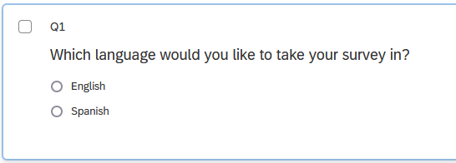
Use the following, changing ES-ES to the correct abbreviation for the language you’re using (as specified in the Translations tab; see Section 14.3).
Qualtrics.SurveyEngine.addOnReady(function()
{
/*Place your JavaScript here to run when the page is fully displayed*/
this.questionclick = function(event,element){
if (element.type == 'radio')
{
var choiceNum = element.id.split('~')[2];
if(choiceNum==1)
{
jQuery("select[id='Q_lang']").val('EN');
}
if(choiceNum==2)
{
jQuery("select[id='Q_lang']").val('ES-ES');
}
jQuery("select[id='Q_lang']").trigger( "change" );
}
}
});
If you have more than two language choices, edit the code accordingly (possibly with the help of ChatGPT or a programmer friend).
You can also optionally hide the drop-down menu that lets survey respondents choose their language using the following code:
Qualtrics.SurveyEngine.addOnload(function()
{
/*Place your JavaScript here to run when the page loads*/
jQuery(".LanguageSelectorContainer").hide();
});
As always, remember to test your changes before publishing the survey.

16.5.2 Click up/down
If you have a number entry question and want respondents to be able to click to increment the number, you can add buttons to the right of the entry field.
For a Text Entry question, use this:
Qualtrics.SurveyEngine.addOnload(function()
{
var q = document.getElementById("QR~"+this.questionId);
q.type = 'number';
q.min = 0;
q.max = 100;
});
(You can adjust min and max as desired.)
Source: Qualtrics Community post by ElieD
For a Constant Sum or Form Field question, use this:
Qualtrics.SurveyEngine.addOnReady(function()
{
var that = this.questionId;
jQuery("#"+this.questionId+" .InputText").attr({"type":"number","min":"0"});
});
Source: Adapted from a Qualtrics Community post by Shashi/Anonymous

16.5.3 Conditional looping
It’s possible to set up a block to loop a variable number of times, for example, if you ask respondents to report on incidents where a power line failed or happy memories of childhood, and you anticipate that partway through one iteration of the loop they may think of another incident.
- Set up Loop & Merge for the appropriate block. In the ‘field’ column, insert any text you would like to pipe into the questions (i.e., “first”, “second” etc. for “describe the n-th incident”), making sure to include as many iterations as you think want to permit. (i.e., if you want to allow up to 5 incidents, make sure the ‘field’ column has 5 rows.)
- In the Survey Flow, above the block that will be looped, set Embedded Data. Call the field EndLoop and set it equal to 1.
- For all questions in the block, add display logic (see Section 2.5.1) so that the question only displays if EndLoop is equal to 1.
- The final question in the block should be something like, “Do you want to report another incident?”
- Add the following JavaScript to that question. (Note that if you named your variable something other than EndLoop in step 2, you should replace it below with the appropriate variable name.)
Qualtrics.SurveyEngine.addOnload(function ()
{
this.questionclick = function(event,element)
{
console.log(event,element);
if (element.type == 'radio')
{
var choiceNum = element.id.split('~')[2];
if (choiceNum == 2)
{
Qualtrics.SurveyEngine.setEmbeddedData("EndLoop", choiceNum);
}
}
}
});

17. Troubleshooting
This section is a sort of catch-all section, a first-response guide to solve problems as they occur. To find results faster, we recommend using the navigation sidebars and the search feature.

17.1 Copying a Survey
If you’re trying to copy a survey project, you may get an error that says, “You currently don’t have permission to use this question type. Please contact your account administrator for upgrade options.” The most likely cause for this error is that Graphic Slider questions have been disabled by default for everyone at the university because they are not accessible to blind users. (They can be re-enabled on a case-by-case basis, especially for researchers working with sighted but non-literate participants.) To solve the issue, either delete the graphic slider question(s) or change them to another question type (i.e., slider or multiple choice). If you have a very long survey and would like help finding the affected question(s), please contact CITL Data Analytics and we will be happy to help.

17.2 Emails

17.2.1 Unexpected emails
If you set up email notifications from Qualtrics (for example, to notify you every week about X or Y), depending on how you set it up, the setting to remove it could be under Chapter 15 (Workflows) or Reports or the deprecated Email Triggers feature (see Qualtrics documentation on email triggers]).

17.2.2 Cross-brand email distributions
If you are getting an error when trying to distribute a survey via email, and you have collaborated the survey with someone outside UIUC, please see Section 13.2.1 or the Qualtrics documentation on collaboration.

17.3 Downloading survey responses

17.3.1 Numeric versions of answer choices are out of order
It’s possible to survey data and find that the text of answer choices doesn’t match the numeric options.
For example:
Example of mismatched answer choices
Text | Numeric recode
Not at all | 2
A little | 1
Somewhat | 5
Very much | 7
Completely | 3

In this case, you may have forgotten to recode the values of that question; see Section 2.4.3.

17.3.2 Question numbers are out of order
Often, the question numbers get out of order as you create, edit, and delete survey questions. We recommend replacing them with meaningful variable names; see Section 2.3.1.

17.3.3 Non-English characters (i.e., ñ, é, etc.)
If you download your survey data and the text gets garbled (i.e., español is rendered as espaÃ±ol), the problem is a combination of how Qualtrics and Excel handle data.
The short answer is to download the data in a different format, such as .tsv or .xlsx, instead of .csv. You can do this by choosing the correct format in the Export data pop-up window.
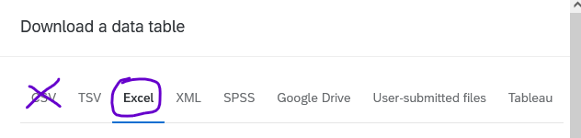

17.3.4 HTTP header error
If you’re trying to download a .csv of your survey data and get an error saying HTTP header exceeds the configured limit of 8192 characters, then delete your browser cookies and try again. It’s a browser error, not a Qualtrics error.
If the numbers corresponding to text options don’t match up how you think they should (for example, a multiple choice question downloads as 1 = Not at all, 7 = Not very much, 4 = A moderate amount, 2 = A lot, etc.) it is likely that you don’t have Recode values enabled. See Section 2.4.3.

18. Date Formatting
In Qualtrics, there are multiple ways to ask respondents to enter a date. Some perform much better than others, but none are thoroughly explained in the official Qualtrics documentation. We offer various suggestions below that are relatively easy to implement and will export usable data.

18.1 Text Entry Question with Validation (Easiest)
The simplest way to obtain a date is for respondents to type it in.
As outlined in the image below, you can create a text entry question, then add validation by content type, then select the appropriate “Date format” option (e.g., mm/dd/yyyy, dd/mm/yyyy, or yyyy/mm/dd).
This method lets respondents enter any valid date between 01/01/1000 and 12/31/2999. It requires leading zeroes (e.g., 01/01/2020 instead of 1/1/2020) and prevents typing invalid dates (e.g., February 30th). It allows “/”, “-”, or “.” as the separator, but most respondents will use “/” if it is suggested in the text of the question.

18.2 Text Entry Question with JavaScript
After creating a text entry question, you can add a JavaScript element that will provide the “mm/dd/yyyy” template as well as a clickable date picker.
When clicked, the date picker displays a small popup calendar.
To add the JavaScript, select the question, and in the “Edit Question” pane, scroll all the way down to the “Question Behavior” section and click “JavaScript.”
The pop-up window will contain 3 small chunks of code. Replace the first chunk of code with the following:
Qualtrics.SurveyEngine.addOnload(function() {
var textInputs = this.questionContainer.querySelectorAll('input[type="text"]');
if (typeof textInputs[0] !== 'undefined') {
textInputs[0].type = 'date';
}
});
Then click “Save.”
JavaScript code comes from Curt Grimes on StackOverflow
Note on validation
Adding the JavaScript does not validate dates, so respondents could choose to enter “01/01/0001” or “02/30/111111”. If you anticipate this being a problem with your respondents, you can add the validation described above in addition to the Javascript, but if you do so, you must change the date format to “yyyy/mm/dd”. This is because the JavaScript converts all dates to the “yyyy-mm-dd” format behind the scenes, so respondents will not be able to answer the question or finish the survey if another validation format is selected. Moreover, once the correct options are selected, it can still be confusing for a respondent who types “12/31/2015” and sees the error message, “Please enter a valid date of the form yyyy/mm/dd”, though this should seldom occur in normal usage.

18.3 Text Entry Question with HTML
There are two ways to create a question with HTML code dates:
- Follow the instructions under Qualtrics Question Templates below to insert a preformatted question.
- Alternatively, create a text entry question, click “HTML View,” and copy-paste this code from the Brown University OIT website.
In our testing, the question will include a clickable calendar, but the calendar will break if you try to edit the question text outside of HTML View.
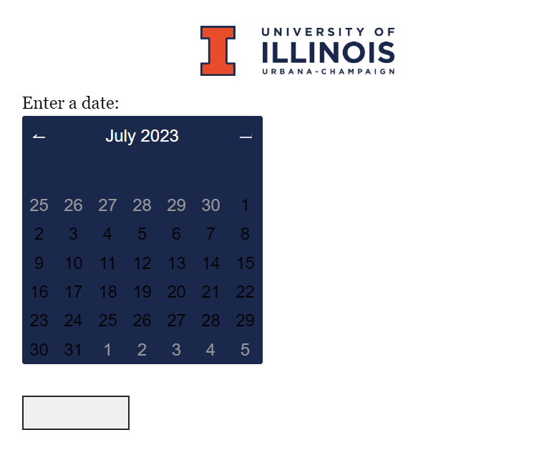
This is because the calendar is stored in the HTML code, which is only visible by clicking the question text and choosing “HTML View.” In HTML view, you can edit the question text (highlighted yellow below), but if you edit the question text in the normal view, it will overwrite all the HTML code and remove the calendar.
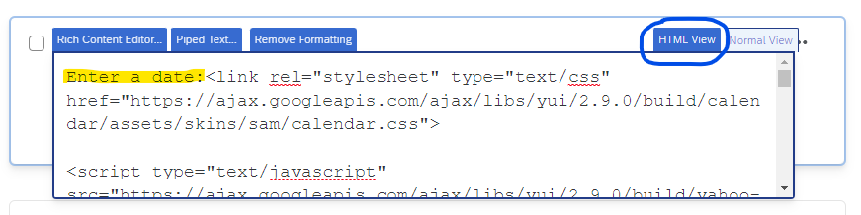 This method will auto-populate the text entry box with a date in the format “dd-mm-yyyy”, so it can be used with the content validation options described above if you so choose.

18.4 Qualtrics Question Templates (results may vary)
Qualtrics includes 3 pre-formatted date questions, which can be accessed by choosing “Import from Library” in the survey builder.
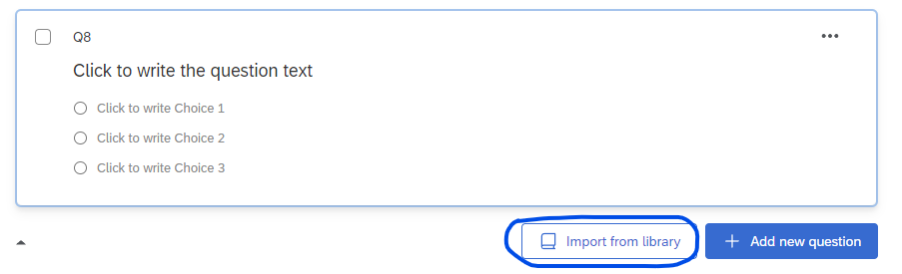
In the pop-up window, choose “Demographics” under the Qualtrics Library.
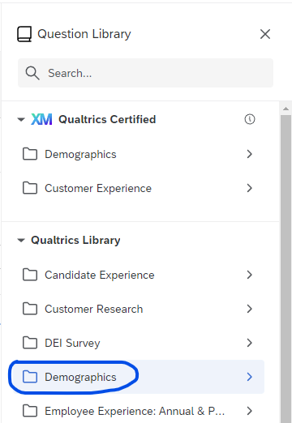
Then choose “Calendar & Date Questions.”
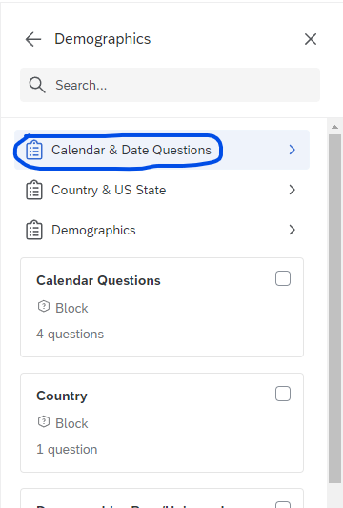
Choose one of the three options.
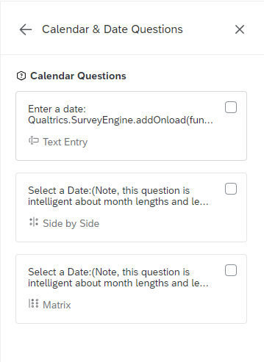
The Side-by-side and Matrix date question templates default to including all years from 1900 to 2049 in their drop-down menus, though this can be configured by entering the Javascript editor. Unlike the clickable calendar, you can edit the question text of these question templates without losing the functionality.
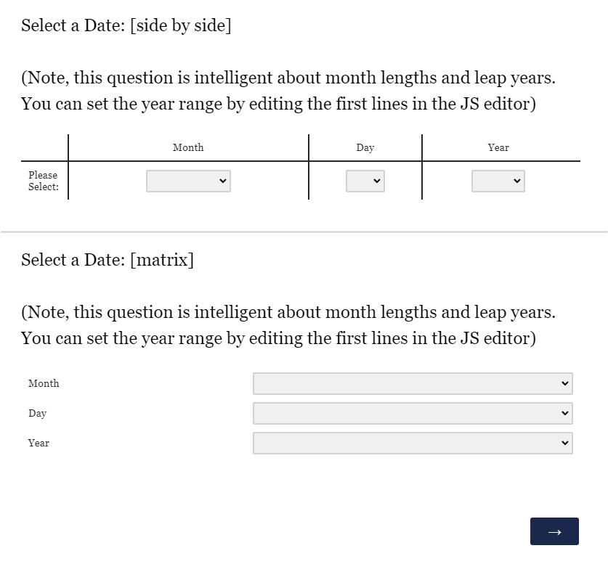
We do not recommend the Side-by-side or Matrix templates, however, because in the dataset they will place month, day, and year into separate columns, which hinders efforts to sort or graph results by date. These columns cannot be combined without exporting the survey data.
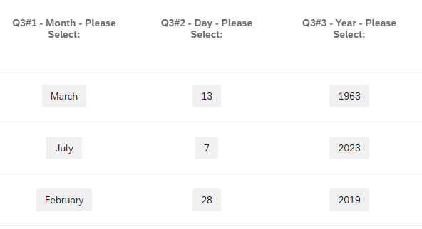
Important
If you choose the “Calendar Questions” block instead of “Calendar & Date Questions,” there will be a fourth option, which is a drill-down question. The drill down question is not recommended because it does not export well. For example, in SPSS, months are labelled correctly but the values show no discernible pattern, e.g. “1 = January, 2389 = February, 4623 = March” etc.

18.5 Exporting Date Data

18.5.1 Data Types
A Text Entry Question with Validation will record any valid date between 01/01/1000 and 12/31/2999 that uses “/”, “-”, or “.” as the separator, and can be configured to specify mm/dd/yyyy, dd/mm/yyyy, or yyyy/mm/dd format.
A question using the suggested JavaScript code will record dates in the format “yyyy-mm-dd”.
Qualtrics’ suggested Matrix and Side-by-Side questions will record month, day, and year in separate columns.

18.5.2 Excel
Dates using “/” or “-” as the separator will export correctly to Excel, and dates after Jan 1, 1900 will be automatically recognized by Excel as dates.

18.5.3 SPSS
Dates will export as a string variable to SPSS, but can be easily fixed by opening a syntax editor and calling alter type VARNAME (adate10). (This command will automatically interpret the separators “/”, “-”, and “.”)
Note: If the data is in mm/dd/yyyy format, use adate10. If it is in yyyy/mm/dd format, use sdate10, and if it is in dd/mm/yyyy format, use edate10.

18.5.4 R
In R, you can import the dates normally as a .csv file, though importing a .xlsx or .sav file may be easier. If you choose to use .csv and find that respondents used different separators, they can be converted to a single separator using stringr::str_replace_all(VARNAME, '[:punct:]', '/') which will replace all punctuation in the variable with “/”, which can then be parsed into a date using as.Date() or readr::parse_date().

19. Survey Research Literature
This page provides references in readings for survey research. This page is continually being revised and updated to reflect new resources. Do you have suggestions for readings we should add to this page? Send us an email with your suggestions and a link to this page!
Quicklinks:
- Introduction to Survey Research
- Data Collection Literature
- Sample Design and Selection Literature
- Questionnaire Development and Layout Literature
- Data Collection and Processing Literature
- Data Analysis Literature

20. Introduction to Survey Research Literature
Krosnick, Jon A. 1999. “Survey Research.” Annual Review of Psychology. 50:537-567.
AUTHOR ABSTRACT
For the first time in decades, conventional wisdom about survey methodology is being challenged on many fronts. The insights gained can not only help psychologists do their research better but also provide useful insights into the basics of social interaction and cognition. This chapter reviews some of the many recent advances in the literature, including the following: New findings challenge a long-standing prejudice against studies with low response rates; innovative techniques for pretesting questionnaires offer opportunities for improving measurement validity; surprising effects of the verbal labels put on rating scale points have been identified, suggesting optimal approaches to scale labeling; respondents interpret questions on the basis of the norms of everyday conversation, so violations of those conventions introduce error; some measurement error thought to have been attributable to social desirability response bias now appears to be due to other factors instead, thus encouraging different approaches to fixing such problems; and a new theory of satisficing in questionnaire responding offers parsimonious explanations for a range of response patterns long recognized by psychologists and survey researchers but previously not well understood.
Robert Groves et al. 2009. Survey Methodology, 2nd Edition. John Wiley and Sons.
BOOK DESCRIPTION
This new edition of Survey Methodology continues to provide a state-of-the-science presentation of essential survey methodology topics and techniques. The volume’s six world-renowned authors have updated this Second Edition to present newly emerging approaches to survey research and provide more comprehensive coverage of the major considerations in designing and conducting a sample survey.
Key topics in survey methodology are clearly explained in the book’s chapters, with coverage including sampling frame evaluation, sample design, development of questionnaires, evaluation of questions, alternative modes of data collection, interviewing, nonresponse, post-collection processing of survey data, and practices for maintaining scientific integrity. Acknowledging the growing advances in research and technology, the Second Edition features:
- Updated explanations of sampling frame issues for mobile telephone and web surveys New scientific insight on the relationship between nonresponse rates and nonresponse errors
- Restructured discussion of ethical issues in survey research, emphasizing the growing research results on privacy, informed consent, and confidentiality issues
- The latest research findings on effective questionnaire development techniques
- The addition of 50% more exercises at the end of each chapter, illustrating basic principles of survey design
- An expanded FAQ chapter that addresses the concerns that accompany newly established methods
Providing valuable and informative perspectives on the most modern methods in the field, Survey Methodology, Second Edition is an ideal book for survey research courses at the upper-undergraduate and graduate levels. It is also an indispensable reference for practicing survey methodologists and any professional who employs survey research methods.
Lior Gideon. 2012. Handbook of Survey Methodology for the Social Sciences. New York: Springer
BOOK DESCRIPTION
Surveys enjoy great ubiquity among data collection methods in social research: they are flexible in questioning techniques, in the amount of questions asked, in the topics covered, and in the various ways of interactions with respondents. Surveys are also the preferred method by many researchers in the social sciences due to their ability to provide quick profiles and results. Because they are so commonly used and fairly easy to administer, surveys are often thought to be easily thrown together. But designing an effective survey that yields reliable and valid results takes more than merely asking questions and waiting for the answers to arrive. Geared to the non-statistician, the Handbook of Survey Methodology in Social Sciences addresses issues throughout all phases of survey design and implementation. Chapters examine the major survey methods of data collection, providing expert guidelines for asking targeted questions, improving accuracy and quality of responses, while reducing sampling and non-sampling bias. Relying on the Total Survey Error theory, various issues of both sampling and non-sampling sources of error are explored and discussed. By covering all aspects of the topic, the Handbook is suited to readers taking their first steps in survey methodology, as well as to those already involved in survey design and execution, and to those currently in training. Featured in the Handbook: • The Total Survey Error: sampling and non-sampling errors. • Survey sampling techniques. • The art of question phrasing. • Techniques for increasing response rates • A question of ethics: what is allowed in survey research? • Survey design: face-to-face, phone, mail, e-mail, online, computer-assisted.? • Dealing with sensitive issues in surveys. • Demographics of respondents: implications for future survey research. • Dealing with nonresponse, and nonresponse bias The Handbook of Survey Methodology in Social Sciences offers how-to clarity forresearchers in the social and behavioral sciences and related disciplines, including sociology, criminology, criminal justice, social psychology, education, public health, political science, management, and many other disciplines relying on survey methodology as one of their main data collection tools.

21. Data Collection Literature
Bauman, Adrian, P. Phongsavan, A. Cowle, E. Banks, L. Jorm, K. Rogers, B. Jalaludin, and A. Grunseit. 2016. “Maximising Follow-up Participation Rates in a Large Scale 45 and Up Study in Australia.” Emerging Themes in Epidemiology 13:6.
AUTHOR ABSTRACT
The issue of poor response rates to population surveys has existed for some decades, but few studies have explored methods to improve the response rate in follow-up population cohort studies. A sample of 100,000 adults from the 45 and Up Study, a large population cohort in Australia, were followed up 3.5 years after the baseline cohort was assembled. A pilot mail-out of 5000 surveys produced a response rate of only 41.7 %. This study tested methods of enhancing response rate, with three groups of 1000 each allocated to (1) receiving an advance notice postcard followed by a questionnaire, (2) receiving a questionnaire and then followup reminder letter, and (3) both these strategies.The enhanced strategies all produced an improved response rate compared to the pilot, with a resulting mean response rate of 53.7 %. Highest response was found when both the postcard and questionnaire reminder were used (56.4 %) but this was only significantly higher when compared to postcard alone (50.5 %) but not reminder alone (54.1 %). The combined approach was used for recruitment among the remaining 92,000 participants, with a resultant further increased response rate of 61.6 %. Survey prompting with a postcard and a reminder follow-up questionnaire, applied separately or combined can enhance follow-up rates in large scale survey-based epidemiological studies.
Dutwin, David, Scott Keeter, and Courtney Kennedy. “Bias from wireless substitution in surveys of Hispanics.” Hispanic Journal of Behavioral Sciences 32.2 (2010): 309-328.
AUTHOR ABSTRACT
Increasingly, American households are choosing to forgo ownership of landline telephones in favor of cell phones. Presently, more than 25% of Hispanics now only own a cell phone. Concern about potential bias from non-coverage of this “cell-only” population in traditional general population RDD (random digit dial) telephone interviewing has been a particular focus among the survey research community. Because Hispanics lead all ethnic and racial groups in the percentage who are now cell-only, it is critical to understand the impact this has on research of Hispanics, which to date is still largely accomplished using traditional landline telephone survey methods. This article explores the extent to which non-coverage of cell-only Hispanics leads to raw bias in landline telephone surveys of Hispanics and the degree to which survey weights may correct for such bias.
Kim, ChangHwan and Christopher R. Tamborini. 2014. “Response Error in Earnings: An Analysis of the Survey of Income and Program Participation Matched With Administrative Data.” Sociological Methods & Research 43(1):39-72.
AUTHOR ABSTRACT
This article examines the problem of response error in survey earnings data. Comparing workers’ earnings reports in the U.S. Census Bureau’s Survey of Income and Program Participation (SIPP) to their detailed W-2 earnings records from the Social Security Administration, we employ ordinary least squares (OLS) and quantile regression models to assess the effects of earnings determinants and demographic variables on measurement errors in 2004 SIPP earnings in terms of bias and variance. Results show that measurement errors in earnings are not classical, but mean-reverting. The directions of bias for subpopulations are not constant, but varying across levels of earnings. Highly educated workers more correctly report their earnings than less educated workers at higher earnings levels, but they tend to overreport at lower earnings levels. Black workers with high earnings underreport to a greater degree than comparable whites, while black workers with low earnings overreport to a greater degree. Some subpopulations exhibit higher variances of measurement errors than others. Blacks, Hispanics, high school dropouts, part-year employed workers, and occupation ‘‘switchers’’ tend to misreport—both over- and underreport—their earnings rather than unilaterally in one direction. The implications of our findings are discussed.
Kleiner, Brian, Oliver Lipps, and Eliane Ferrez. 2015. “Language Ability and Motivating among Foreigners in Survey Responding. Journal of Survey Statistics and Methodology 3:339-360.
AUTHOR ABSTRACT
With increasing migration and linguistic diversification in many countries, survey researchers and methodologists should consider whether data provided by individuals with variable levels of command of the survey language are of the same quality. This paper examines the question of whether answers from resident foreign respondents who do not master available survey languages may suffer from problems of comprehension of survey items, especially items that are more complicated in terms of content and/or form. In addition, it addresses the extent to which motivation may affect the response quality of resident foreigners. We analyzed data from two large-scale surveys conducted in Switzerland, a country with three national languages and a burgeoning foreign population, employing a set of dependent measures of response quality, including don’t know responses, extreme responding, mid-5 responding, recency effects, and straight-lining. Results show overall poorer response quality among foreigners, and indicate that both reduced language mastery and motivation among foreigners are relevant factors. This is especially true for foreign groups from countries that do not share a common language with those spoken in Switzerland. A general conclusion is that the more distant respondents are culturally and linguistically from the majority mainstream within a country, the more their data may be negatively affected. We found that more complex types of questions do generally lead to poorer response quality, but to a much lesser extent than respondent characteristics, such as nationality, command of the survey language, level of education, and age.
Olsen, Frank, Birgit Abelsen, and Jan Abel Olsen. 2012. “Improving Response Rate and Quality of Survey Data with a Scratch Lottery Ticket Incentive.” Medical Research Methodology 12:52.
AUTHOR ABSTRACT
The quality of data collected in survey research is usually indicated by the response rate; the representativeness of the sample, and; the rate of completed questions (item-response). In attempting to improve a generally declining response rate in surveys considerable efforts are being made through follow-up mailings and various types of incentives. This study examines effects of including a scratch lottery ticket in the invitation letter to a survey. Questionnaires concerning oral health were mailed to a random sample of 2,400 adults. A systematically selected half of the sample (1,200 adults) received a questionnaire including a scratch lottery ticket. One reminder without the incentive was sent. The incentive increased the response rate and improved representativeness by reaching more respondents with lower education. Furthermore, it reduced item nonresponse. The initial incentive had no effect on the propensity to respond after the reminder. When attempting to improve survey data, three issues become important: response rate, representativeness, and item-response. This study shows that including a scratch lottery ticket in the invitation letter performs well on all the three.

22. Sample Design and Selection Literature
Alwin, Duane F. 2014. “Investigating Response Errors in Survey Data.” Sociological Methods & Research, 43(1), 3-14.
AUTHOR ABSTRACT
This special issue of Sociological Methods & Research contributes to recent trends in studies that exploit the availability of multiple measures in sample surveys in order to detect the level and patterning to measurement errors. Articles in this volume focus on topics in one of (or some combination of) the three areas: (1) those that develop and test theoretical hypotheses regarding the behavior of measurement errors under specific conditions of measurement, (2) those that focus on the methodological problems encountered in the design of data collection permitting the estimation of measurement models, and (3) those that focus on the evaluation of existing models for detecting and quantifying the nature of measurement errors. The designs included in these investigations include those that incorporate follow-up probes, record-check studies, multitrait-multimethod designs, longitudinal designs, and latent class models for assessing measurement errors for categorical variables.
Bauman, Adrian, Philayrath Phongsavan, Alison Cowle, Emily Banks, Louisa Jorm, Kris Rogers, Bin Jalaludin, and Anne Grunseit. 2016. “Maximising follow-up participation rates in a large scale 45 and Up Study in Australia.” Emerging Themes in Epidemiology, 13(6), 1-7.
AUTHOR ABSTRACT
Background: The issue of poor response rates to population surveys has existed for some decades, but few studies have explored methods to improve the response rate in follow-up population cohort studies.
Methods: A sample of 100,000 adults from the 45 and Up Study, a large population cohort in Australia, were followed up 3.5 years after the baseline cohort was assembled. A pilot mail-out of 5000 surveys produced a response rate of only 41.7 %. This study tested methods of enhancing response rate, with three groups of 1000 each allocated to (1) receiving an advance notice postcard followed by a questionnaire, (2) receiving a questionnaire and then followup reminder letter, and (3) both these strategies.
Results: The enhanced strategies all produced an improved response rate compared to the pilot, with a resulting mean response rate of 53.7 %. Highest response was found when both the postcard and questionnaire reminder were used (56.4 %) but this was only significantly higher when compared to postcard alone (50.5 %) but not reminder alone (54.1 %). The combined approach was used for recruitment among the remaining 92,000 participants, with a resultant further increased response rate of 61.6 %.
Conclusions: Survey prompting with a postcard and a reminder follow-up questionnaire, applied separately or combined can enhance follow-up rates in large scale survey-based epidemiological studies.
Keywords: Epidemiological studies, Follow-up, Response rates, Recruitment strategies
Yeager, D. S., Krosnick, J. A., Chang, L., Javitz, H. S., Levendusky, M. S., Simpser, A., et al. 2011. “Comparing the Accuracy of RDD Telephone Surveys and Internet Surveys Conducted with Probability and Non-probability Samples.” Public Opinion Quarterly, 75(4), 709-747.
AUTHOR ABSTRACT
This study assessed the accuracy of telephone and Internet surveys of probability samples and Internet surveys of non-probability samples of American adults by comparing aggregate survey results against benchmarks. The probability sample surveys were consistently more accurate than the non-probability sample surveys, even after post-stratification with demographics. The non-probability sample survey measurements were much more variable in their accuracy, both across measures within a single survey and across surveys with a single measure. Post-stratification improved the overall accuracy of some of the non-probability sample surveys but decreased the overall accuracy of others. Higher completion and response rates of the surveys were associated with less accuracy. Accuracy did not appear to change from 2004/2005 to 2009 for any of the methods, and these conclusions are reinforced by data collected in 2008 as well. These results are consistent with the conclusion that non-probability samples yield data that are neither as accurate as nor more accurate than data obtained from probability samples.

23. Questionnaire Development and Layout Literature
Bradley, Kelly D., Michael R. Peabody, Kathryn S. Akers, and Nichole M Knutson. 2015. “Rating Scales in Survey Research: Using the Rasch Model to Illustrate the Neutral Middle Category Measurement Flaw.” Survey Practice 8(2).
AUTHOR ABSTRACT
The quality of the instrument used in the measurement process of survey data is fundamental to successful outcomes. Issues regarding content and structure are primary during instrument development, but the rating scale is just as important. Specifically for Likert-type questionnaires, the words used to describe rating categories and the placement of a neutral or not sure category is at the core of this measurement issue. This study utilizes the Rasch model to assess the quality of an instrument and structure of the rating scale for a typical data set collected at an institution of higher education. The importance of category placement and an evaluation of the use of a neutral middle category for Likert-type survey data is highlighted in this study.
Krosnick, Jon A. and Stanley Presser. 2010 ‘Question and Questionnaire Design’ in: Handbook of Survey Research. 2nd Ed. Emerald. pp. 263-313.
AUTHOR INTRODUCTION
The heart of a survey is its questionnaire. Drawing a sample, hiring, and training interviewers and supervisors, programming computers, and other preparatory work is all in service of the conversation that takes place between researchers and respondents. Survey results depend crucially on the questionnaire that scripts this conversation (irrespective of how the conversation is mediated, e.g., by an interviewer or a computer). To minimize response errors, questionnaires should be crafted in accordance with best practices.
Recommendations about best practices stem from experience and common lore, on the one hand, and methodological research, on the other. In this chapter, we first offer recommendations about optimal questionnaire design based on conventional wisdom (focusing mainly on the words used in questions), and then make further recommendations based on a review of the methodological research (focusing mainly on the structural features of questions).
We begin our examination of the methodological literature by considering open versus closed questions, a difference especially relevant to three types of measurement: (1) asking for choices among nominal categories (e.g., ‘‘What is the most important problem facing the country?’’), (2) ascertaining numeric quantities (e.g., ‘‘How many hours did you watch television last week?’’), and (3) testing factual knowledge (e.g., ‘‘Who is Joseph Biden?’’).
Next, we discuss the design of rating scales. We review the literature on the optimal number of scale points, consider whether some or all scale points should be labeled with words and/or numbers, and examine the problem of acquiescence response bias and methods for avoiding it. We then turn to the impact of response option order, outlining how it varies depending on whether categories are nominal or ordinal and whether they are presented visually or orally.
After that, we assess whether to offer ‘‘don’t know’’ or no-opinion among a question’s explicit response options. Next we discuss social desirability response bias (a form of motivated misreporting) and recall bias (a form of unmotivated misreporting), and recommend ways to minimize each. Following that, we consider the ordering of questions within a questionnaire and then discuss methods for testing and evaluating questions and questionnaires. Finally, we offer two more general recommendations to guide questionnaire development.
Liu, Mingnan, Sunghee Lee, Frederick G. Conrad. 2015. “Comparing Extreme Response Styles between Agree-Disagree and Item-Specific Scales.” Public Opinion Quarterly 79(4):952-975.
AUTHOR ABSTRACT
Abstract Although Likert scales in agree-disagree (A/D) format are popular in surveys, the data quality yielded by them is controversial among researchers. Recognizing the measurement issues involved with the A/D format, researchers have developed other question formats to measure attitudes. In this study, we focused on an alternative question type, the item-specific (IS) question, which asks the respondent to choose an option that best describes his or her attitude. Using political efficacy items from the American National Election Studies (ANES), we compare extreme response style (ERS) between A/D and IS scales. Latent class factor analysis showed that ERS exists in both A/D and IS scale formats, but differs slightly across the two. Also, when analyzing ERS within subjects across two waves, there is only a single ERS for both question formats, after controlling for the correlation within respondents. The last finding suggests that ERS is a stable characteristic.
Pasek, Josh, and Jon A. Krosnick. 2010. “Optimizing Survey Questionnaire Design in Political Science: Insights from Psychology.” The Oxford Handbook of American Elections and Political Behavior, edited by Jan E. Leighley.
AUTHOR ABSTRACT
This article provides a summary of the literature’s suggestions on survey design research. In doing so, it points researchers toward question formats that appear to yield the highest measurement reliability and validity. Using the American National Election Studies as a starting point, it shows the general principles of good questionnaire design, desirable choices to make when designing new questions, biases in some question formats and ways to avoid them, and strategies for reporting survey results. Finally, it offers a discussion of strategies for measuring voter turnout in particular, as a case study that poses special challenges. Scholars designing their own surveys should not presume that previously written questions are the best ones to use. Applying best practices in questionnaire design will yield more accurate data and more accurate substantive findings about the nature and origins of mass political behavior.
Presser, Stanley. 1990. “Measurement Issues in the Study of Social Change.” Social Forces 68(3):856-868.
AUTHOR ABSTRACT
The assumption that relationships between variables are unaffected by formal features of the measurement indicators has been shown to hold for most associations between attitudes and other variables, where the other variables are elf/ier background characteristics or other attitudes. This article tests the assumption of “form-resistant correlations” in the context of studying social change, where the other variable is time. It examines whether alternate forms of the same attitude item behave in similar fashion across time.
Reja, Ursa, Katja Lozar Manfreda, Valentina Hlebec, and Vasja Vehovar. 2003. “Open-ended vs. Close-ended Questions in Web Questionnaires. pp 159-177 in Developments in Applied Statistics, edited by Anuska Ferligoj and Andrej Mrvar. Ljubljana:FDV.
AUTHOR ABSTRACT
Two quite different reasons for using open-ended as opposed to close-ended questions can be distinguished. One is to discover the responses that individuals give spontaneously; the other is to avoid the bias that may result from suggesting responses to individuals. However, open-ended questions also have disadvantages in comparison to close-ended, such as the need for extensive coding and larger item non-response. While this issue has already been well researched for traditional survey questionnaires, not much research has been devoted to it in recently used Web questionnaires. We therefore examine the differences between the open-ended and the close-ended question form in Web questionnaires by means of experiments within the large-scale RIS 2001 Web survey. The question “What is the most important, critical problem the Internet is facing today?” was asked in an open-ended and two close-ended question forms in a split-ballot experiment. The results show that there were differences between question forms in univariate distributions, though no significant differences were found in the ranking of values. Close-ended questions in general yield higher percentages than open-ended question for answers that are identical in both question forms. It seems that respondents restricted themselves with apparent ease to the alternatives offered on the close-ended forms, whereas on the open-ended question they produced a much more diverse set of answers. In addition, our results suggest that open-ended questions produce more missing data than close-ended. Moreover, there were more inadequate answers for open-ended question. This suggests that open-ended questions should be more explicit in their wording (at least for Web surveys, as a self administered mode of data collection) than close-ended questions, which are more specified with given response alternatives.
Revilla, Melanie A., Willem E. Saris, and Jon A. Krosnick. 2014. “Choosing the Number of Categories in Agree-Disagree Scales.” Sociological Methods & Research 43(1):73-97.
AUTHOR ABSTRACT
Although agree–disagree (AD) rating scales suffer from acquiescence response bias, entail enhanced cognitive burden, and yield data of lower quality, these scales remain popular with researchers due to practical considerations (e.g., ease of item preparation, speed of administration, and reduced administration costs). This article shows that ifresearchers want to use AD scales, they should offer 5 answer categories rather than 7 or 11, because the latter yield data of lower quality. This is shown using data from four multitrait-multimethod experiments implemented in the third round of the European Social Survey. The quality of items with different rating scale lengths were computed and compared.
Saris, Willem E., Melanie Revilla, Jon A. Krosnick, and Eric M Shaeffer. 2010.”Comparing Questions with Agree/Disagree Response Options to Questions with Item-specific Response Options.” Survey Research Methods 4 (1), pp. 61-79.
AUTHOR ABSTRACT
Although Agree/Disagree (A/D) rating scales are hugely popular in the social sciences, a large body of research conducted during more than five decades has documented the bias that results from acquiescence in responses to these items. This may be a reason to prefer questions with Item Specific (IS) response options, but remarkably little research has explored whether responses to A/D rating scale questions are indeed of lower quality than responses to questions with IS response options. Using a research design that combines the advantages of a random assignment between-subjects experiment and the multitrait-multimethod approach in the context of representative sample surveys, we found that responses to A/D rating scale questions indeed had much lower quality than responses to comparable questions offering IS response options. These results attest to the superiority of questions with IS response options.
Schuman, Howard, Jacob Ludwig, & Jon A. Krosnick. 1986. “The Perceived Threat of Nuclear War, Salience, and Open Questions. Public Opinion Quarterly 50(4):519-536.
AUTHOR ABSTRACT
The most serious problem facing the United States, according to many scientific and political leaders, is the threat of nuclear war. Yet the standard survey question on the most important problem facing the country has often shown little public concurrence with this assumption. Our article uses experimentation in national samples to test whether this difference can be traced to limitations in either the form or the wording of the standard question. The results indicate that there are some important systematic differences between open and closed versions of the question, and also differences that result from reference to the nation as distinct from the world, but neither type of difference accounts for the infrequent mention of nuclear war on the standard question. Instead, other evidence indicates that most Americans believe that nuclear war is not going to happen at all, or that if it does happen it will be too far in the distant future to be of pressing concern to them personally.
Schwarz, Norbert. 2010. “If it’s Easy to Read, it’s Easy to Do, Pretty, Good, and True.” The Psychologist 23(2).
AUTHOR INTRODUCTION
Thinking can feel easy or difficult. But what effect does the ease or difficulty of reading a text have on information processing? Can something as seemingly irrelevant as the print font in which information is presented influence how information is evaluated, or even whether it is accepted as true or false? What are the practical implications for everyday life?
KEY QUESTIONS: What is the likely role of metacognitive feelings of ease and difficulty in your own field of psychology? What are the implications for teaching, counselling, advertising, health education, and political communication? What do these influences imply for the rationality of human judgement?
Schwarz, Norbert. 1999. “Self-Reports: How the Questions Shape the Answers.” American Psychologist 54(2): 93-105 American Psychological Association.
AUTHOR ABSTRACT
Self-reports of behaviors and attitudes are strongly influenced by features of the research instrument, including question wording, format, and context. Recent research has addressed the underlying cognitive and communicative processes, which are systematic and increasingly well-understood. I review what has been learned, focusing on issues of question comprehension, behavioral frequency reports, and the emergence of context effects in attitude measurement. The accumulating knowledge about the processes underlying self-reports promises to improve questionnaire design and data quality.
Schwarz, Norbert. 1995. “What Respondents Learn from Questionnaires: The Survey Interview and the Logic of Conversation.” International Statistical Institute 63(2):153-177.
AUTHOR ABSTRACT
Drawing on psychological theories of language comprehension and conversational conduct, I review what respondents learn from various features of questionnaires, including the response alternatives and the context in which a question is asked. This review indicates that many apparent “artifacts” in survey measurement reflect a systematic and thoughtful use of contextual information that is licensed by the tacit rules that govern the conduct of conversation in daily life. Implications for questionnaire construction are discussed.
Schwarz, Norbert, Eryn Newman, and William Leach. 2016. “Making the Truth Stick and The Myths Fade: Lessons from Cognitive Psychology. Behavioral Science & Policy.
AUTHOR ABSTRACT
Erroneous beliefs are difficult to correct. Worse, popular correction strategies may backfire and further increase the spread and acceptance of misinformation. People evaluate the truth of a statement by assessing its compatibility with other things they believe, its internal consistency, amount of supporting evidence, acceptance by others, and the credibility of the source. To do so, they can draw on relevant details (an effortful analytic strategy) or attend to the subjective experience of processing fluency (a less effortful intuitive strategy). Throughout, fluent processing facilitates acceptance of the statement – when thoughts flow smoothly, people nod along. Correction strategies that make false information more fluent (e.g., through repetition or pictures) can therefore increase its later acceptance. We review recent research and offer recommendations for more effective correction strategies.
Schwarz, N., & Oyserman, D. (2001). Asking Questions About Behavior: Cognition, Communication, and Questionnaire Construction. American Journal Of Evaluation, 22(2), 127.
AUTHOR ABSTRACT
Evaluation researchers frequently obtain self-reports of behaviors, asking program participants to report on process and outcome-relevant behaviors. Unfortunately, reporting on one’s behavior poses a difficult cognitive task, and participants’ reports can be profoundly influenced by question wording, format, and context. We review the steps involved in answering a question about one’s behavior and highlight the underlying cognitive and communicative processes. We alert researchers to what can go wrong and provide theoretically grounded recommendations for pilot testing and questionnaire construction.
Sturgis, Patrick, Caroline Roberts, and Patten Smith. 2014. “Middle Alternatives Revisited: How the neither/nor Response Acts as a Way of Saying ‘I Don’t Know’?” Sociological Methods & Research 43(1): 15-38.
AUTHOR ABSTRACT
A persistent problem in the design of bipolar attitude questions is whether or not to include a middle response alternative. On the one hand, it is reasonable to assume that people might hold opinions which are ‘neutral’ with regard to issues of public controversy. On the other, question designers suspect that offering a mid-point may attract respondents with no opinion, or those who lean to one side of an issue but do not wish to incur the cognitive costs required to determine a directional response. Existing research into the effects of offering a middle response alternative has predominantly used a split-ballot design, in which respondents are assigned to conditions which offer or omit a midpoint. While this body of work has been useful in demonstrating that offering or excluding a mid-point substantially influences the answers respondents provide, it does not offer any clear resolution to the question of which format yields more accurate data. In this paper, we use a different approach. We use follow-up probes administered to respondents who initially select the mid-point to determine whether they selected this alternative in order to indicate opinion neutrality, or to indicate that they do not have an opinion on the issue. We find the vast majority of responses turn out to be what we term ‘face-saving don’t knows’ and that reallocating these responses from the mid-point to the don’t know category significantly alters descriptive and multivariate inferences. Counter to the survey-satisficing perspective, we find that those with this tendency is greatest amongst those who express more interest in the topic area.
Tourangeau, Roger, and Rom W. Smith. 1996. “Asking Sensitive Questions: The Impact of Data Collection Mode, Question Format, and Question Context.”Public Opinion Quarterly 60(2): 275-304.
AUTHOR ABSTRACT
This study compared three methods of collecting survey data about sexual behaviors and other sensitive topics: computer-assisted personal interviewing (CAPI), computer-assisted self-administered interviewing (CASI), and audio computer-assisted self-administered interviewing (ACASI). Interviews were conducted with an area probability sample of more than 300 adults in Cook County, Illinois. The experiment also compared open and closed questions about the number of sex partners and varied the context in which the sex partner items were embedded. The three mode groups did not differ in response rates, but the mode of data collection did affect the level of reporting of sensitive behaviors: both forms of self-administration tended to reduce the disparity between men and women in the number of sex partners reported. Self-admimstration, especially via ACASI, also increased the proportion of respondents admitting that they had used illicit drugs. In addition, when the closed answer options emphasized the low end of the distribution, fewer sex partners were reported than when the options emphasized the high end of the distribution; responses to the open-ended versions of the sex partner items generally fell between responses to the two closed versions.

24. Data Collection and Processing Literature
Alwin, Duane F., Kristina Zeiser, and Don Gensimore. 2014. “Reliability of Self-reports of Financial Data in Surveys: Results From the Health and Retirement Study.” Sociological Methods & Research 43(1):98-136.
AUTHOR ABSTRACT
This article reports an investigation of errors of measurement in self-reports of financial data in the Health and Retirement Study (HRS), one of the major social science data resources available to those who study the demography and economics of aging. Results indicate significantly lower levels of reporting reliability of the composite variables in the HRS relative to those found for ‘‘summary’’ income approaches used in other surveys. Levels of reliability vary by type of income source—reports of monthly benefit levels from sources such as Social Security or the Veterans Administration achieve near-perfect levels of reliability, whereas somewhat less regular sources of household income that vary across time in their amounts are measured less reliably. One major area of concern resulting from this research, which may be beneficial to users of the HRS surveys, involves the use of imputation in the handling of missing data. We found that imputation of values for top-end open income brackets can produce a substantial number of outliers that affect sample estimates of relationships and levels of reliability. Imputed income values in the HRS should be used with great care.
Berzofsky, Marcus E., Paul P. Biemer, and William D. Kalsbeek. 2014. “Local Dependence in Latent Class Analysis of Rare and Sensitive Events.” Sociological Methods & Research 43(1):137-170.
AUTHOR ABSTRACT
For survey methodologists, latent class analysis (LCA) is a powerful tool for assessing the measurement error in survey questions, evaluating survey methods, and estimating the bias in estimates of population prevalence. LCA can be used when gold standard measurements are not available and applied to essentially any set of indicators that meet certain criteria for identifiability. LCA offers quality inference, provided the key threat to model validity— namely, local dependence—can be appropriately addressed either in the study design or in the model-building process. Three potential causes threaten local independence: bivocality, behaviorally correlated error, and latent heterogeneity. In this article, these threats are examined separately to obtain insights regarding (a) questionnaire designs that reduce local dependence, (b) the effects of local dependence on parameter estimation, and (c) modeling strategies to mitigate these effects in statistical inference. The article focuses primarily on the analysis of rare and sensitivity outcomes and proposes a practical approach for diagnosing and mitigating model failures. The proposed approach is empirically tested using real data from a national survey of inmate sexual abuse where measurement errors are a serious concern. Our findings suggest that the proposed modeling strategy was successful in reducing local dependence bias in the estimates, but its success varied by the quality of the indicators available for analysis. With only three indicators, the biasing effects of local dependence can usually be reduced but not always to acceptable levels.
Millar, M. M., & Dillman, D. A. 2011. “Improving Response to Web and Mixed-mode Surveys.” Public Opinion Quarterly.
AUTHOR ABSTRACT
We conducted two experiments designed to evaluate several strategies for improving response to Web and Web/mail mixed-mode surveys. Our goal was to determine the best ways to maximize Web response rates in a highly Internet-literate population with full Internet access. We find that providing a simultaneous choice of response modes does not improve response rates (compared to only providing a mail response option). However, offering the different response modes sequentially, in which Web is offered first and a mail follow-up option is used in the final contact, improves Web response rates and is overall equivalent to using only mail. We also show that utilizing a combination of both postal and email contacts and delivering a token cash incentive in advance are both useful methods for improving Web response rates. These experiments illustrate that although different implementation strategies are viable, the most effective strategy is the combined use of multiple response-inducing techniques.
Krosnick, J. A. (1999). Survey research. Annual Review Of Psychology, 50(1), 537.
AUTHOR ABSTRACT
Comments on the challenges on the methodologies used for surveys conducted for psychological research. Challenges to prejudice against studies with low response rates; Techniques for pretesting questionnaires offering opportunities to improve measurement validity; Effects of the verbal labels on rating scale points; Violations of survey conventions that cause errors.

25. Data Analysis Literature
Kristensen, Kai & Jacob Eskildsen. 2011. “Is the Net Promoter Score a Reliable Performance Measure?” Proceedings on the 2011 IEEE ICQR.
AUTHOR ABSTRACT
Customer satisfaction and customer loyalty have become very important concepts in modern management and quality models. A number of measurement frameworks have been proposed, and especially the American Customer Satisfaction Index and its European counterpart, EPSI Rating, have been accepted as good solutions. In 2003, however, Reichheld published an article in HBR, in which he claims that the Net Promoter Score (introduced by himself), is the only number you need to grow, and the only number you need to manage customer loyalty. We claim that the NPS is an inefficient and unreliable measure of customer loyalty and this paper clearly demonstrate that the NPS is by far inferior to the standard measures of loyalty used by the ACSI and EPSI Rating.
Morgan, Neal A. and Lopo Leotte Rego. 2006. “The Value of Different Customer Satisfaction and Loyalty Metrics in Predicting Business Performance.” Marketing Science 25(5):426-439.
AUTHOR ABSTRACT
Managers commonly use customer feedback data to set goals and monitor performance on metrics such as “Top 2 Box” customer satisfaction scores and “intention-to-repurchase” loyalty scores. However, analysts have advocated a number of different customer feedback metrics including average customer satisfaction scores and the number of “net promoters” among a firm’s customers. We empirically examine which commonly used and widely advocated customer feedback metrics are most valuable in predicting future business performance. Using American Customer Satisfaction Index data, we assess the linkages between six different satisfaction and loyalty metrics and COMPUSTAT and CRSP data-based measures of different dimensions of firms’ business performance over the period 1994–2000. Our results indicate that average satisfaction scores have the greatest value in predicting future business performance and that Top 2 Box satisfaction scores also have good predictive value. We also find that while repurchase likelihood and proportion of customers complaining have some predictive value depending on the specific dimension of business performance, metrics based on recommendation intentions (net promoters) and behavior (average number of recommendations) have little or no predictive value. Our results clearly indicate that recent prescriptions to focus customer feedback systems and metrics solely on customers’ recommendation intentions and behaviors are misguided.
Sharp, Bryon. 2008. “Net Promoter Score Fails the Test.” Marketing Research, American Marketing Association.
AUTHOR ABSTRACT
Beginning in this issue, Byron Sharp, director of Ehrenberg-Bass Institution, University of South Australia, will be writing a column dealing with issues in marketing research. In this issue, he tackles the Net Promoter Score.

26. Survey Checklist

26.1 Survey Options

26.1.1 General
- ☐ Change the survey “Display Name” and “Survey Description”
- ☐ Turn on “ExpertReview”
- ☐ Turn on “New Survey taking experience”

26.1.2 Responses
- ☐ Enable the back button
- ☐ Turn on “Allow respondents to finish later”

26.1.3 Security
- ☐ Turn on “prevent multiple submissions”
- ☐ Turn on “bot detection”
- ☐ Turn on “prevent indexing”
- ☐ Turn on “anonymize responses” (unless collecting IP address and identifying information with IRB approval)

26.2 Look and Feel
- ☐ Change next and back buttons to text rather than an arrow symbol (e.g., Next page/Previous page)
- ☐ Change next button text to “Submit survey” after last question (in last Block settings)
- ☐ Optional: Include progress bar with verbose text

26.3 Survey Builder
- ☐ Spell check (e.g. use Grammarly or your browser’s spell check feature)
- ☐ Label blocks (e.g., Demographics) and questions (e.g. change “Q2” to “age”) for easier analysis
- ☐ Include 1-3 questions per page (use blocks or page breaks)
- ☐ Include “Force Response” only for necessary variables (e.g., consent) otherwise use “Request response”
- ☐ Include validation for open-ended questions (e.g., content type, length, etc.)
- ☐ Recode variables
- ☐ Set “None of the above” options as “Exclusive”
- ☐ Allow “Text Entry” for “Other (Please Specify)” options
- ☐ Turn on “Mobile friendly” for questions
- ☐ Check survey preview
- ☐ Check “ExpertReview”
- ☐ Publish your survey each time you make changes

26.4 Survey Flow
- ☐ Check/test survey flow
- ☐ Optional: Customize end-of-survey message

26.5 Survey Accessibility
- ☐ Turn on “New Survey taking experience”
- ☐ Include alt text in images
- ☐ Include captions in audio
- ☐ Indicate validation or force/request response
- ☐ Check readability and contrast
- ☐ Change format to “Profile” for Matrix Questions (if not using New Survey Experience)

Thanks to our friends at Wayne State University for the knowledge base article that we based this list on. Our license is quite similar to theirs.

